Tour ID: 104185  
Tour Name: Iceland Group Overland Tour

Tour destinations: ['Reykjavik', 'Borgarnes', 'Snaefellsjokull National Park', 'Stykkisholmur', 'Latrabjarg', 'Isafjordur', 'Holmavik', 'Akureyri', 'Myvatn', 'Husavik', 'Dettifoss', 'Askja', 'Seydisfjordur', 'Djupivogur', 'Hofn', 'Jokulsarlon', 'Skaftafell', 'Vik', 'Skogafoss', 'Geysir', 'Gullfoss', 'Grindavik']

Tour destinations images:

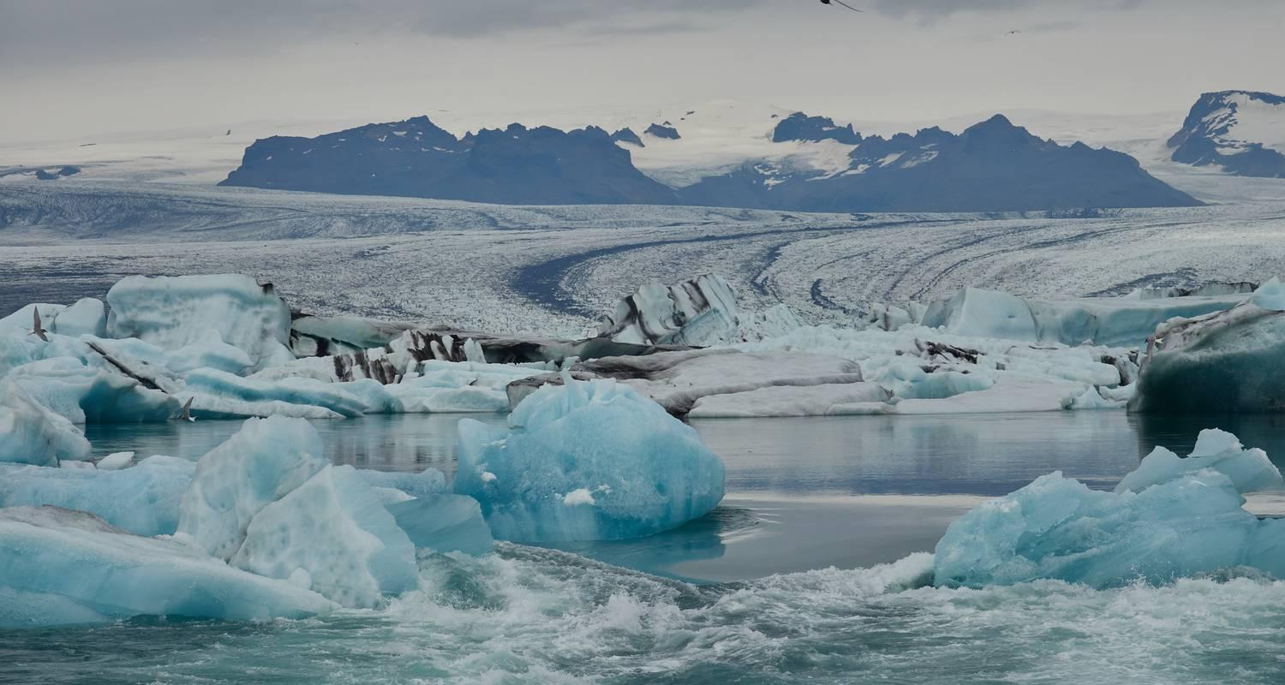

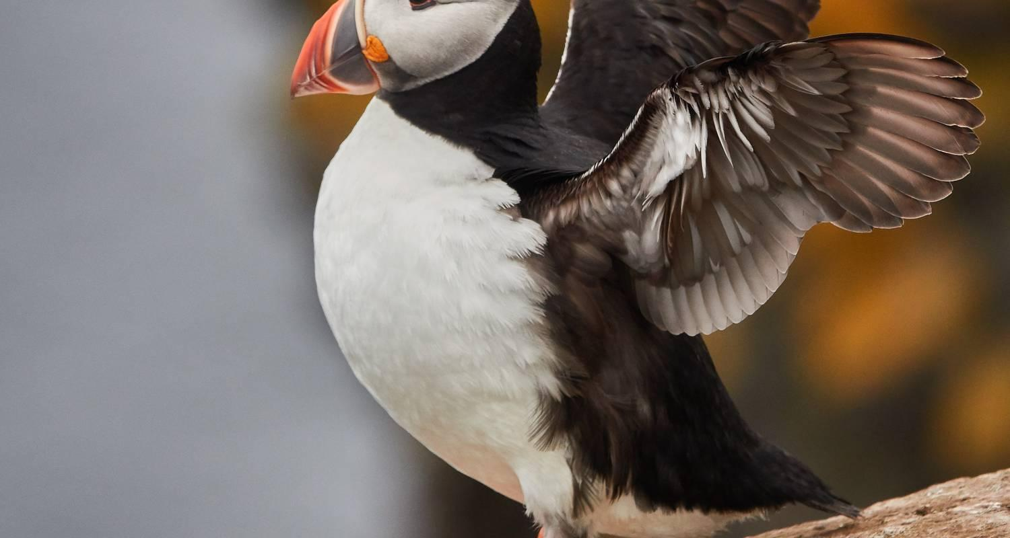

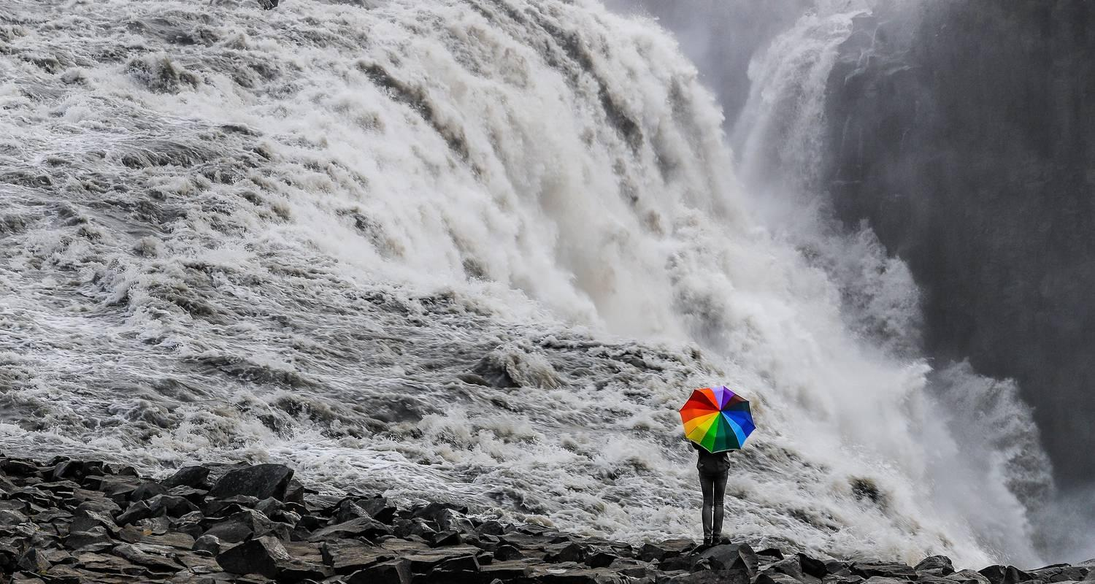

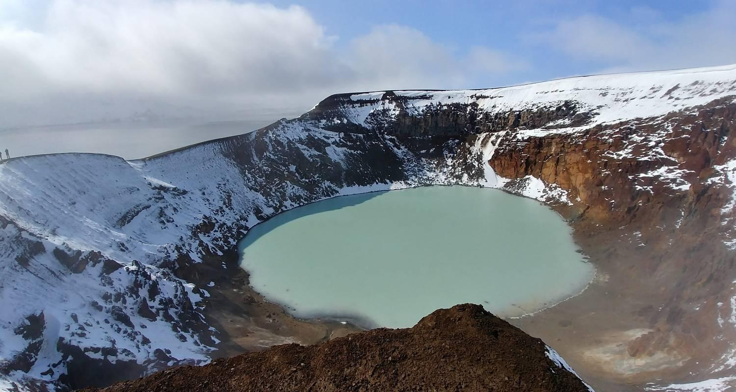

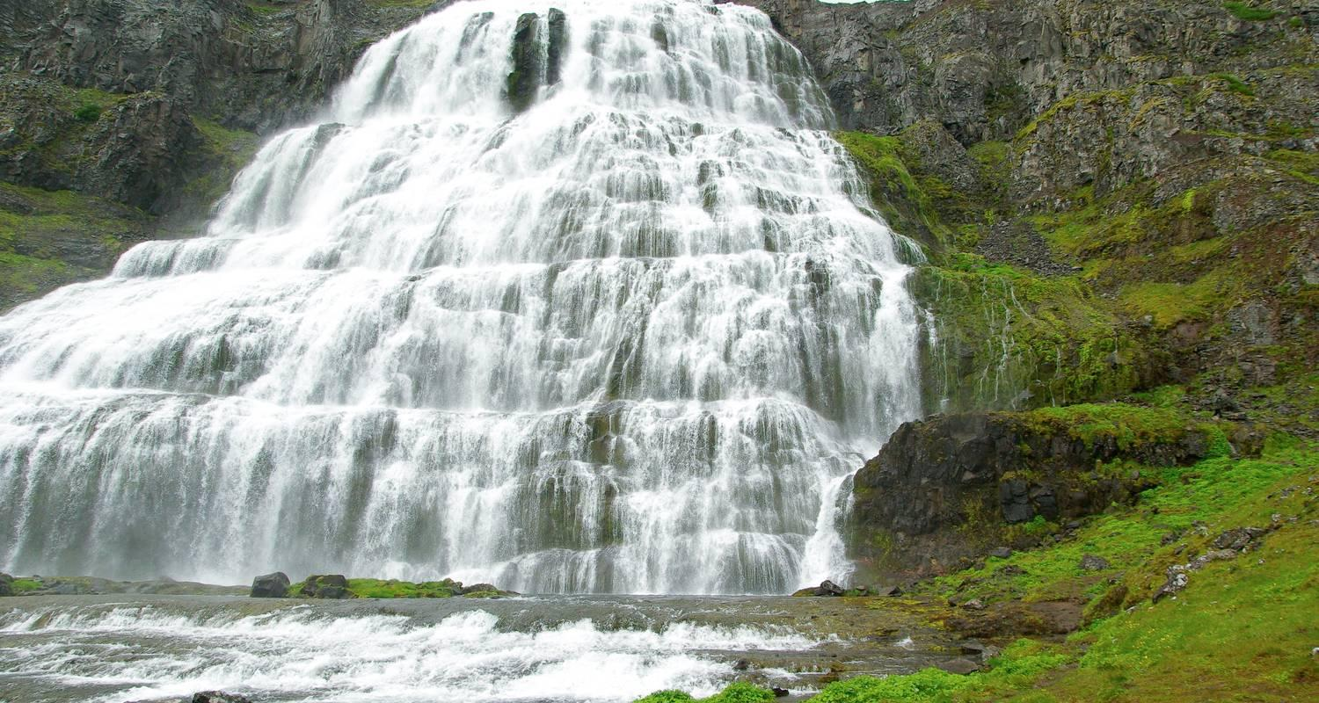

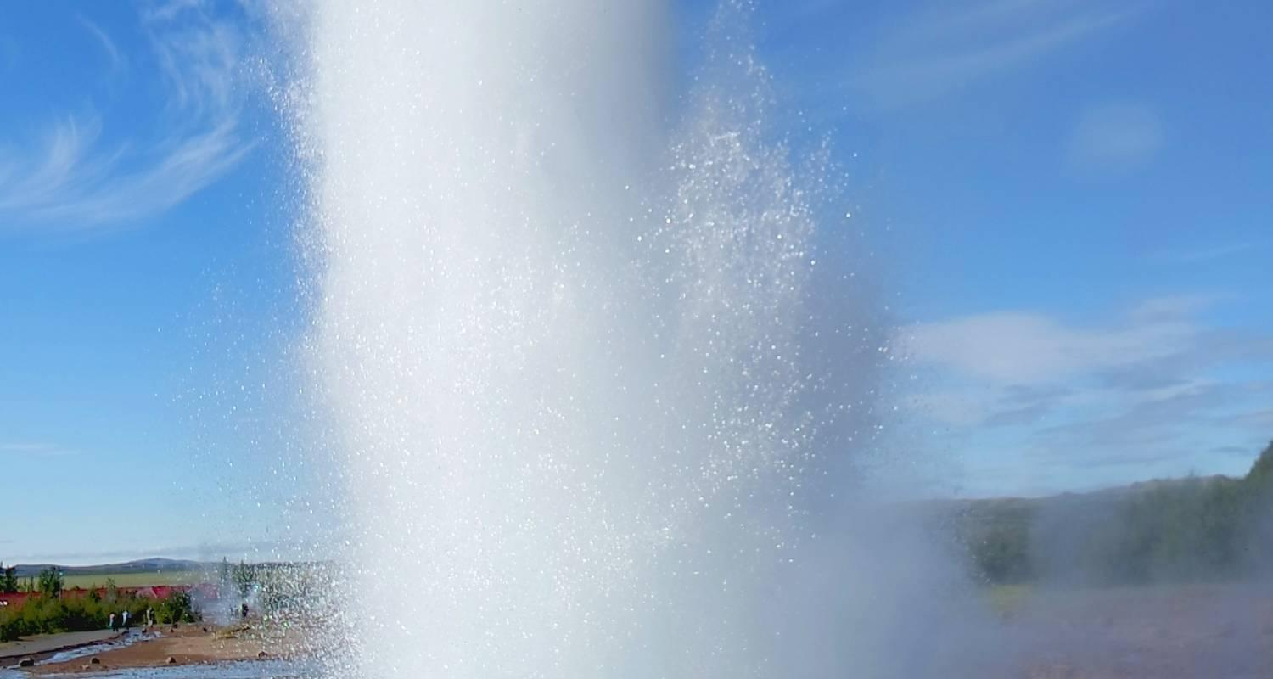

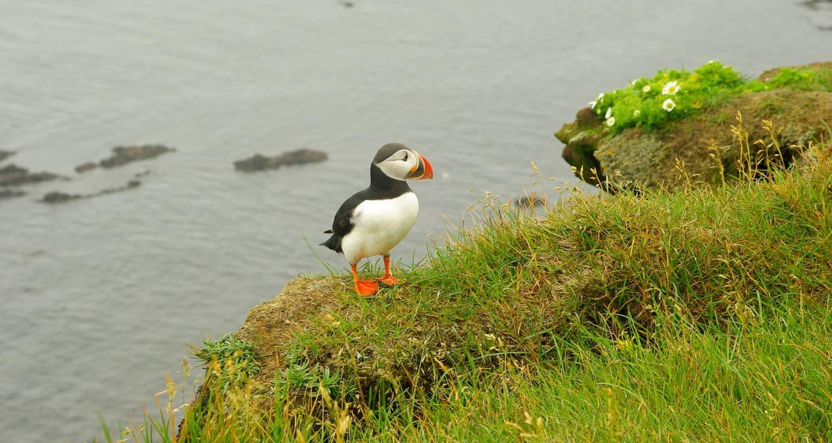

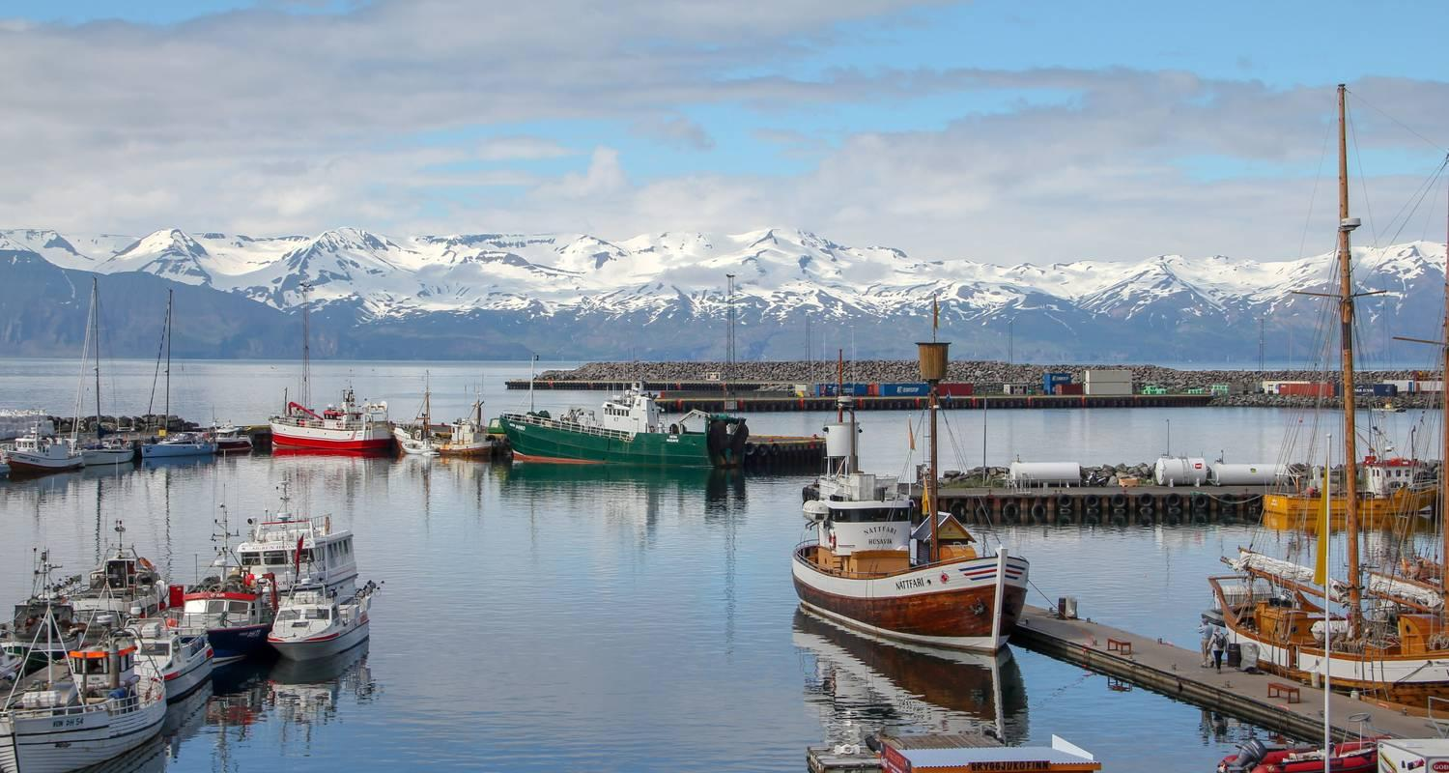

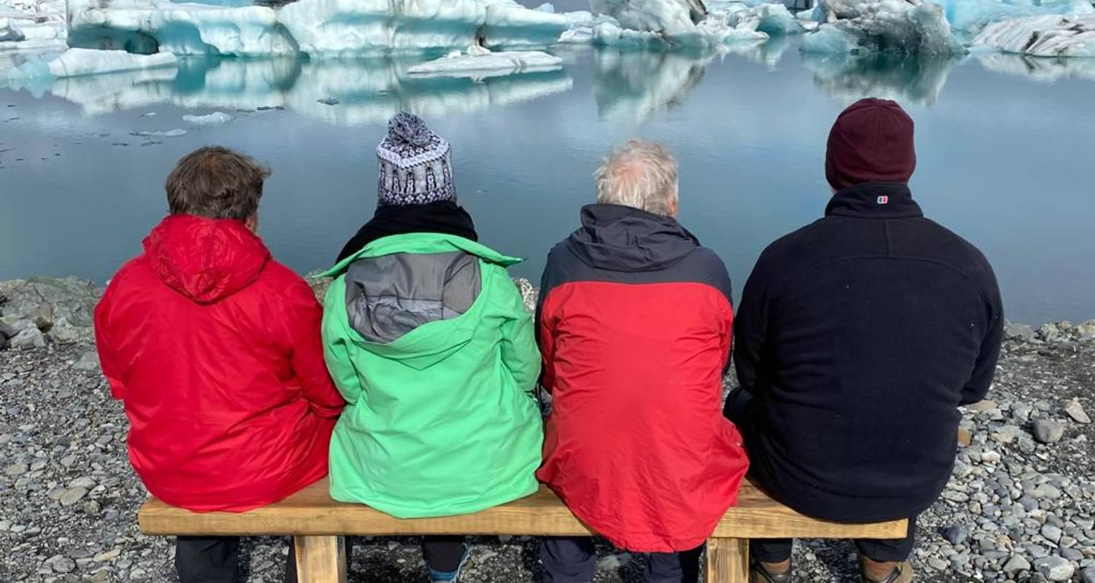

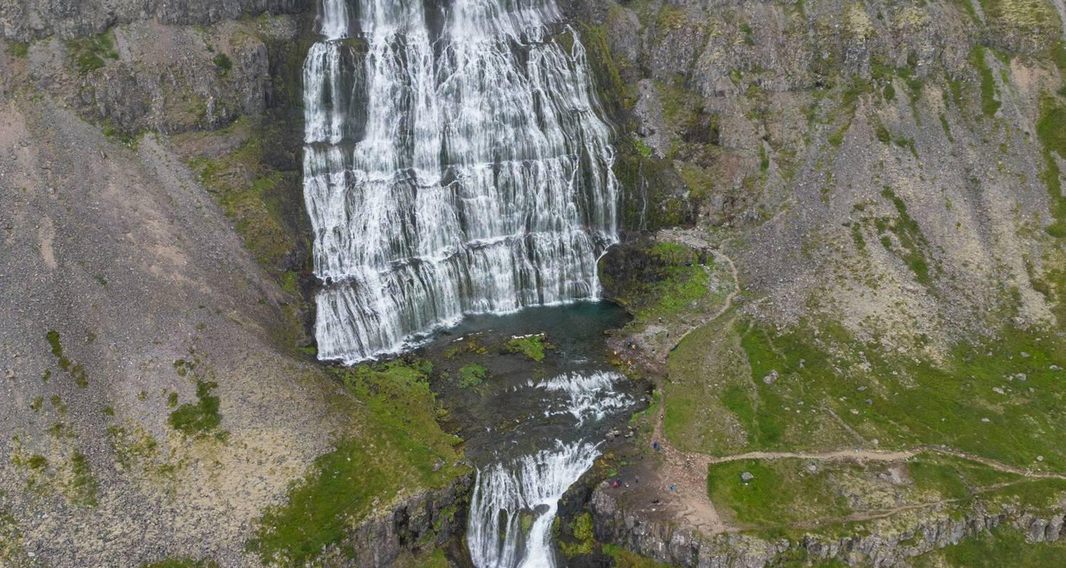

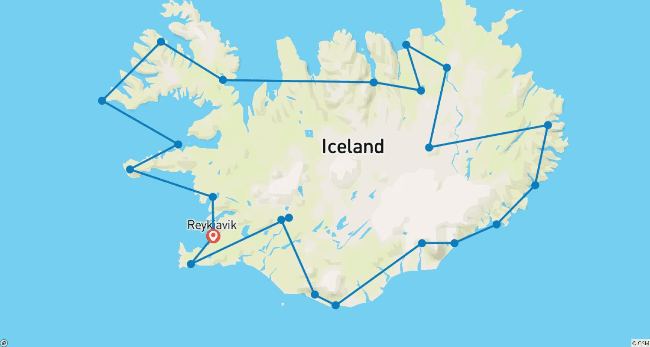

Tour ID: 104212  
Tour Name: 10 day Guided tour | Iceland Complete

Tour destinations: ['Reykjavik', 'Gullfoss', 'Geysir', 'Hella', 'Skogafoss', 'Reynisfjara', 'Vik', 'Skaftafell', 'Jokulsarlon', 'Hofn', 'Egilsstadir', 'Myvatn', 'Akureyri', 'Laugarbakki', 'Borgarnes', 'Snæfellsnes', 'Thingvellir National Park']

Tour destinations images:

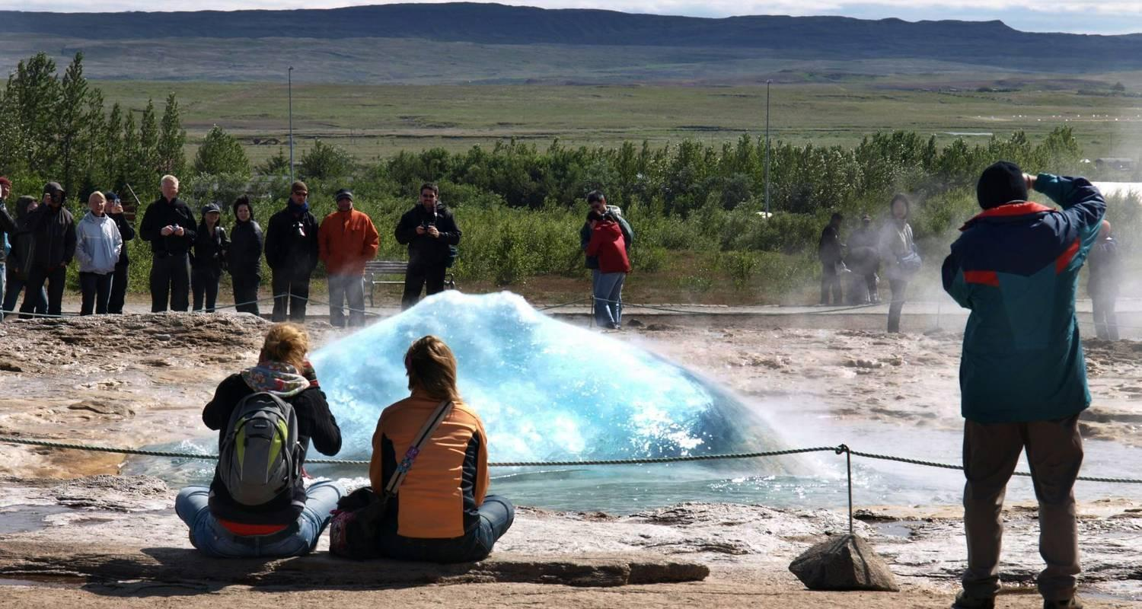

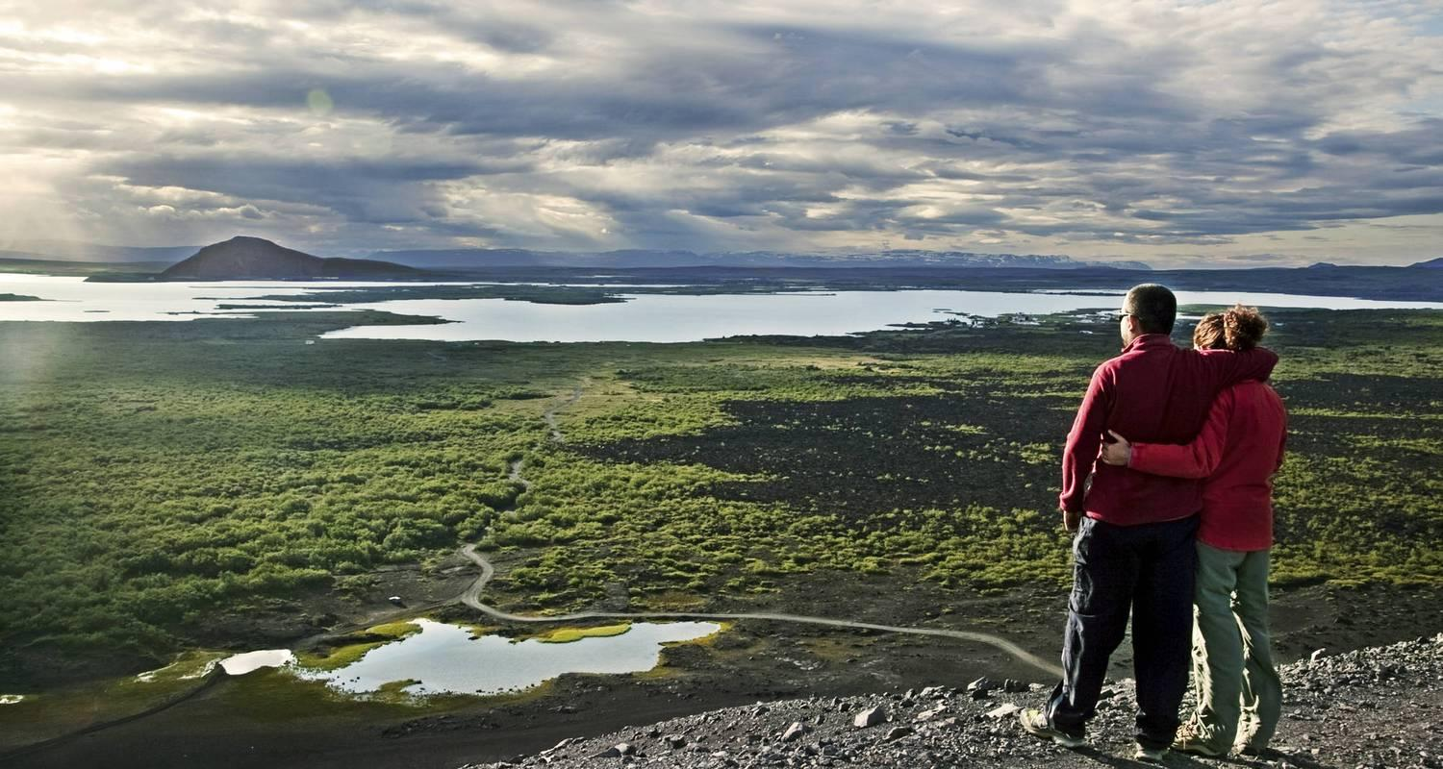

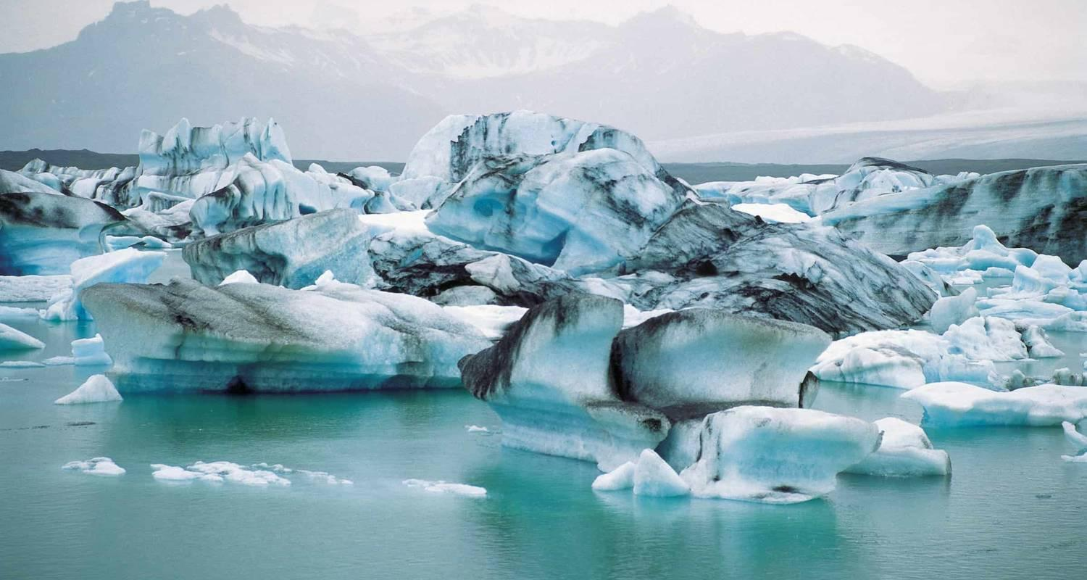

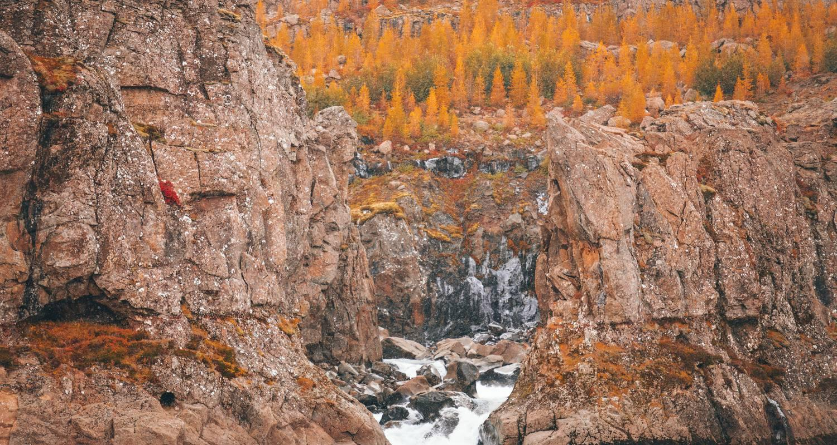

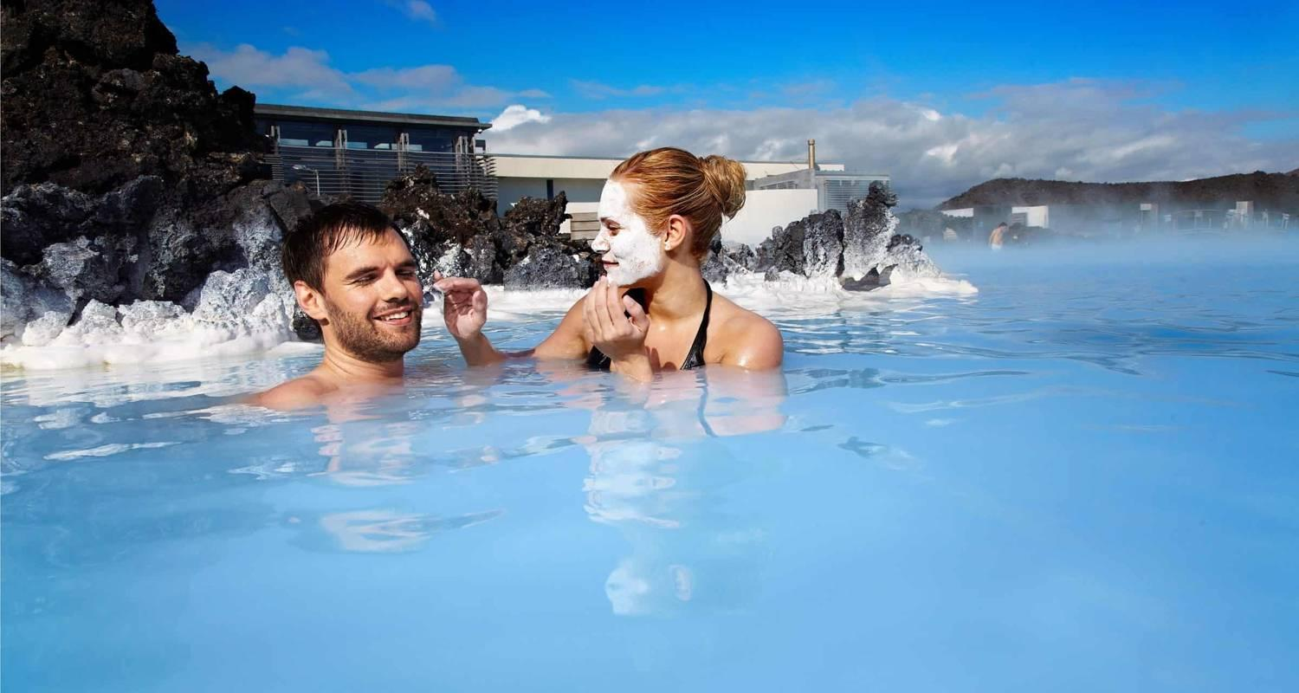

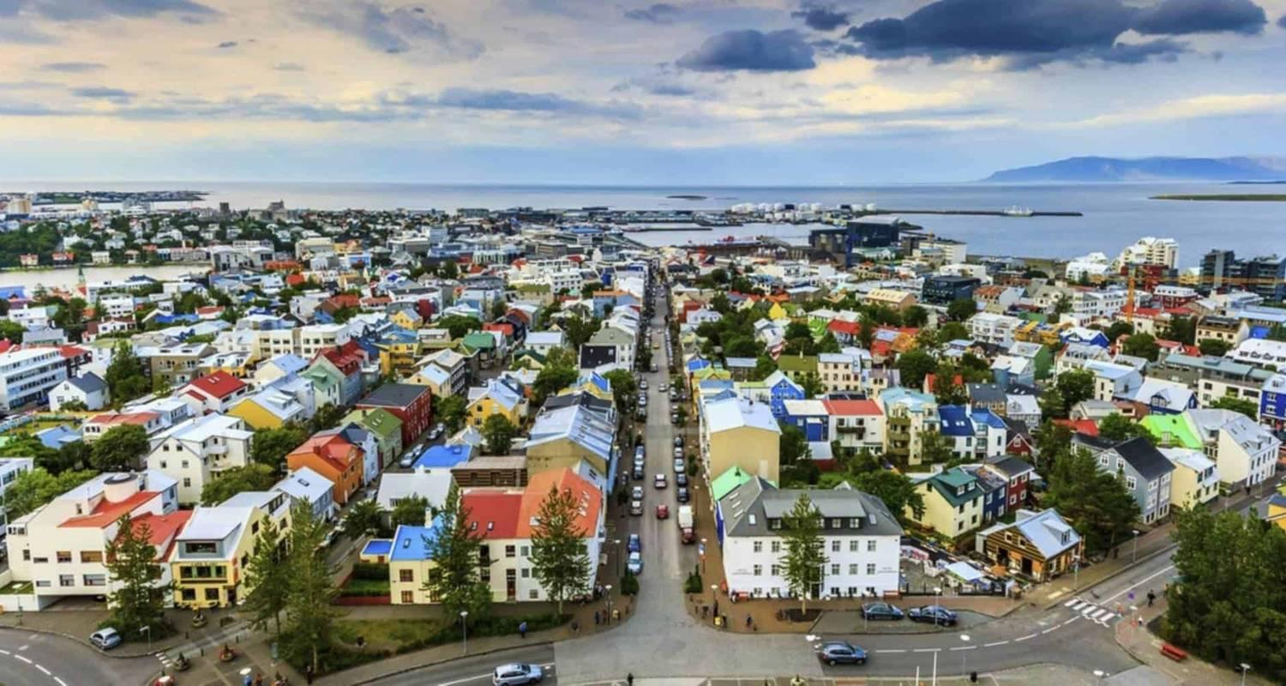

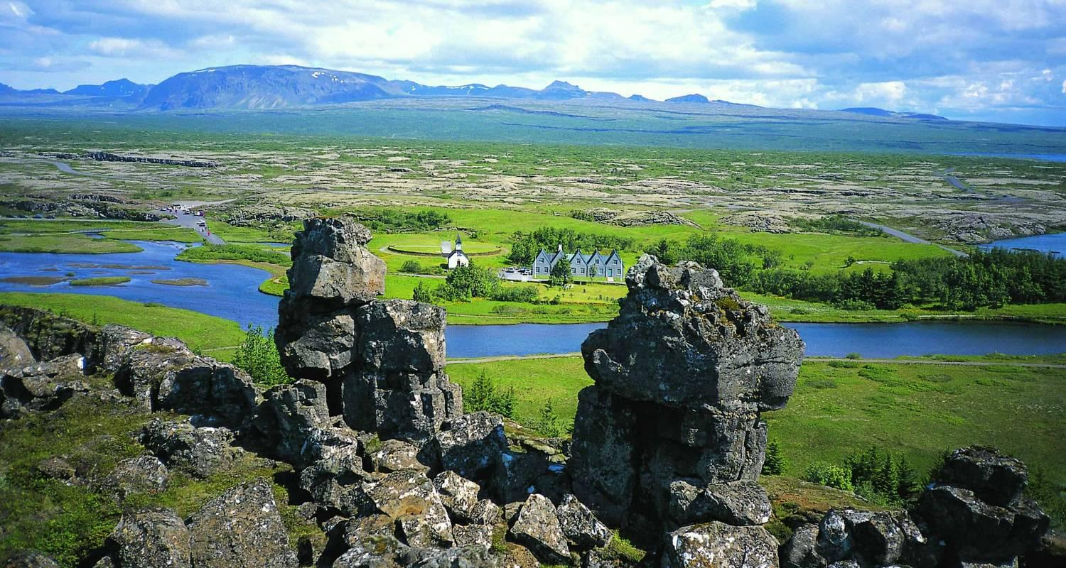

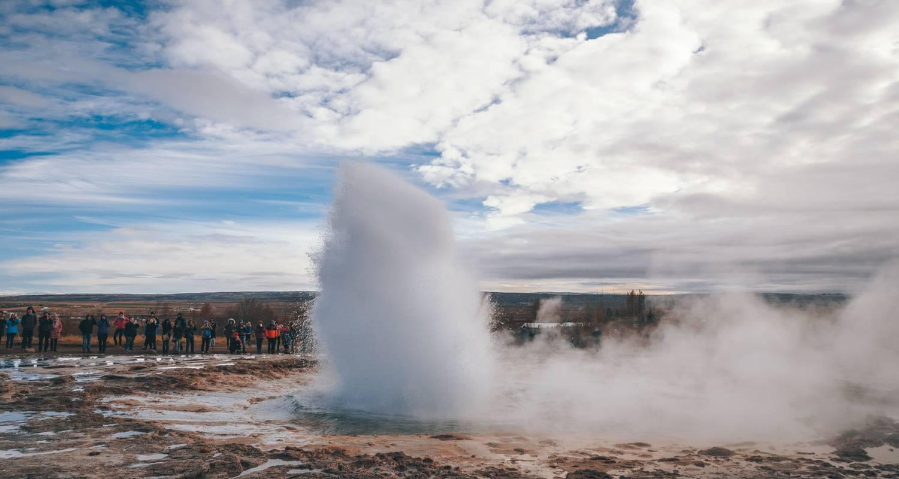

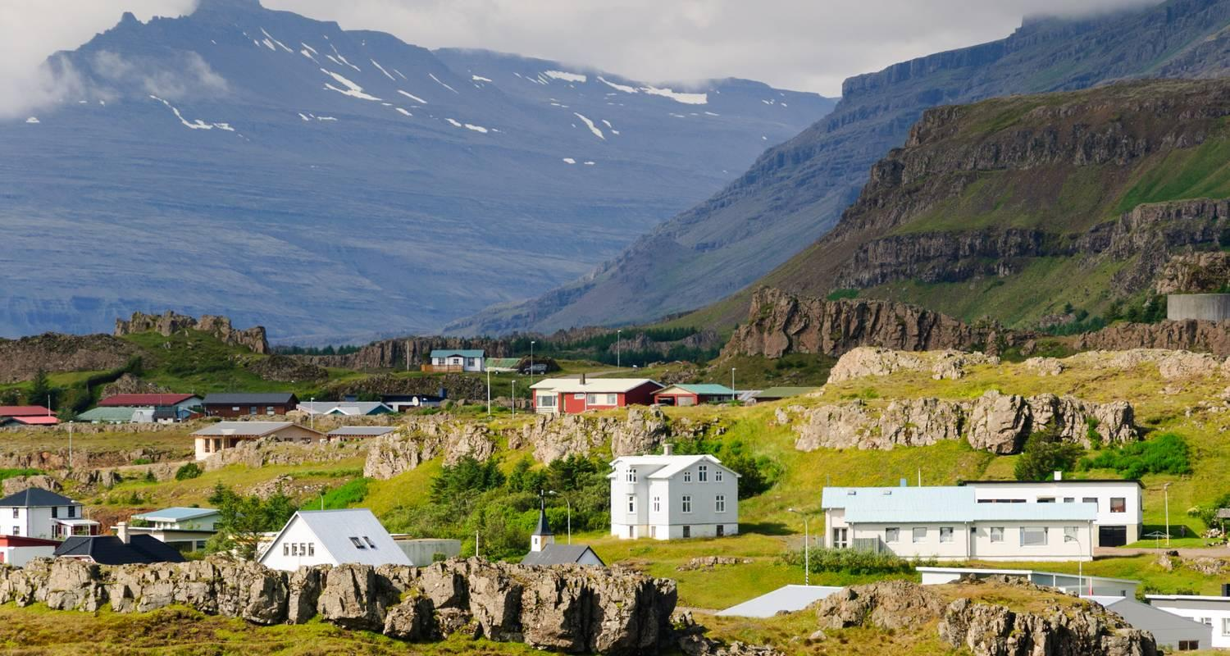

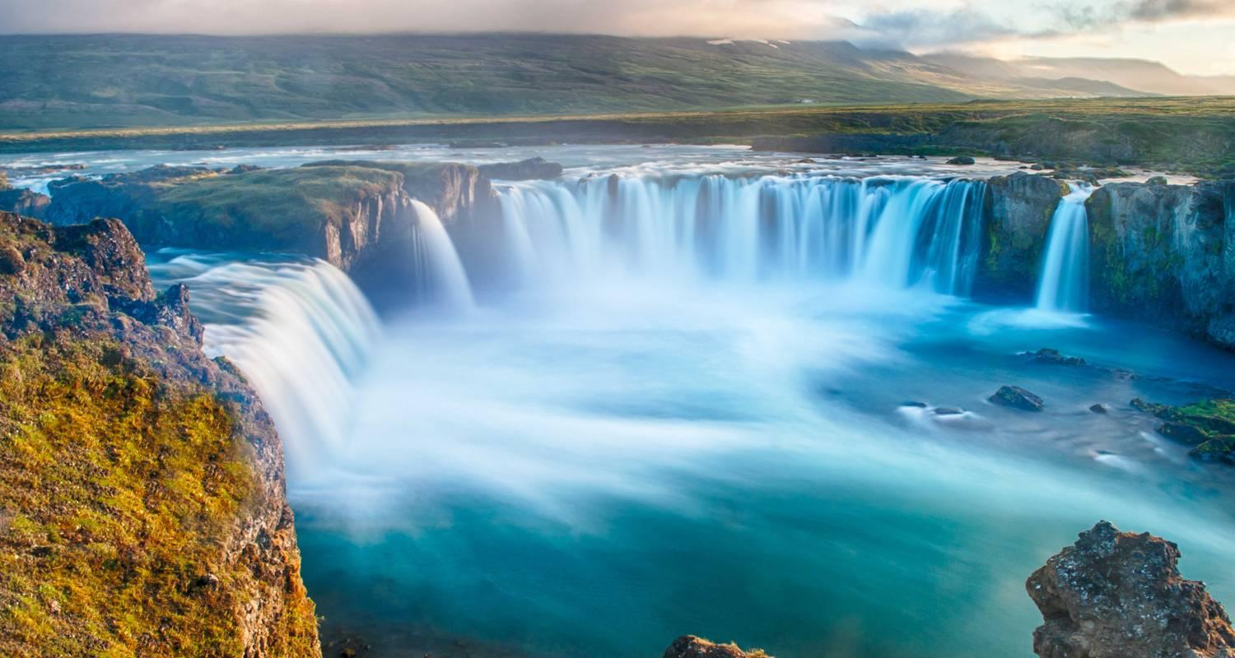

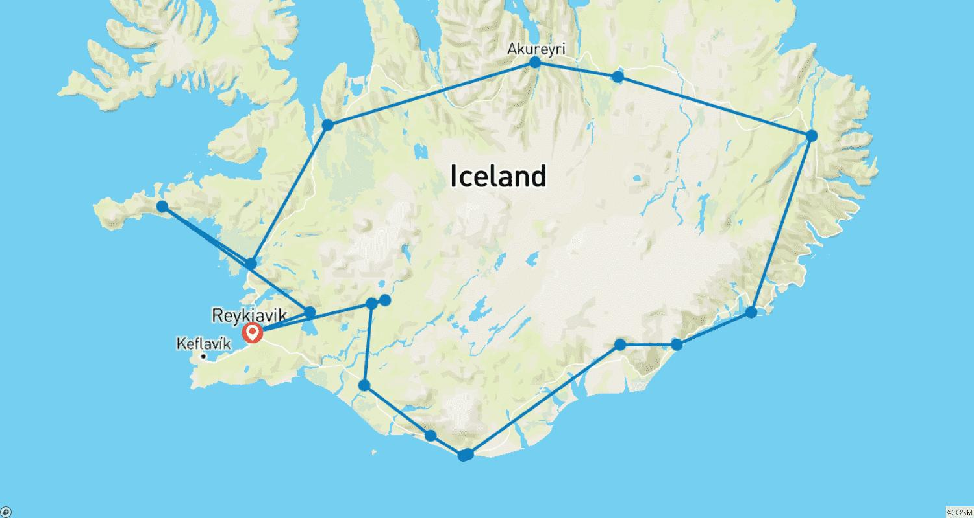

Tour ID: 104220  
Tour Name: 12 day Guided tour | Across the Wilderness - Iceland‘s interior mysteries and more

Tour destinations: ['Reykjavik', 'Thingvellir National Park', 'Gullfoss', 'Vik', 'Reynisfjara', 'Kirkjubaejarklaustur', 'Jokulsarlon', 'Skaftafell', 'Landmannalaugar', 'Myvatn', 'Askja', 'Dettifoss', 'Asbyrgi Canyon', 'Akureyri', 'Saudarkrokur', 'Hvammstangi', 'Snaefellsjokull National Park', 'Borgarnes']

Tour destinations images:

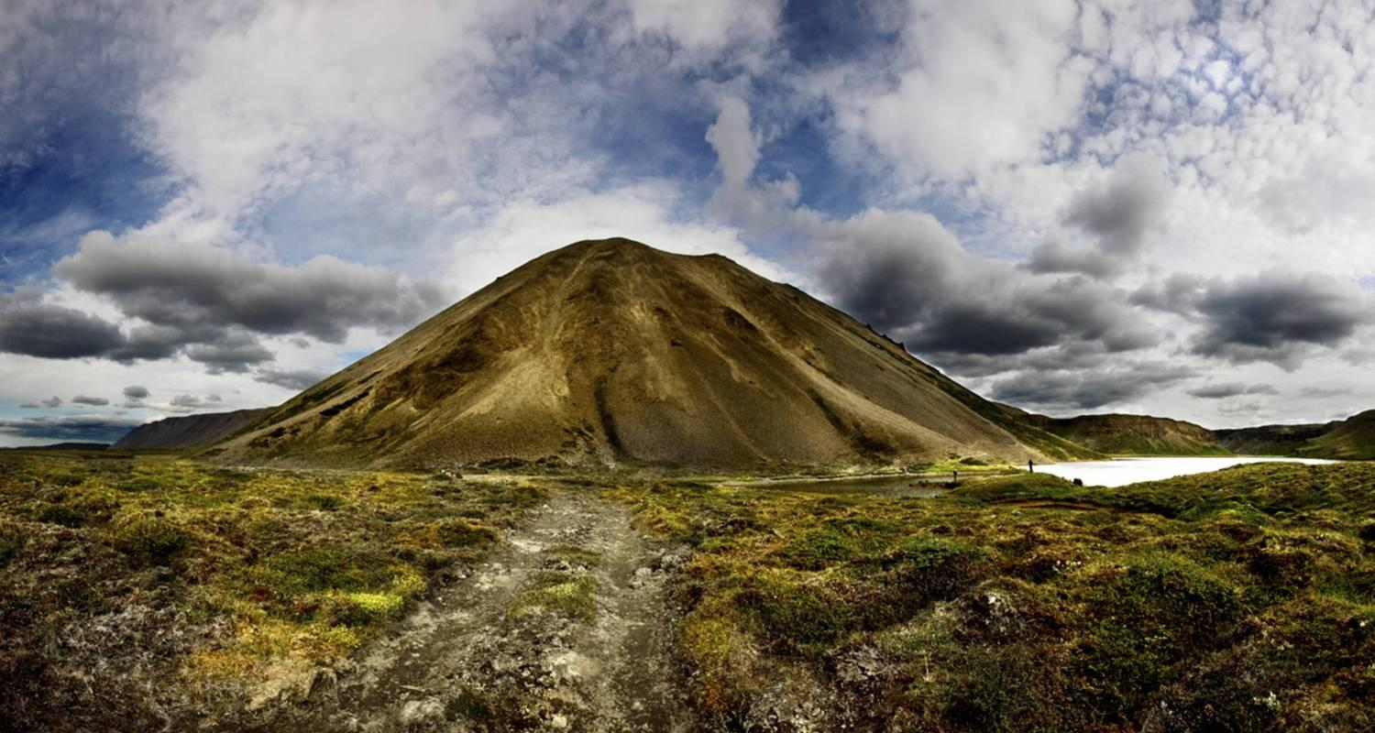

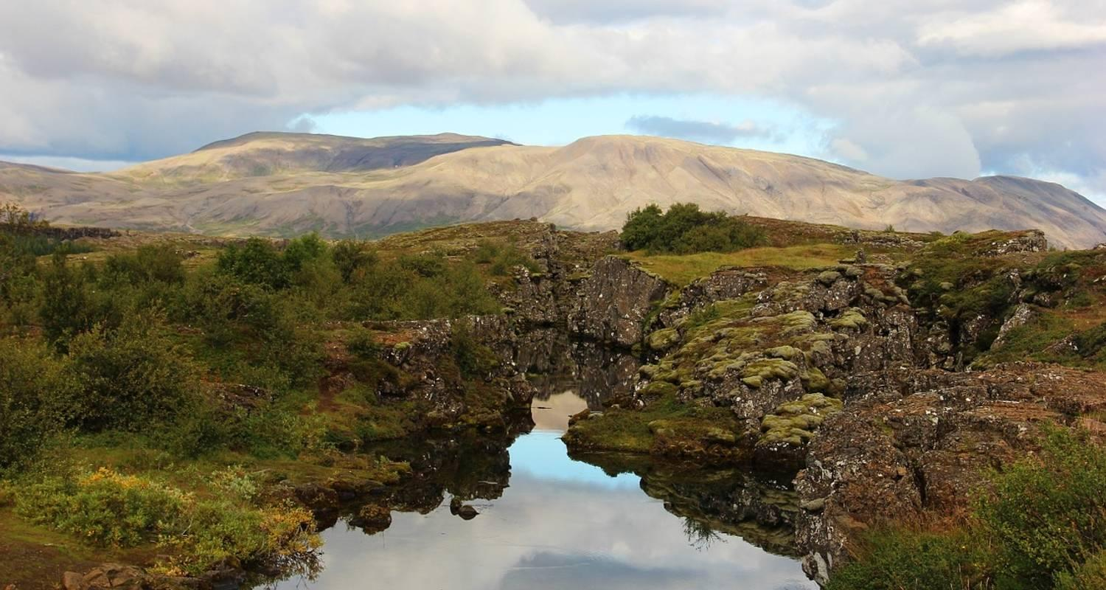

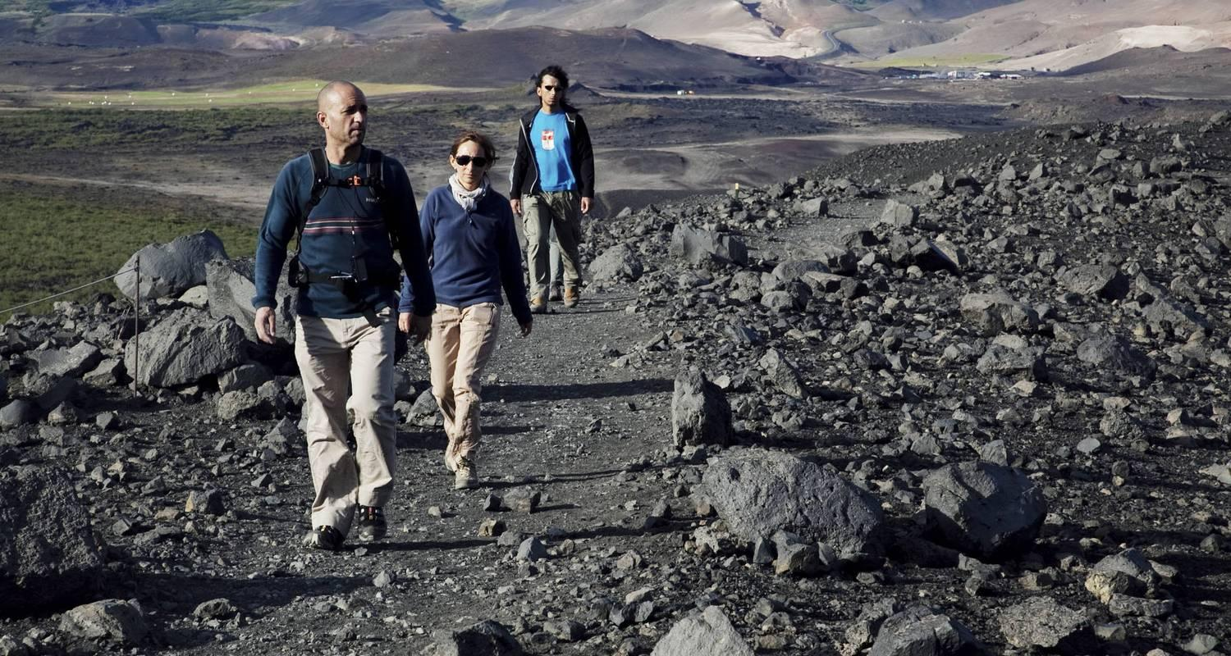

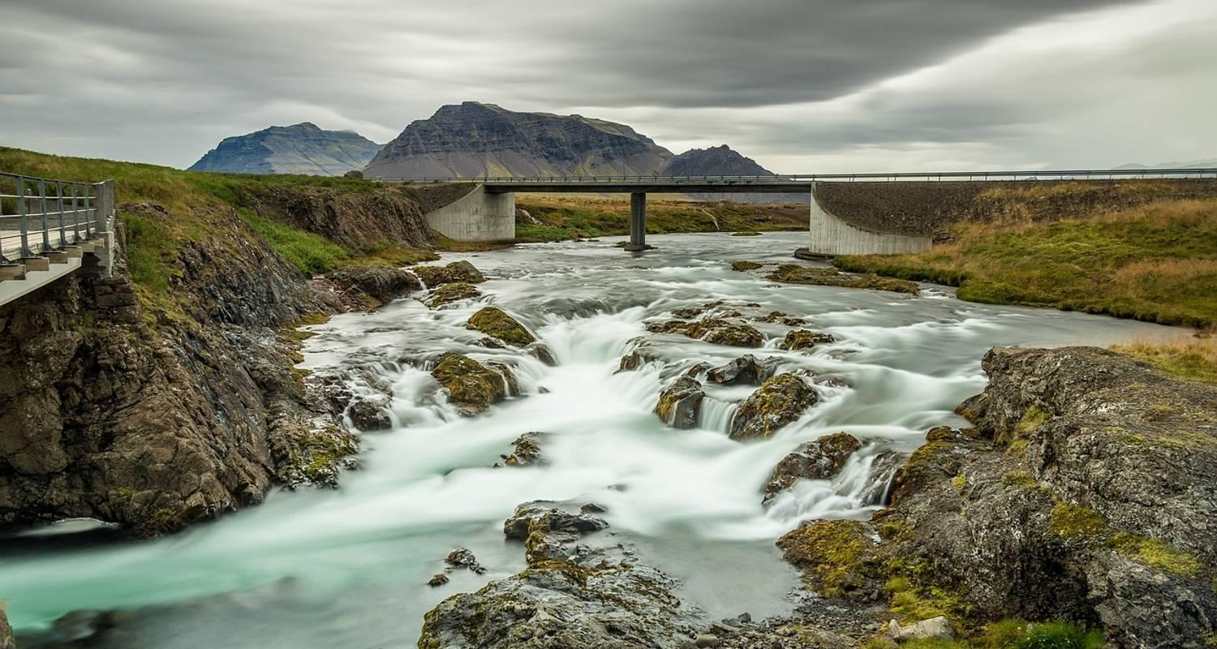

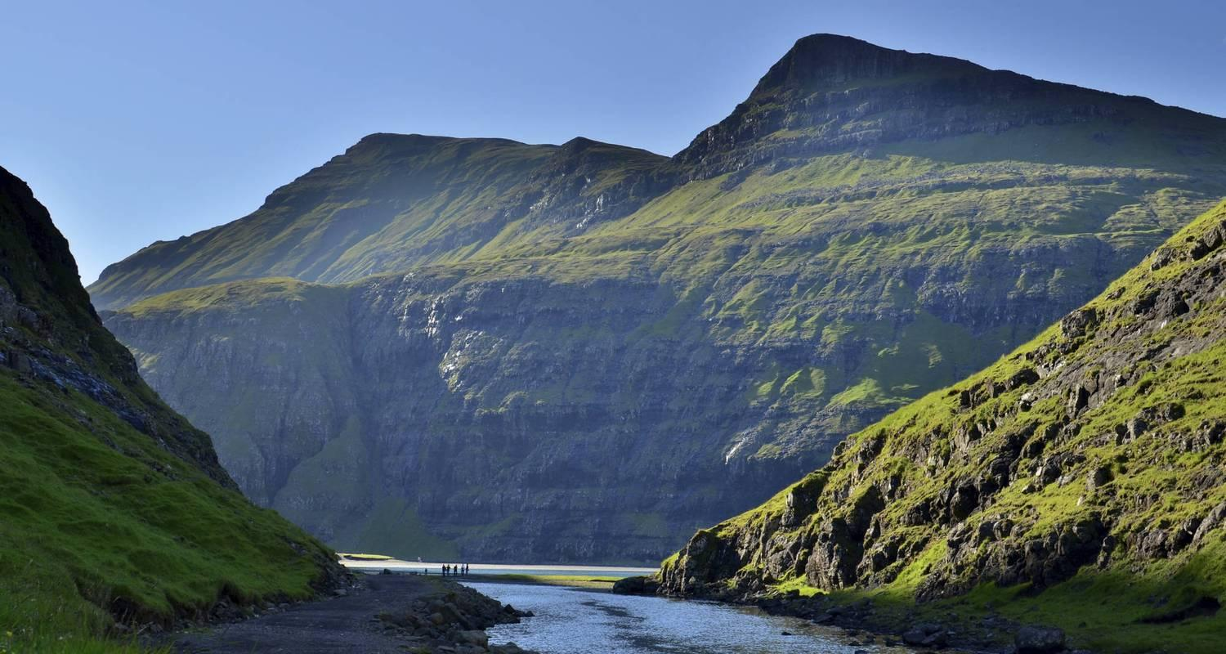

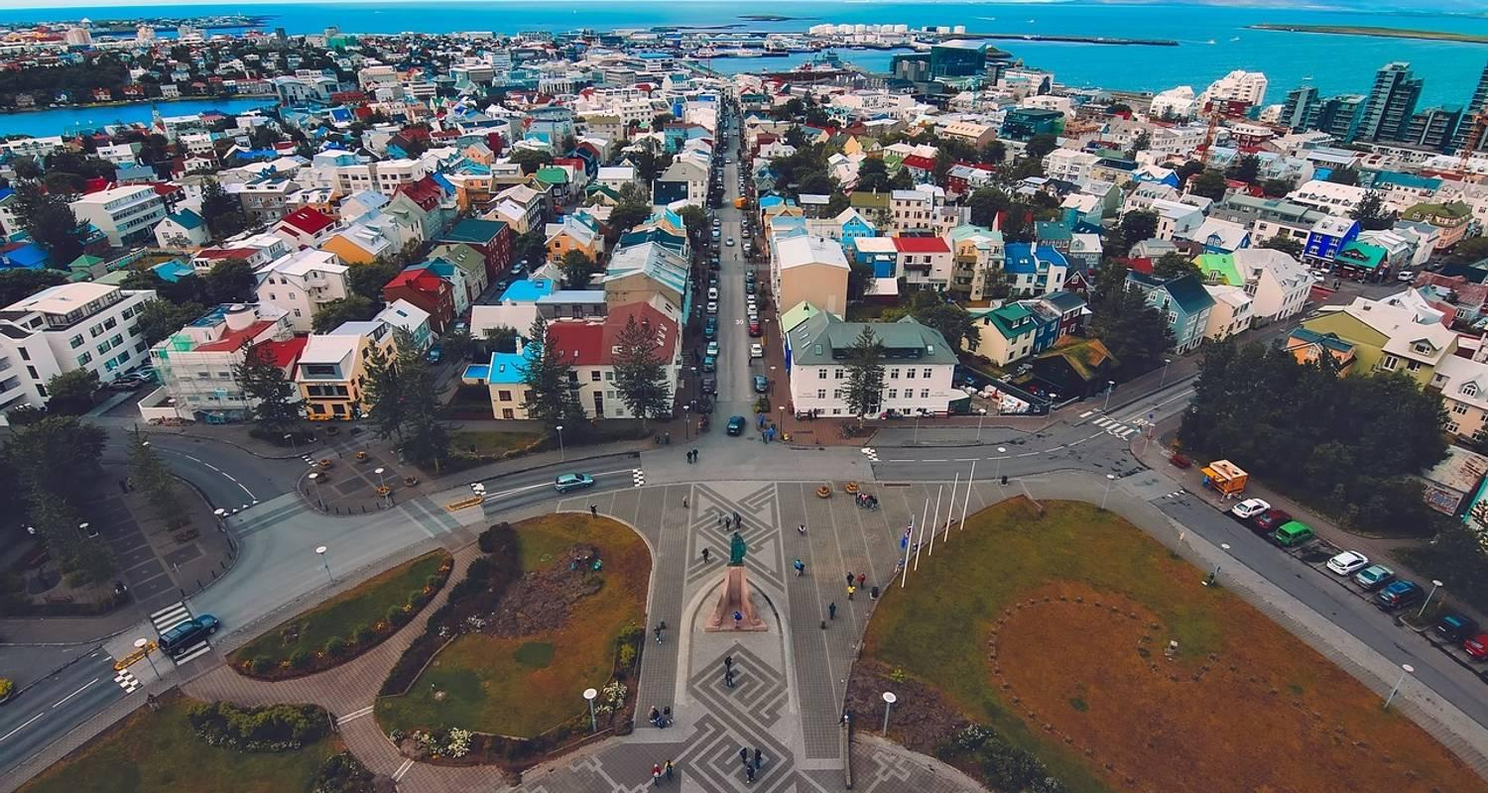

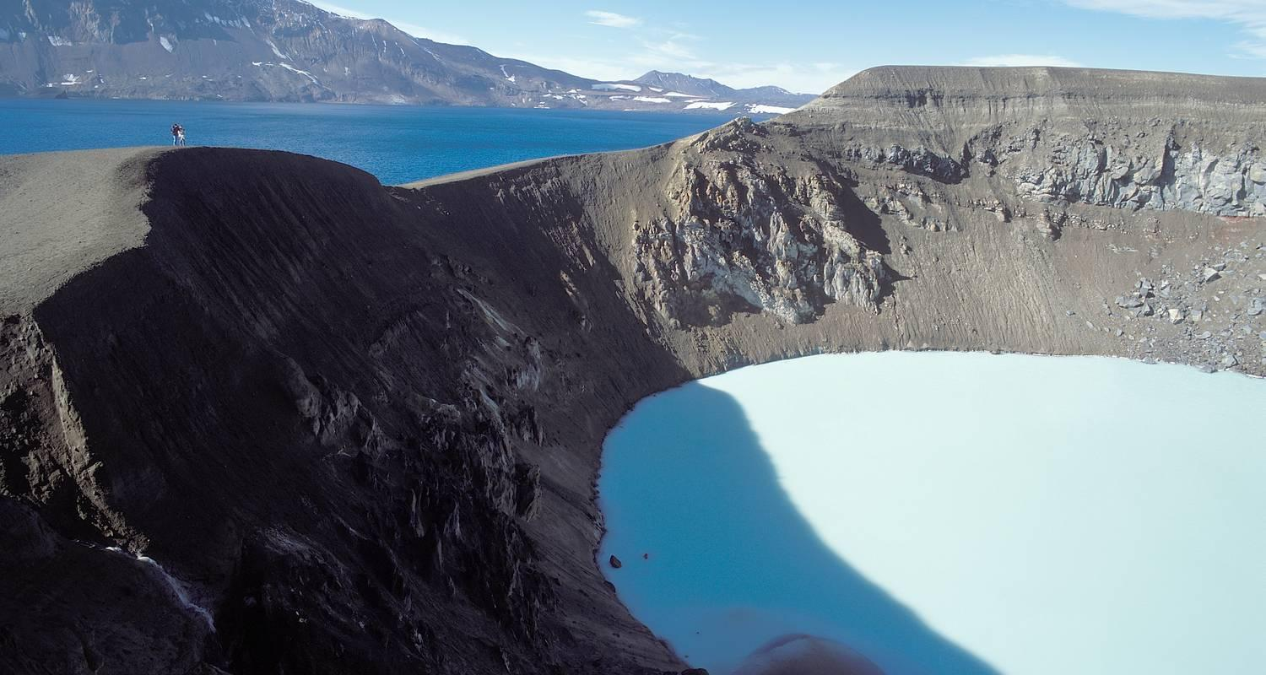

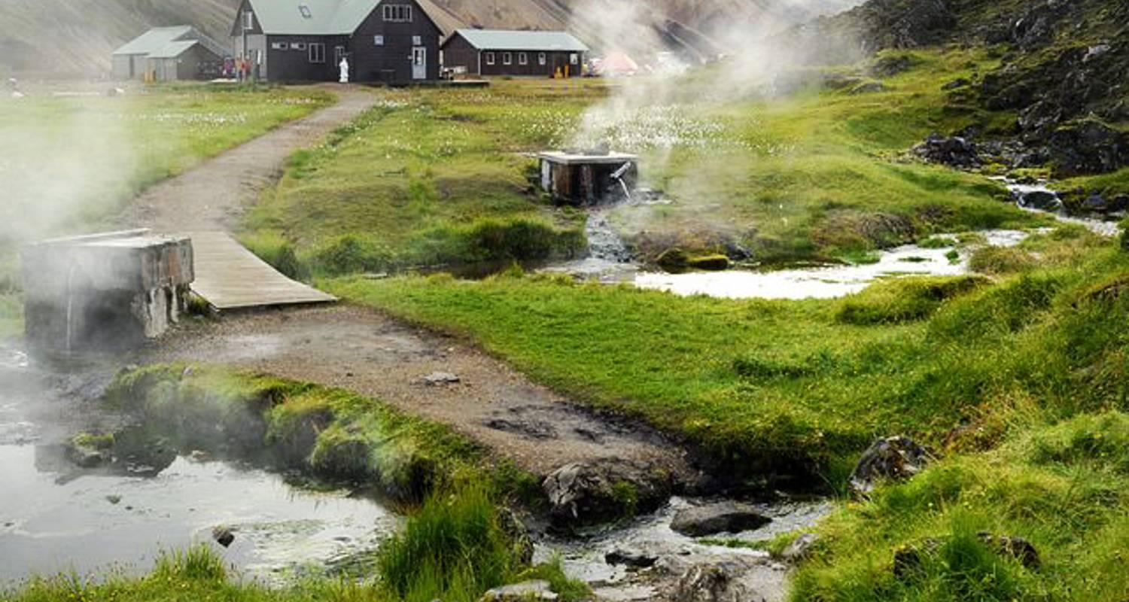

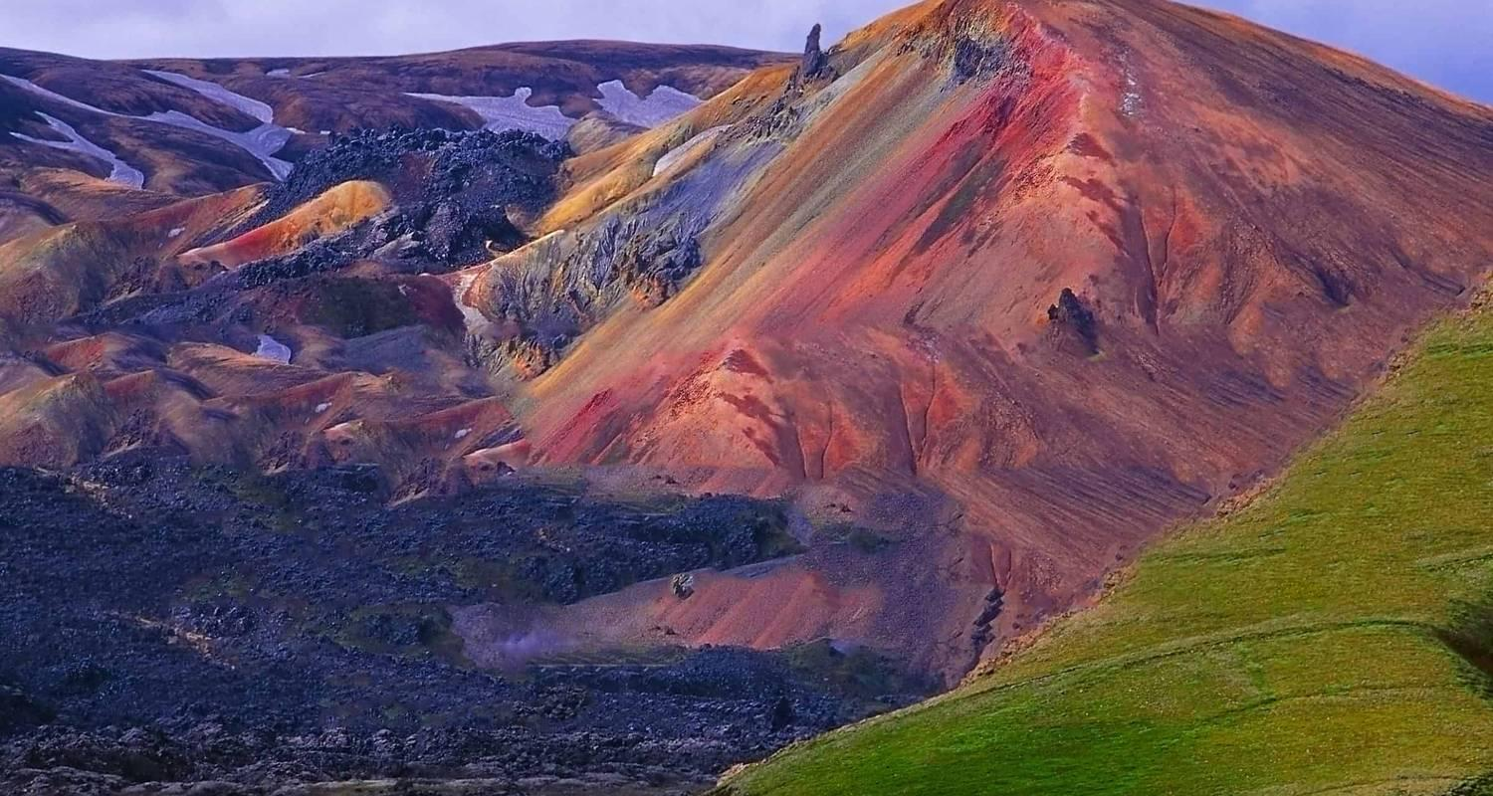

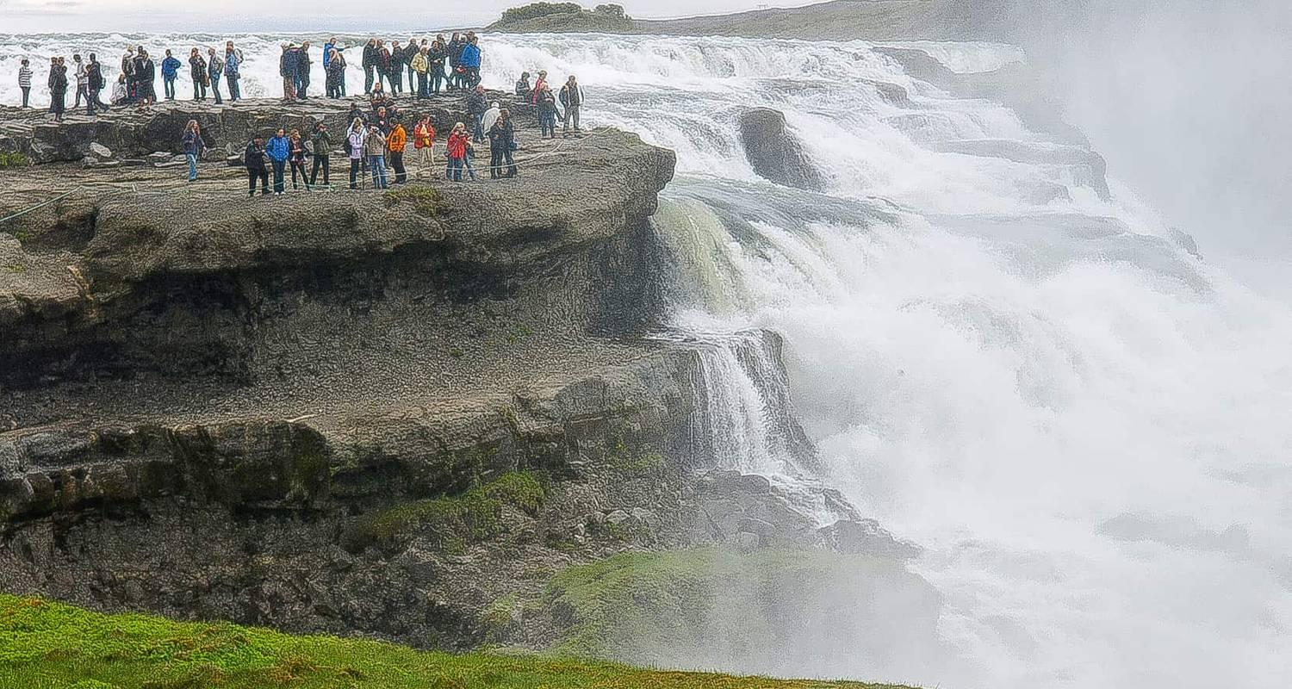

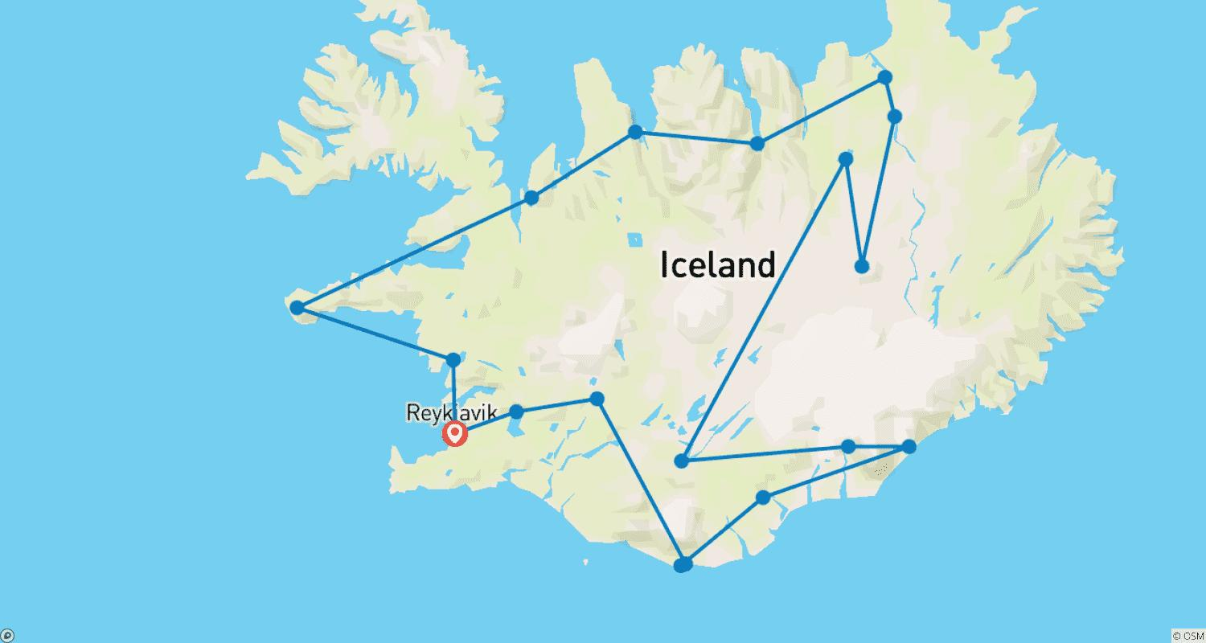

Tour ID: 104282  
Tour Name: 8 day Self-drive tour | Fantastic Iceland

Tour destinations: ['Keflavik', 'Reykjavik', 'Hveragerdi', 'Thingvellir National Park', 'Gullfoss', 'Fludir', 'Selfoss', 'Hella', 'Vik', 'Kirkjubaejarklaustur', 'Skaftafell', 'Jokulsarlon', 'Hofn', 'Djupivogur', 'Egilsstadir', 'Dettifoss', 'Myvatn', 'Akureyri', 'Laugarbakki', 'Borgarnes']

Tour destinations images:

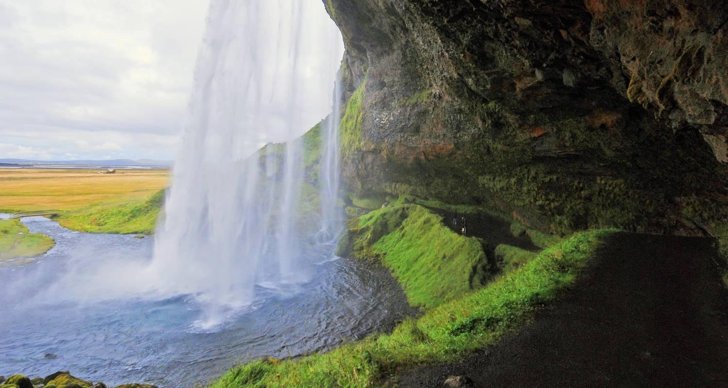

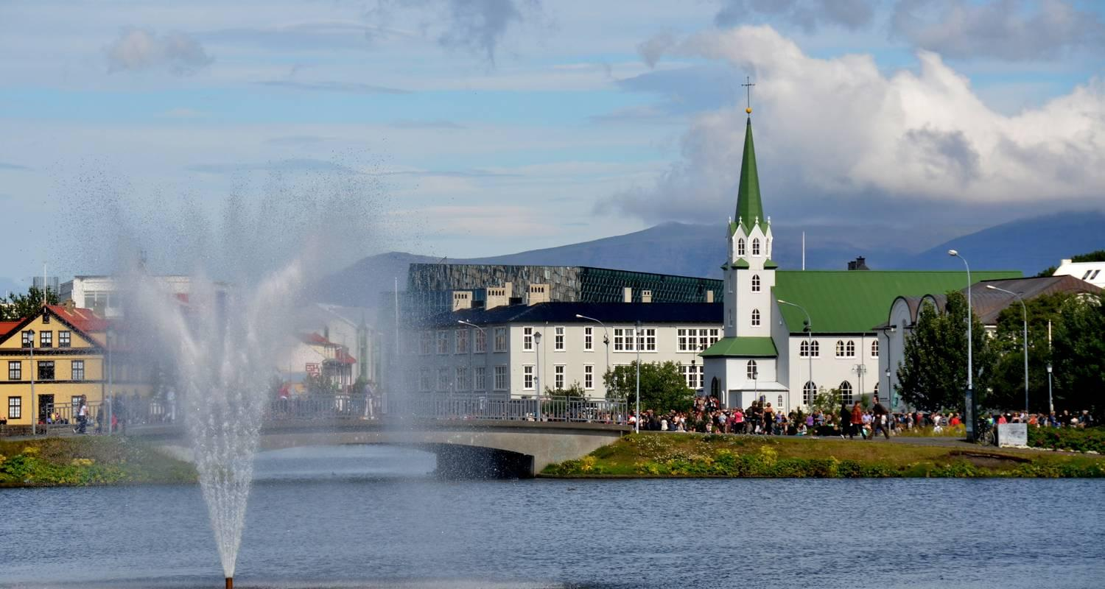

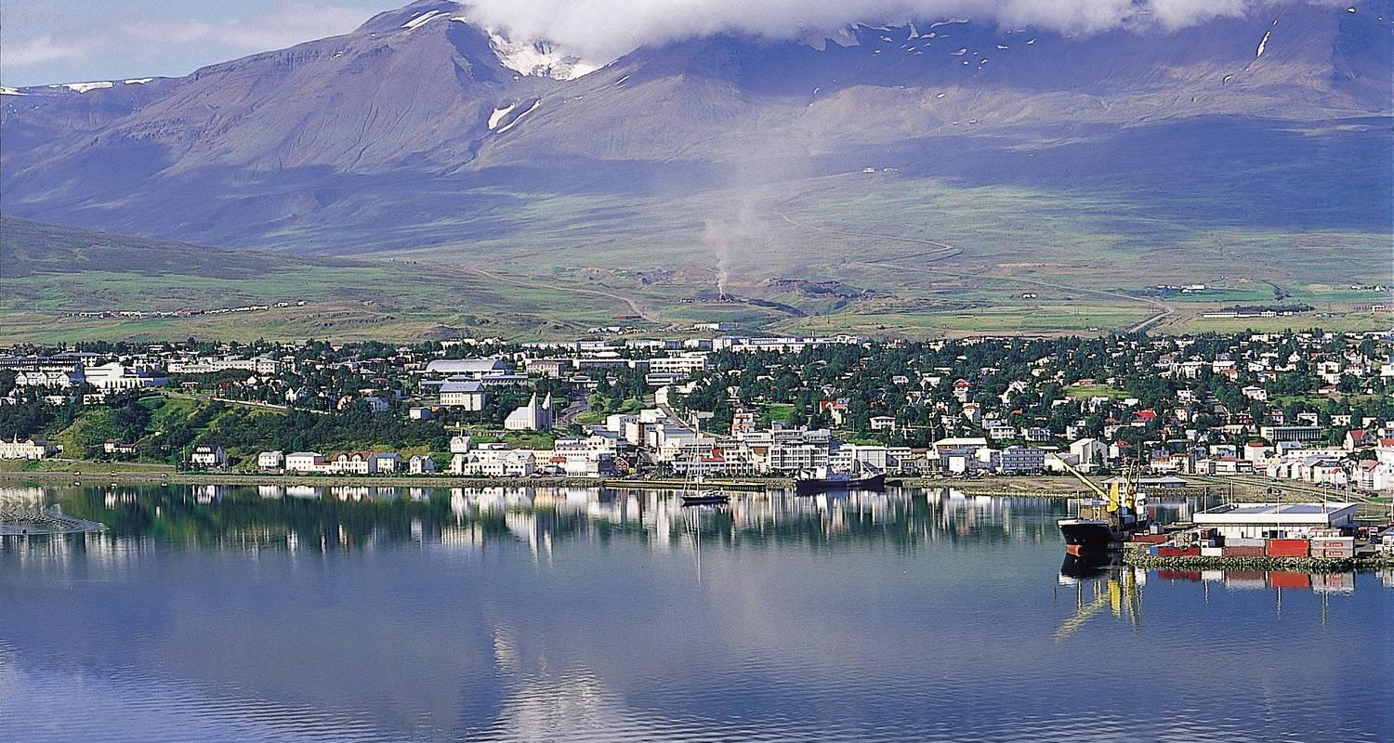

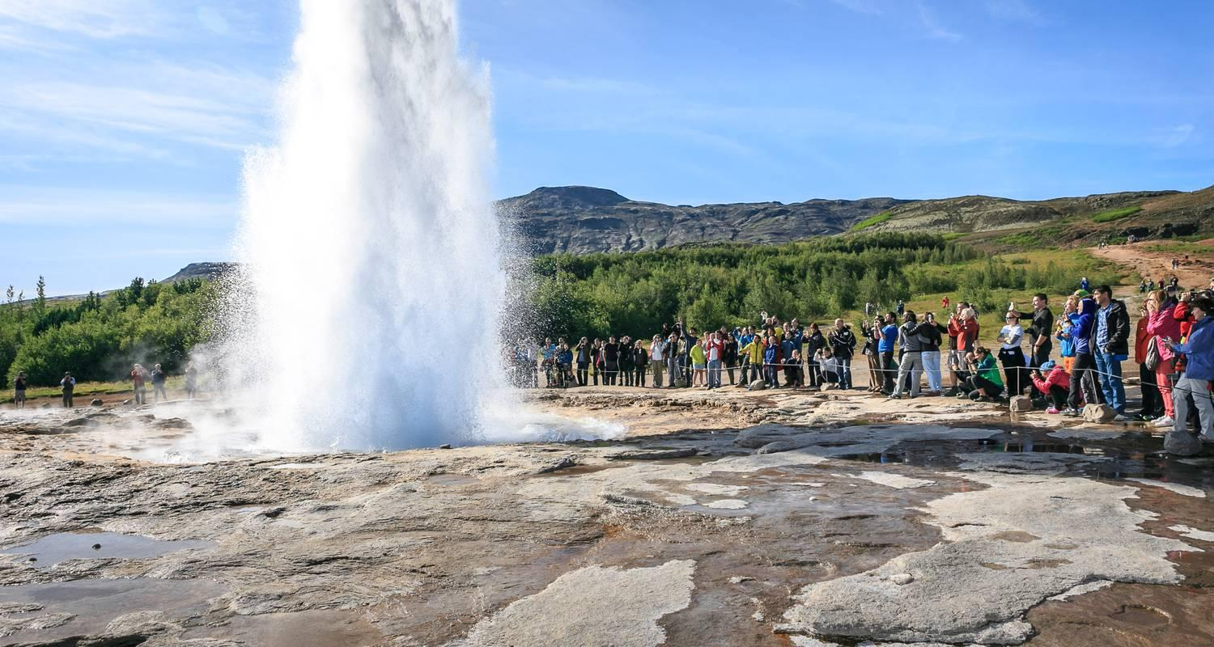

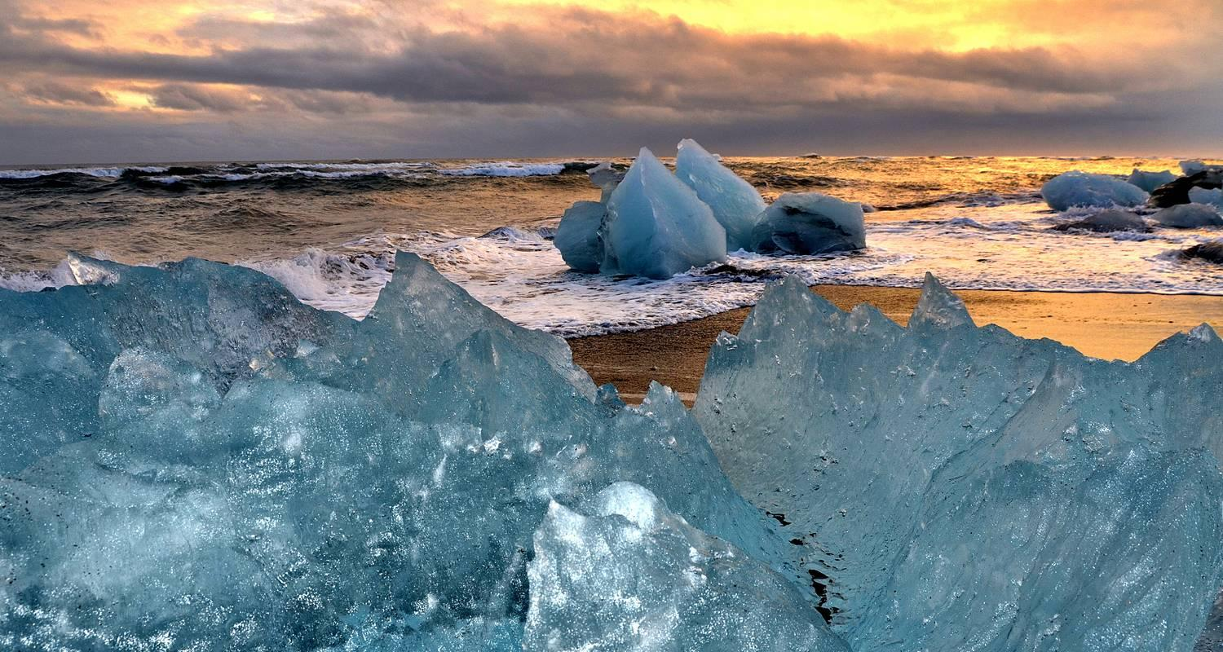

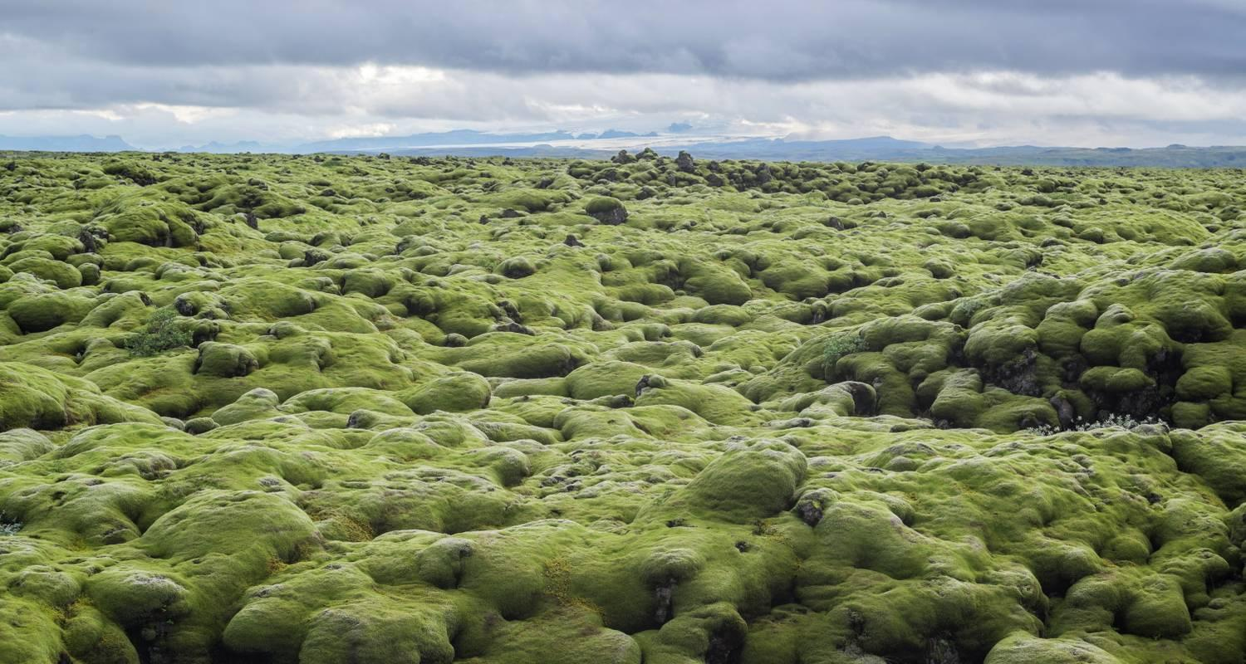

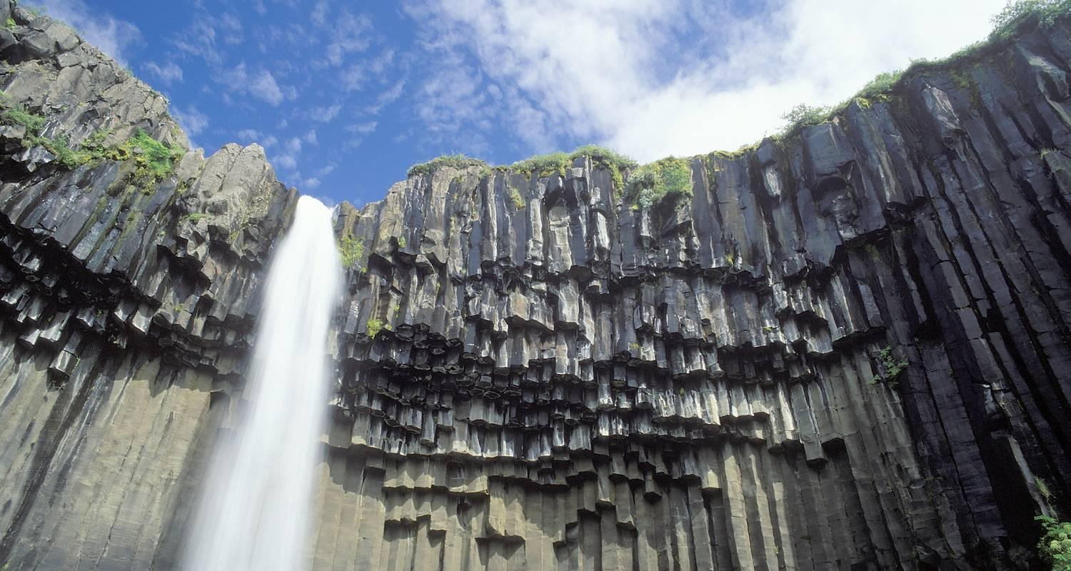

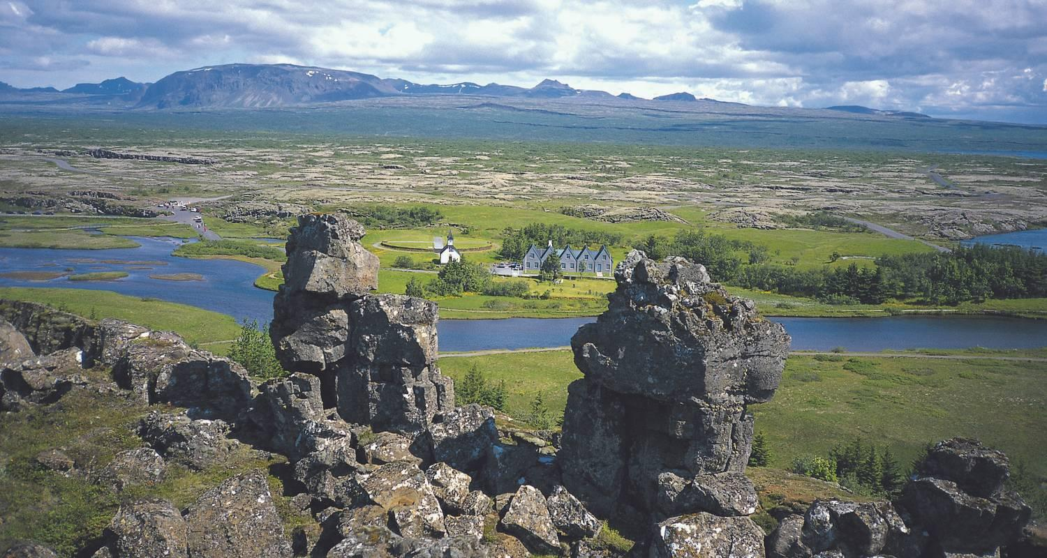

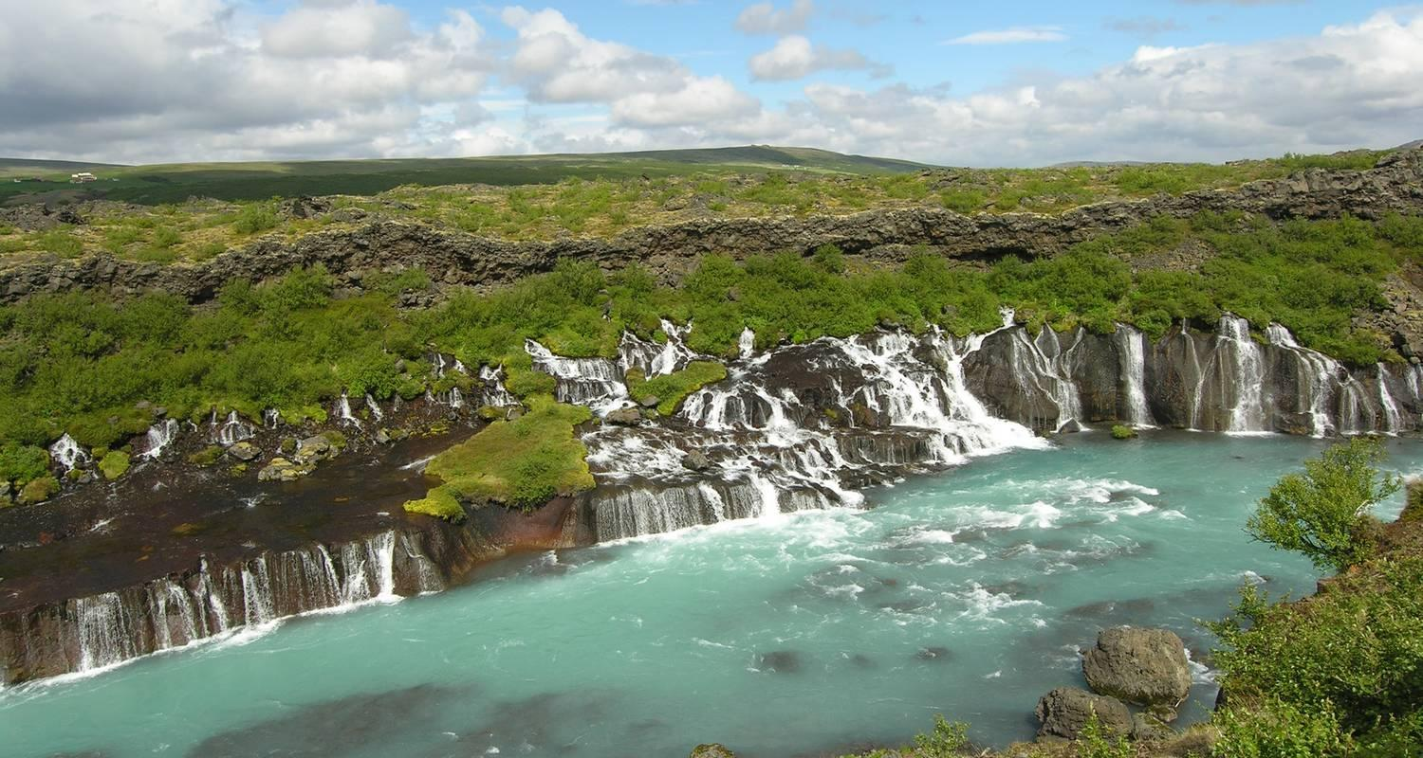

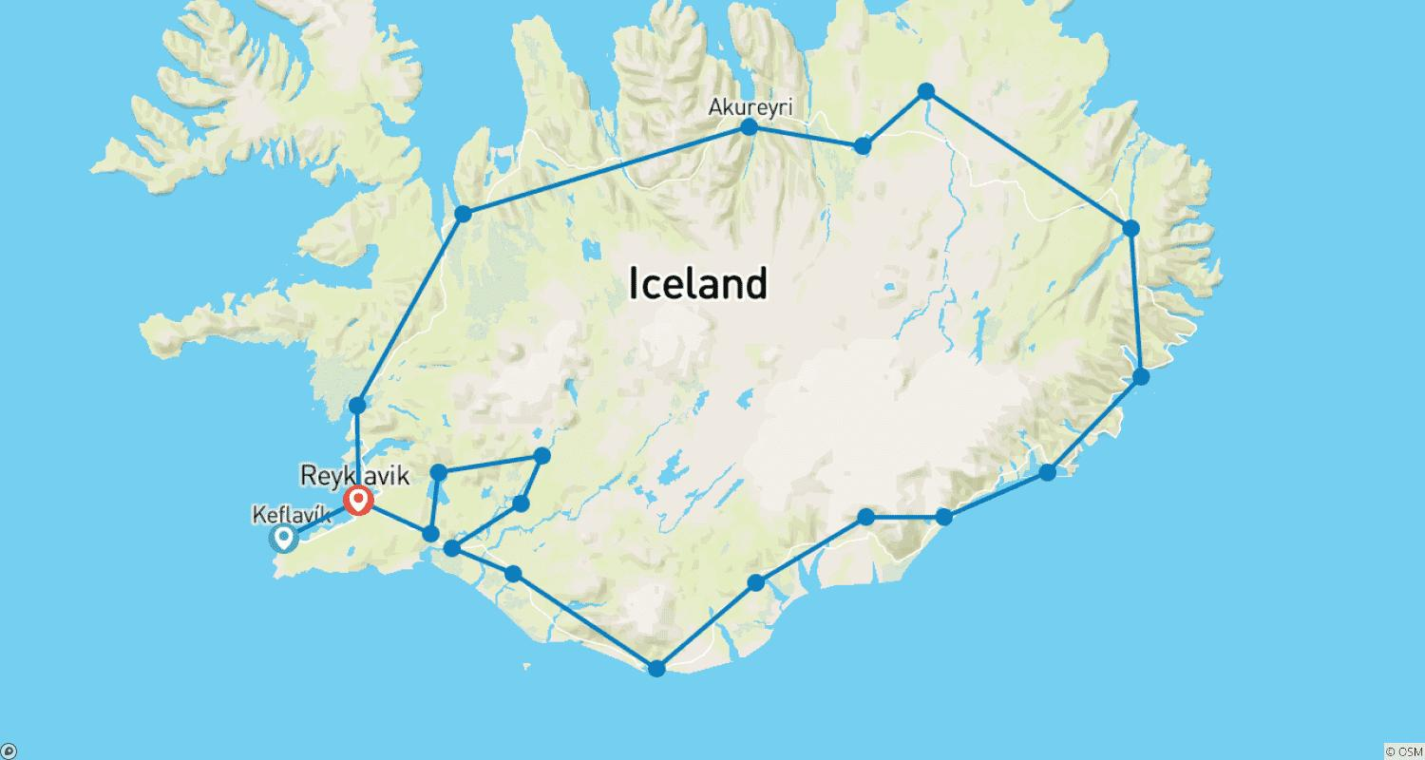

Tour ID: 104291  
Tour Name: 5 day Self-drive tour | Golden Circle Self-Drive

Tour destinations: ['Keflavik', 'Blue Lagoon', 'Reykjanesfólkvangur Reserve', 'Reykjavik', 'Hveragerdi', 'Seljaland', 'Skogafoss', 'Eyjafjallajokull', 'Reynisfjara', 'Vik', 'Hekla Volcano', 'Fludir', 'Geysir', 'Gullfoss', 'Thingvellir National Park', 'Reykholt', 'Hraunfossar', 'Borgarnes']

Tour destinations images:

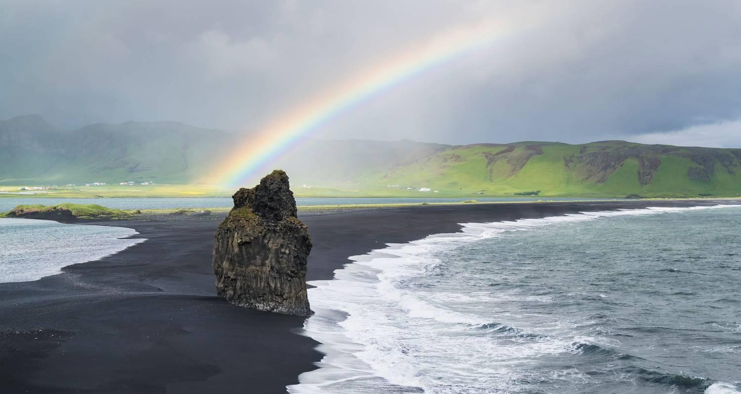

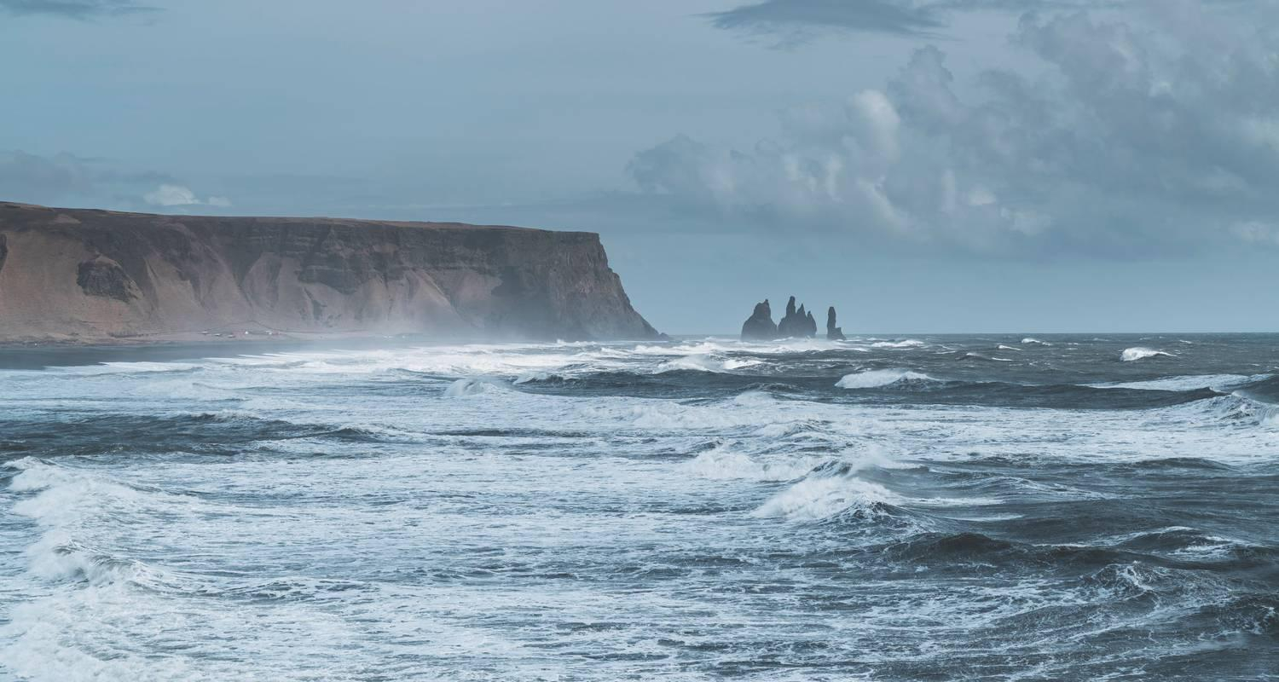

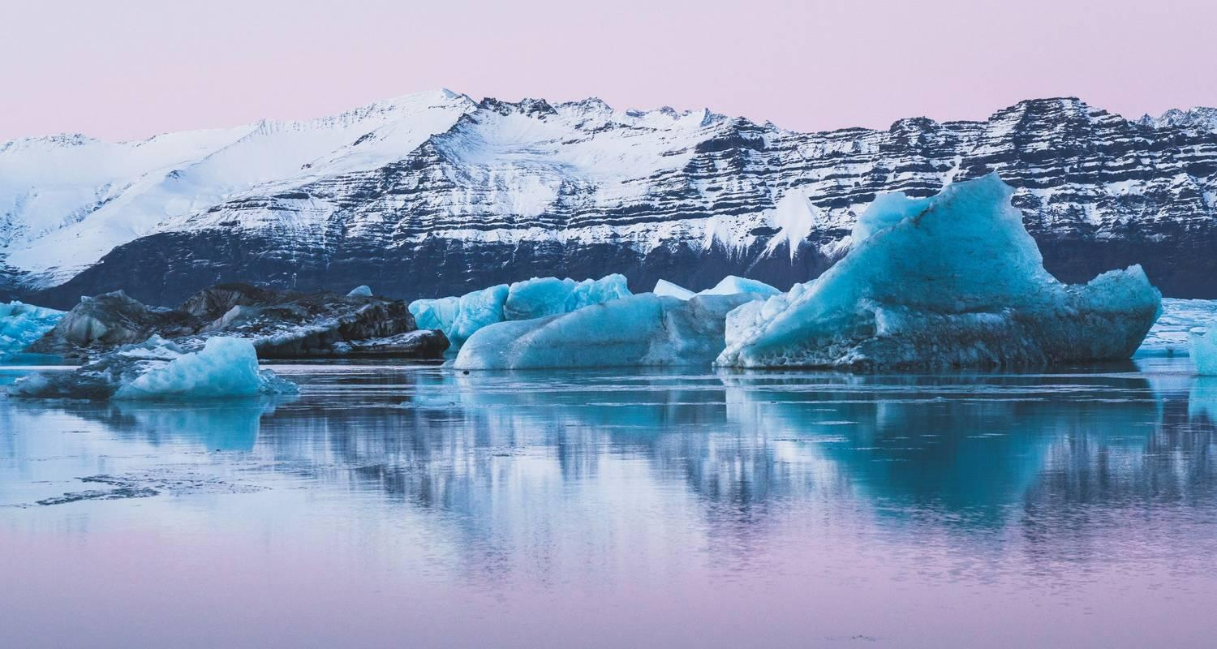

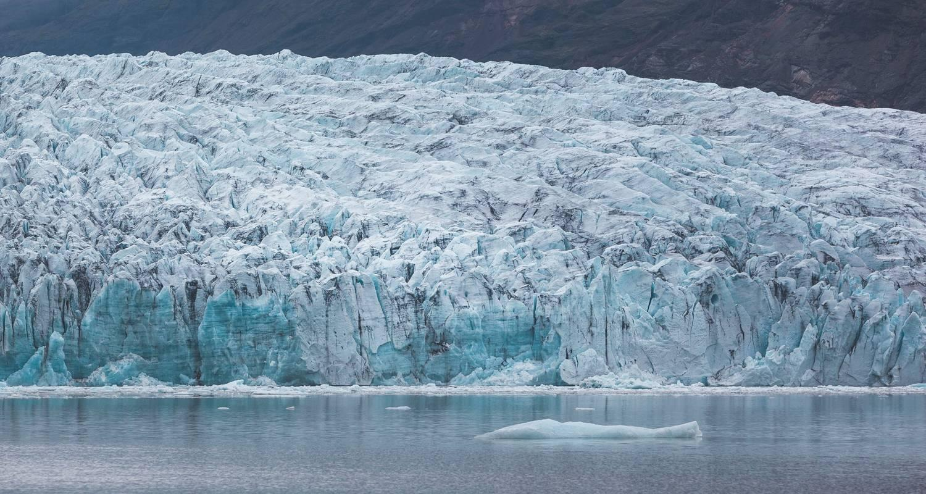

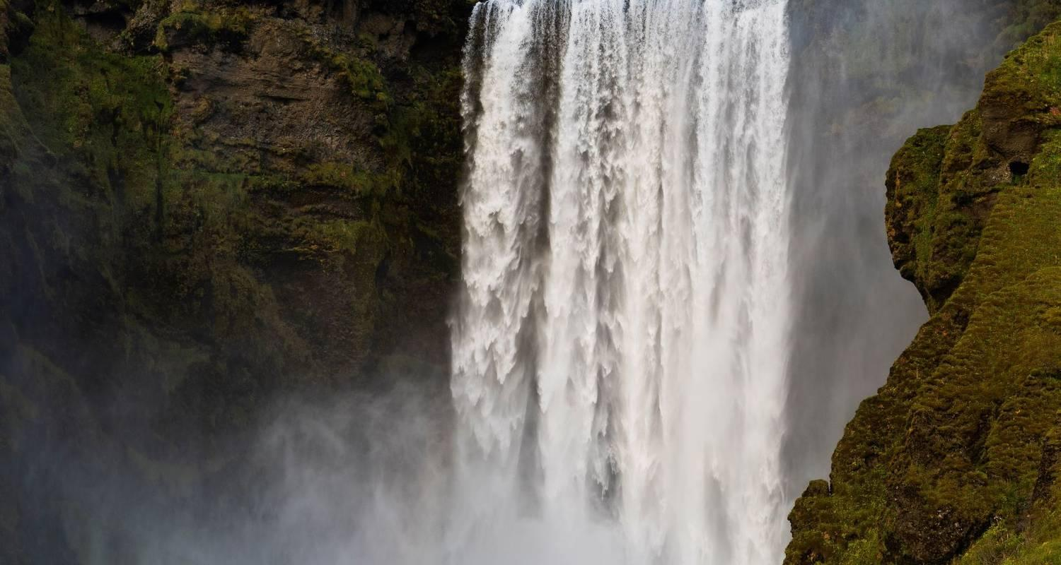

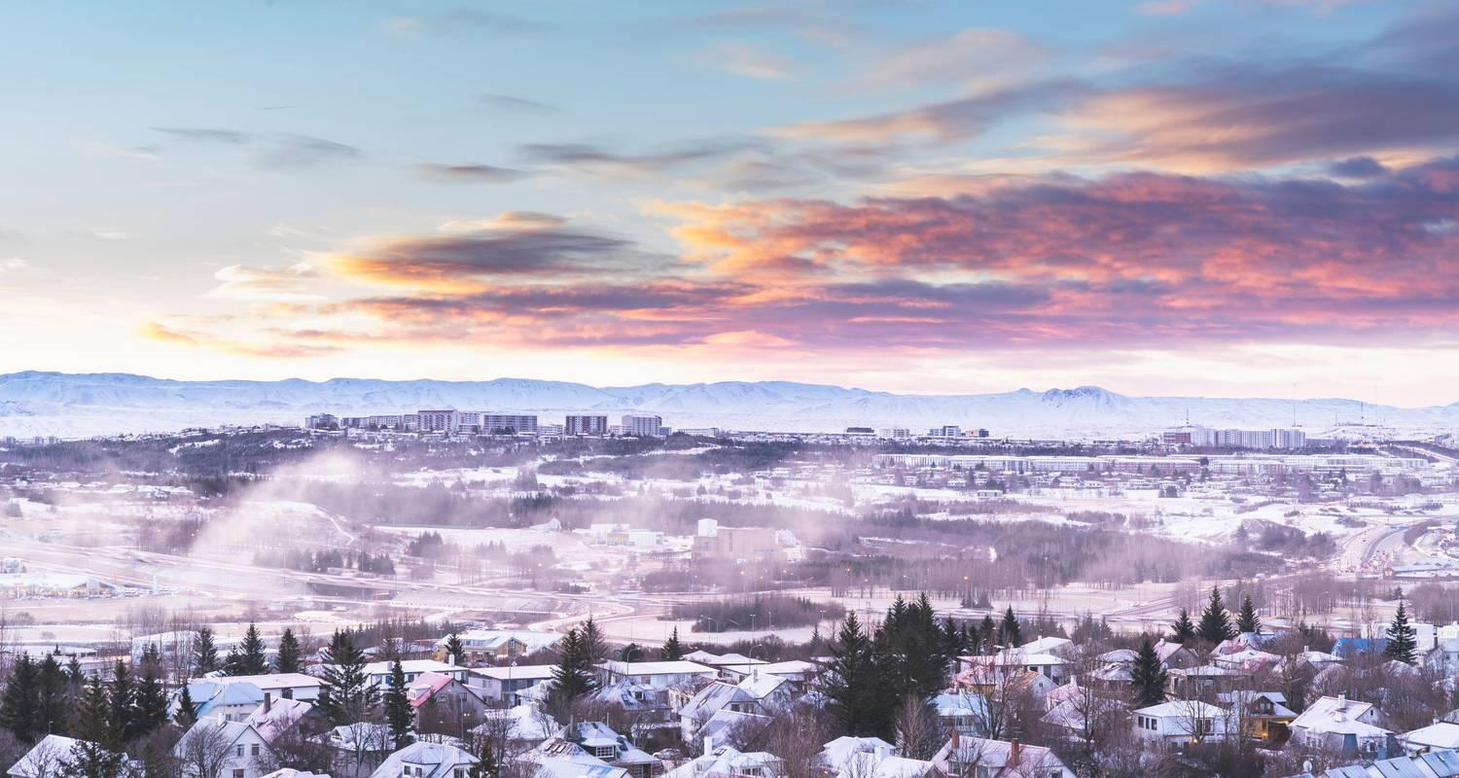

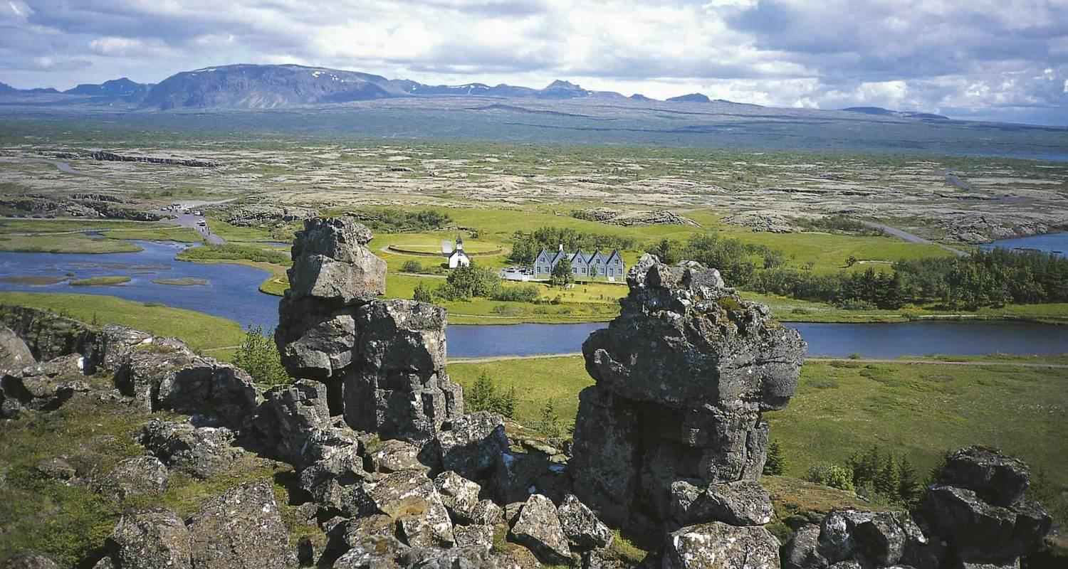

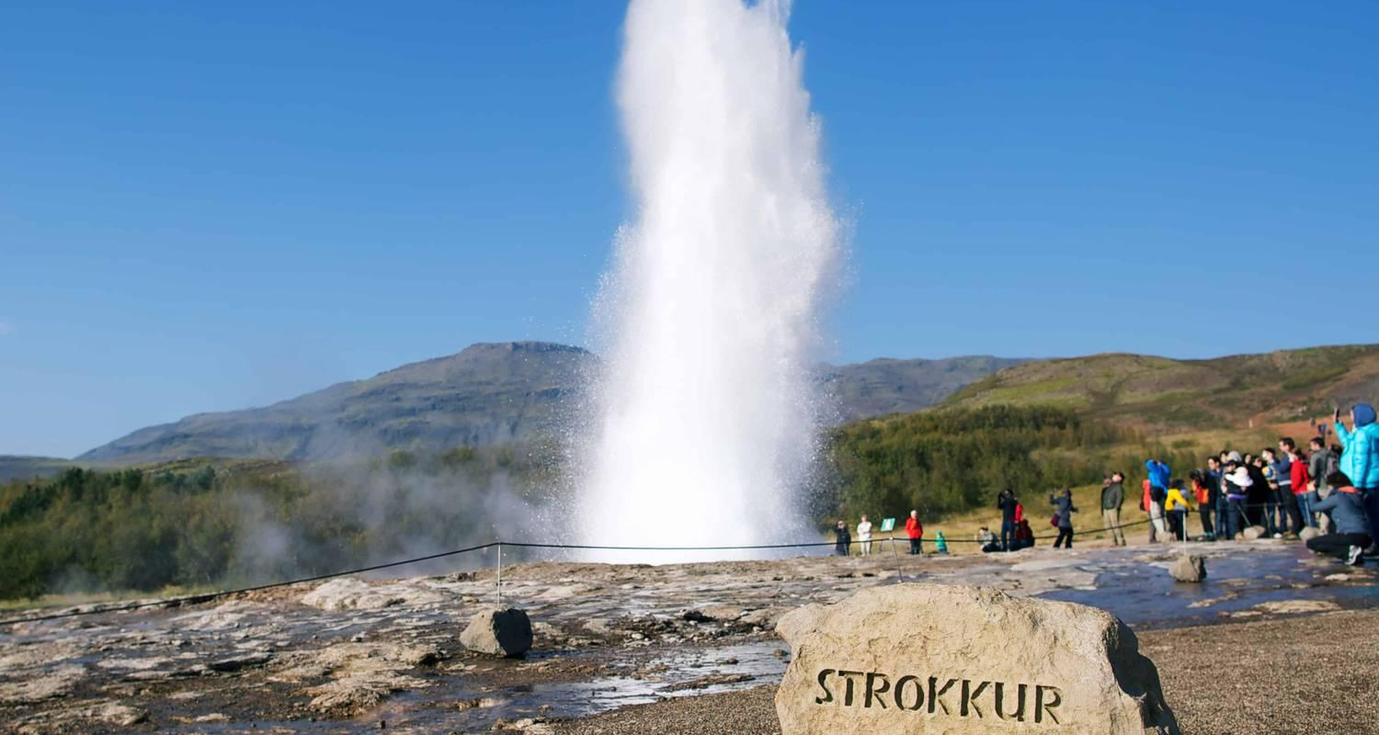

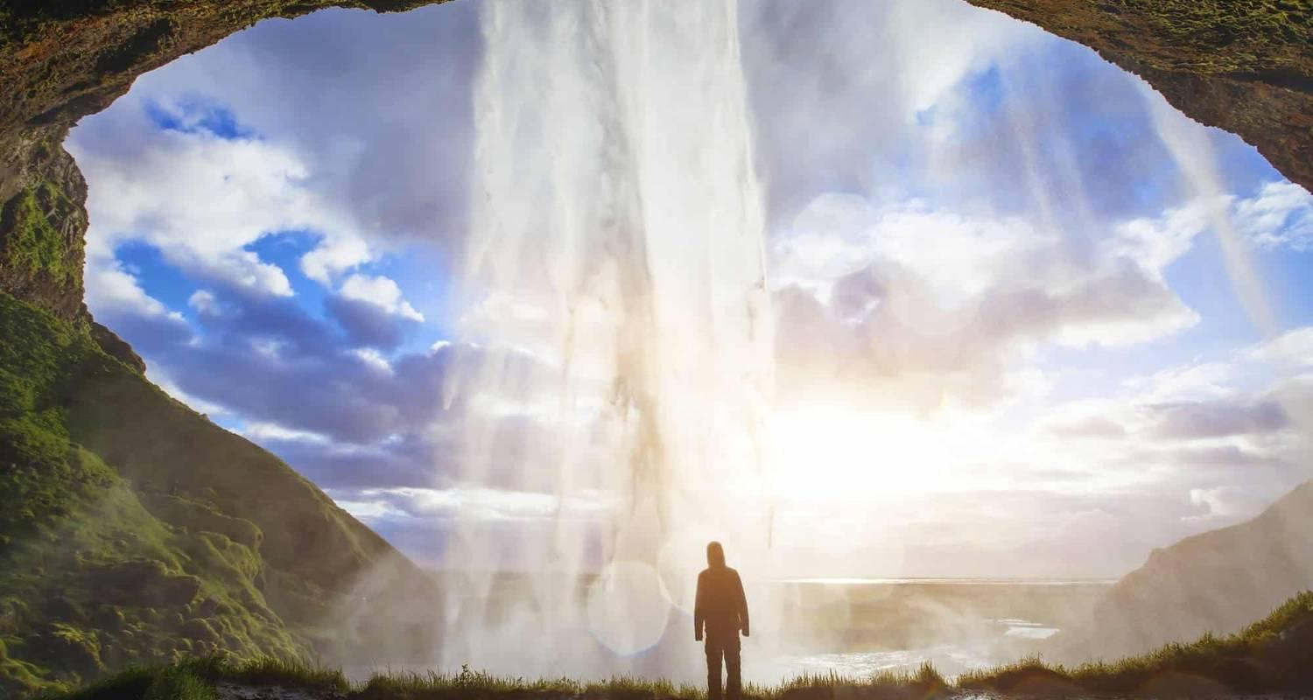

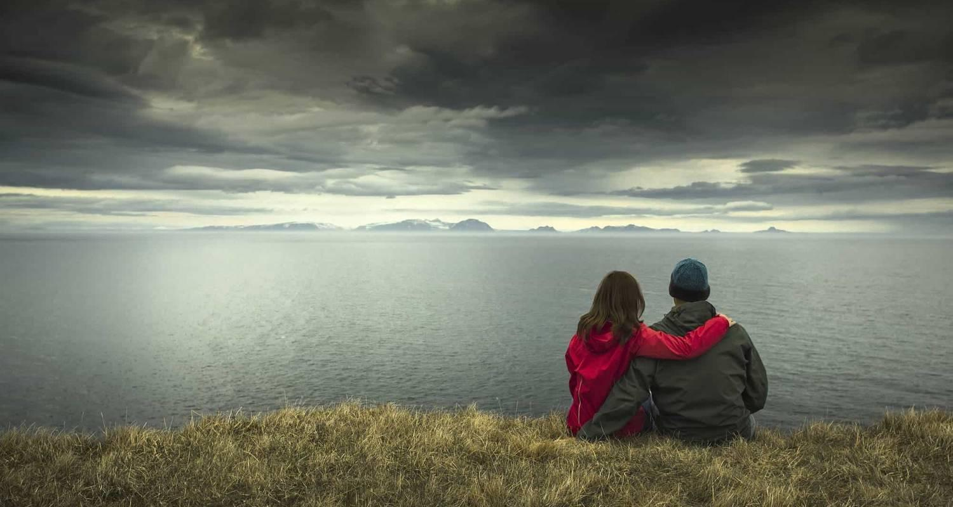

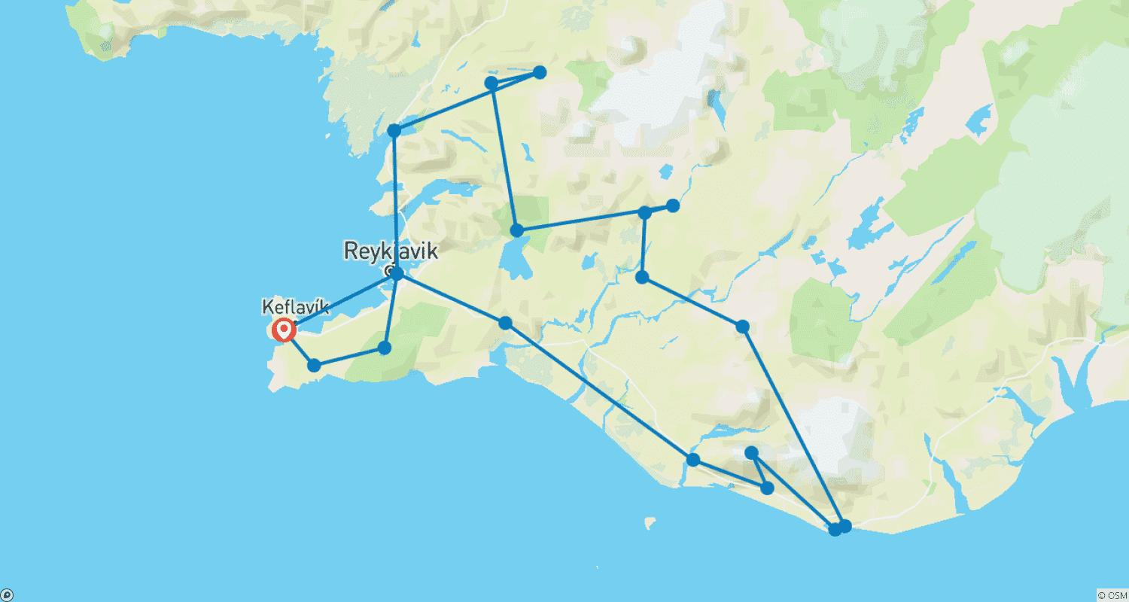

Tour ID: 105084  
Tour Name: Iceland Complete: Around Iceland in 10 days

Tour destinations: ['Reykjavik', 'Thingvellir National Park', 'Gullfoss', 'Hella', 'Seljaland', 'Skogafoss', 'Reynisfjara', 'Skaftafell', 'Jokulsarlon', 'Hofn', 'Egilsstadir', 'Modrudalur', 'Dettifoss', 'Husavik', 'Myvatn', 'Akureyri', 'Siglufjordur', 'Hvitserkur', 'Stykkisholmur', 'Kirkjufell Mountain', 'Djupalonssandur', 'Hellnar', 'Arnarstapi', 'Grábrók Volcano', 'Reykholt']

Tour destinations images:

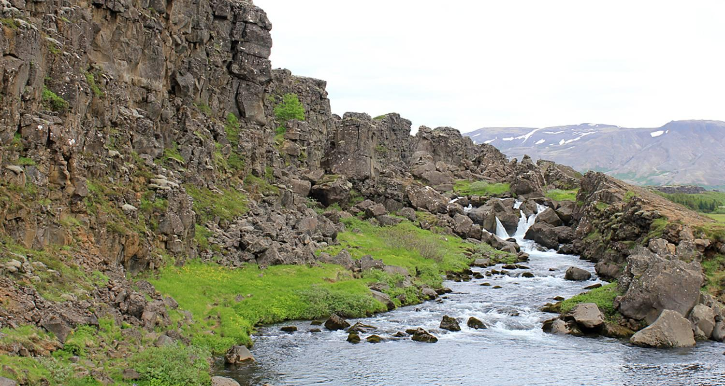

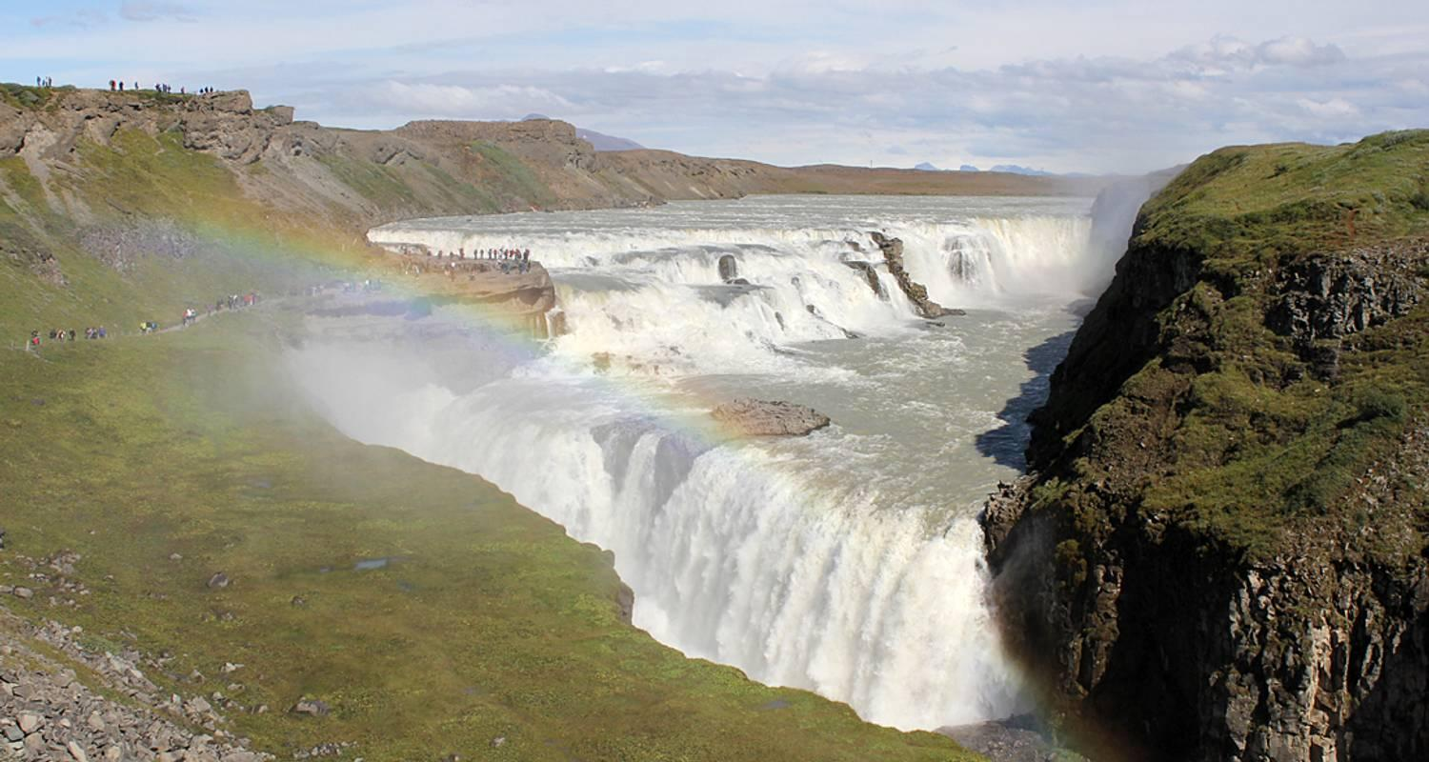

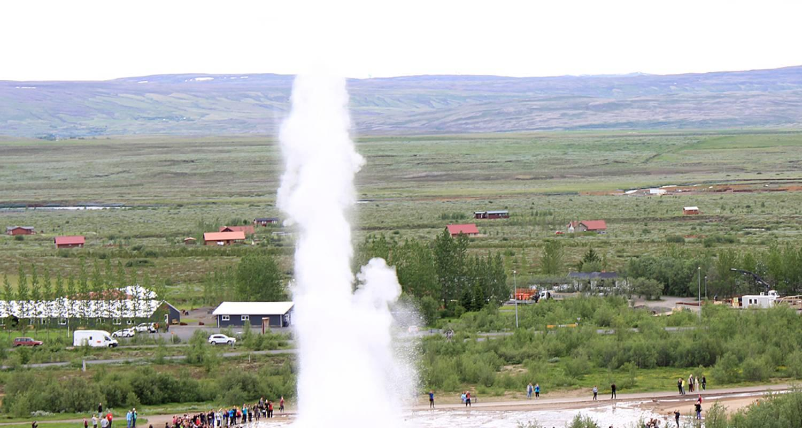

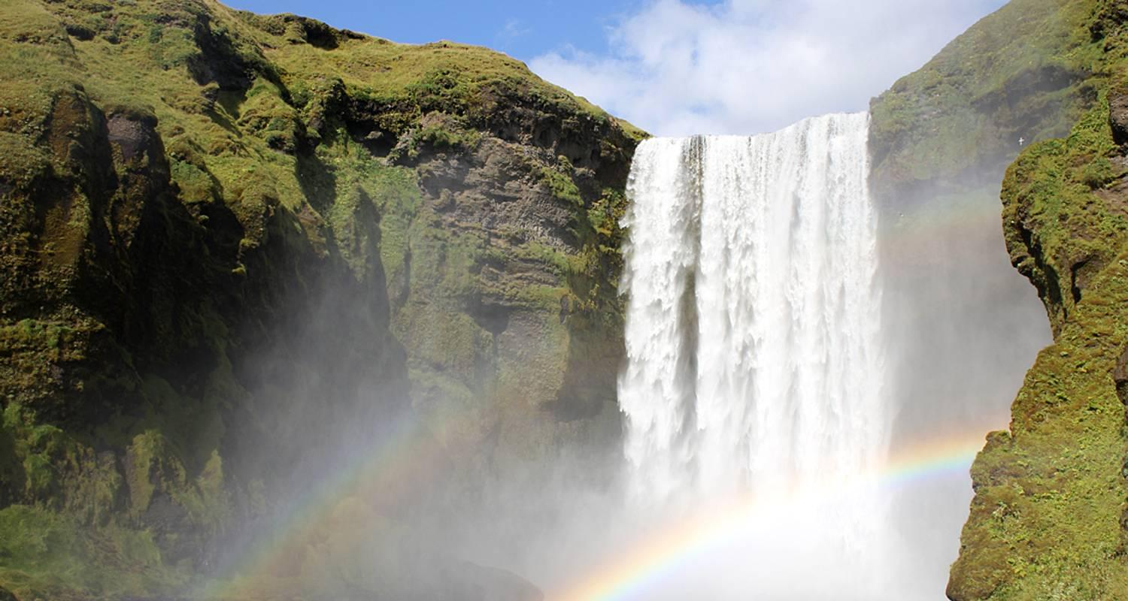

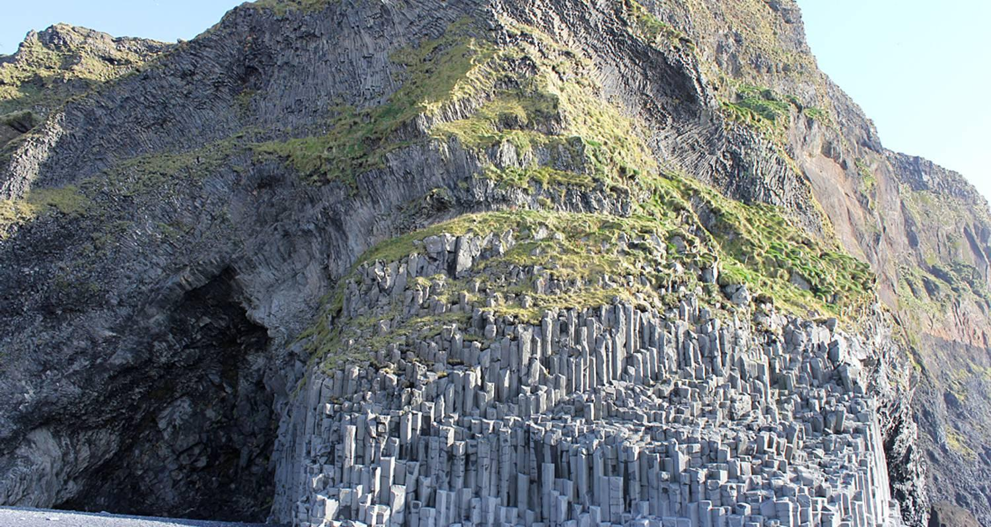

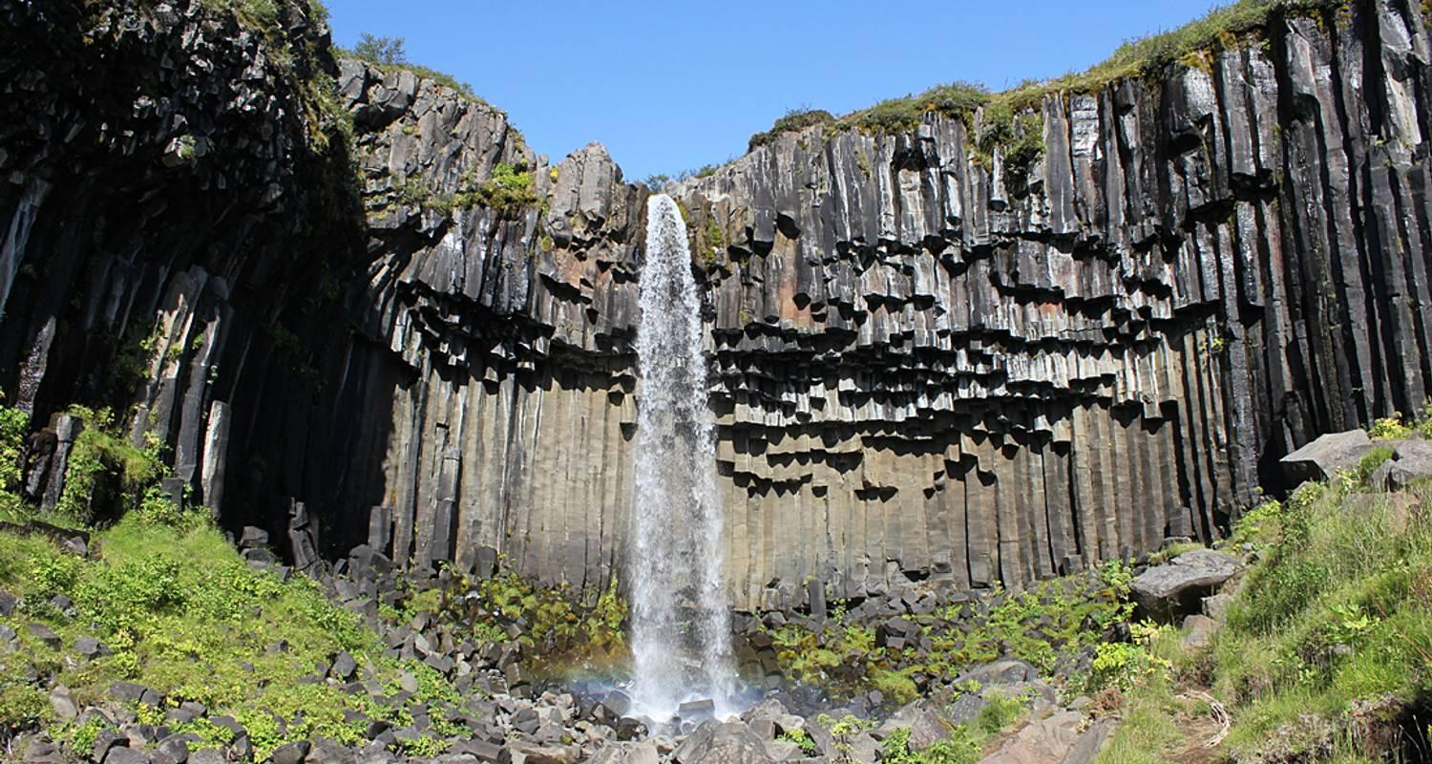

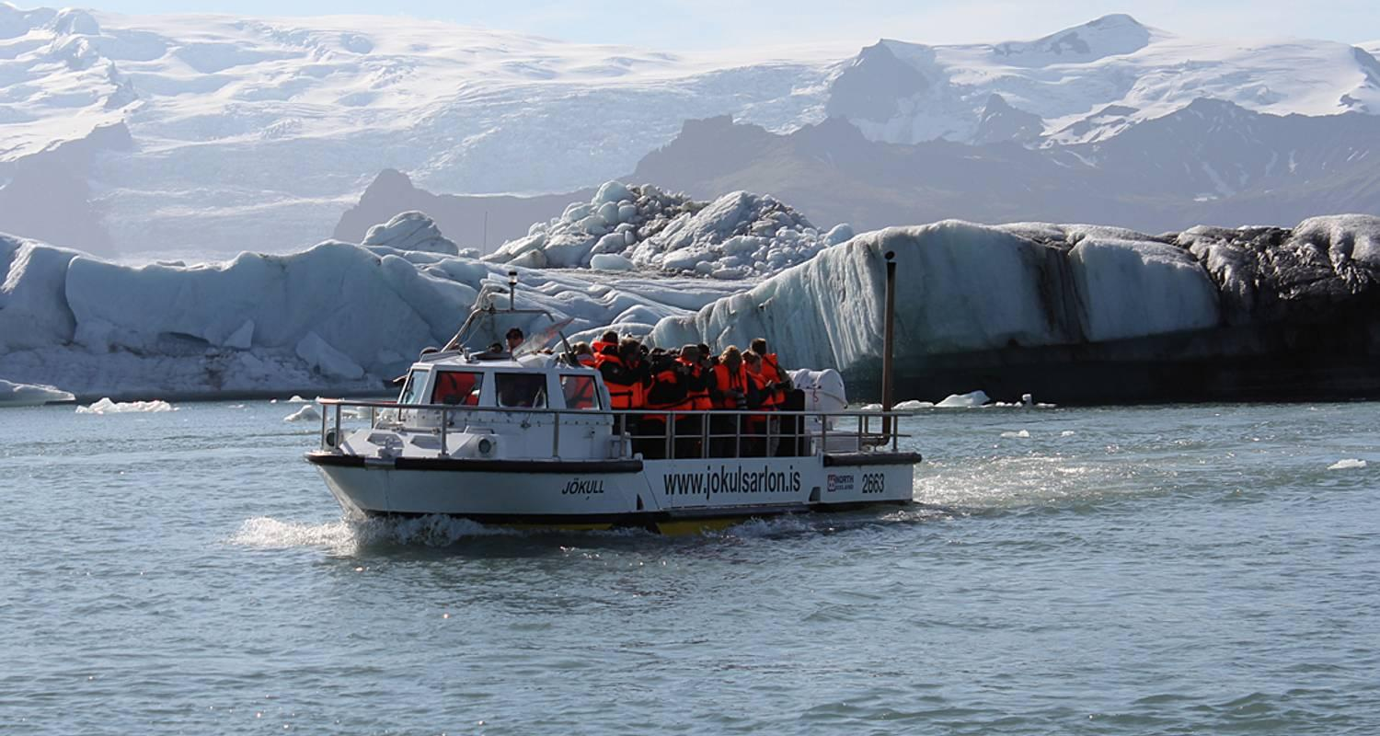

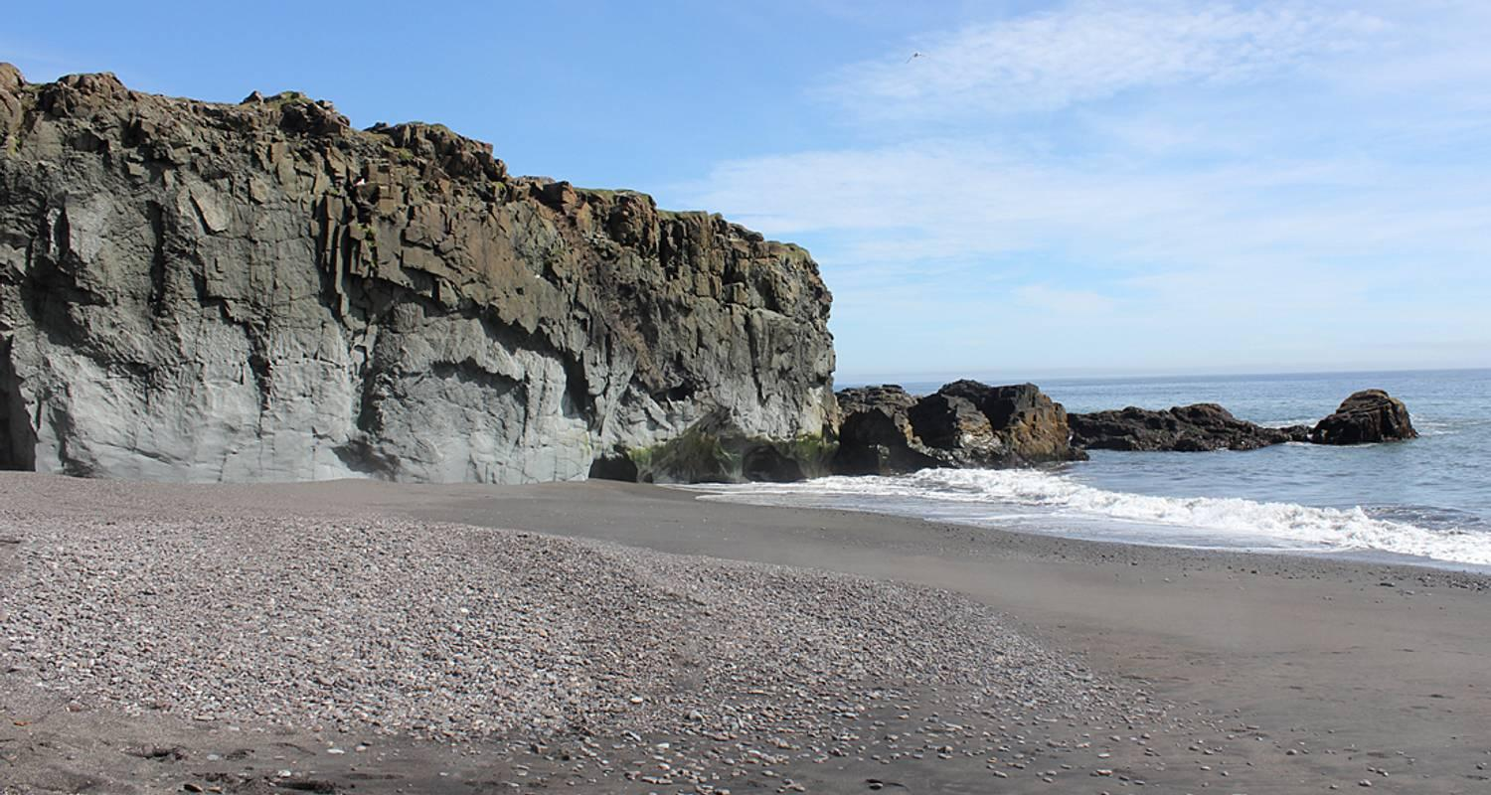

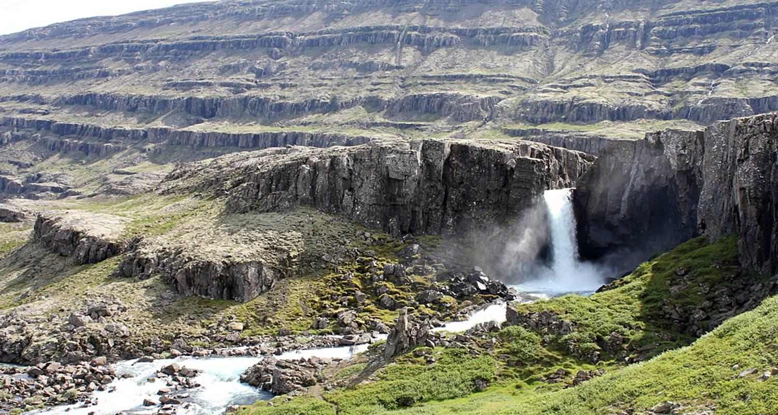

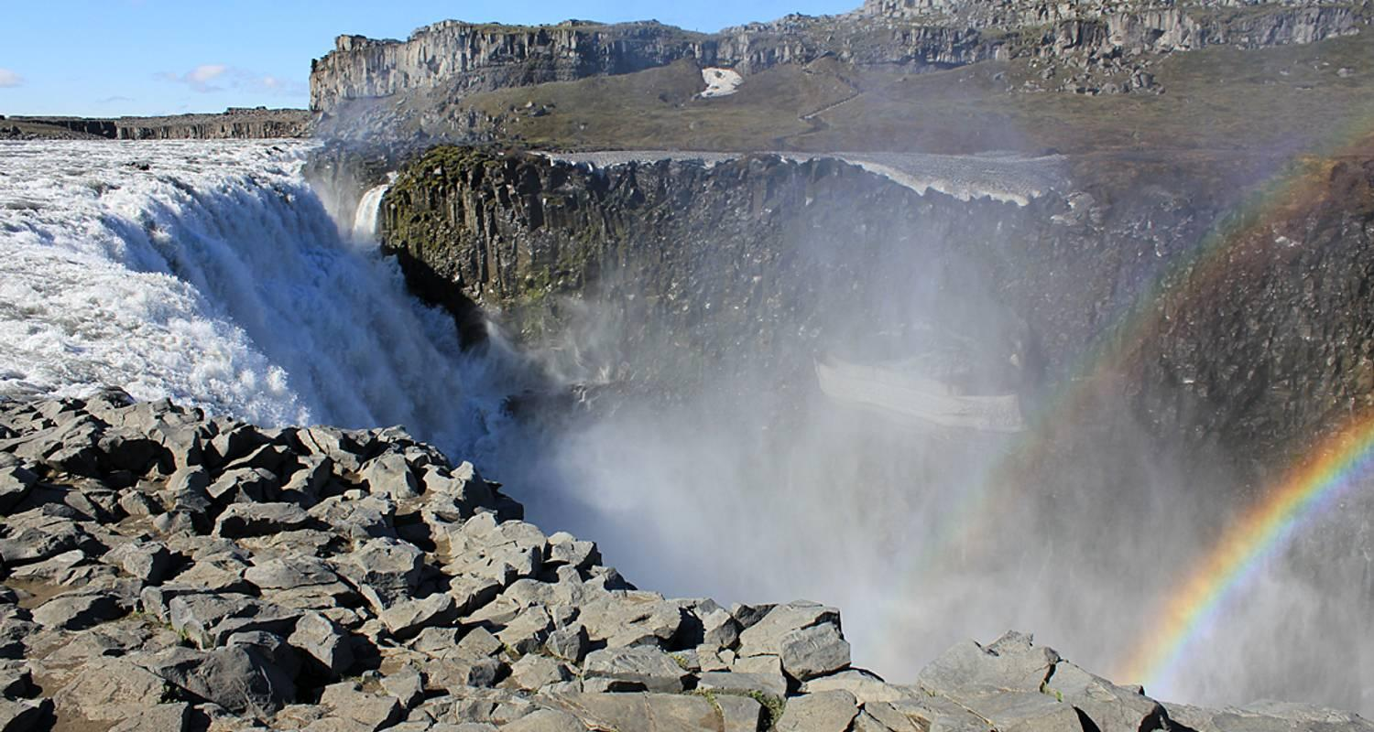

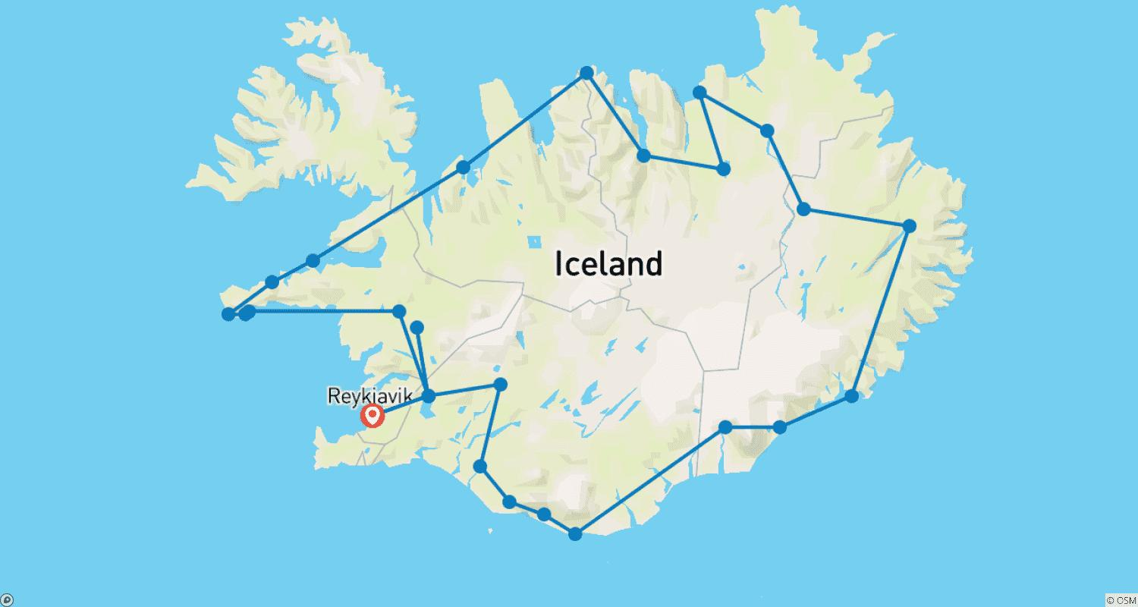

Tour ID: 105085  
Tour Name: The Great Round Tour: Around Iceland in 13 days

Tour destinations: ['Reykjavik', 'Thingvellir National Park', 'Dover', 'Gullfoss', 'Hella', 'Seljaland', 'Skogafoss', 'Solheimajokull', 'Reynisfjara', 'Vik', 'Skaftafell', 'Jokulsarlon', 'Hofn', 'Egilsstadir', 'Modrudalur', 'Dettifoss', 'Asbyrgi Canyon', 'Husavik', 'Myvatn', 'Godafoss', 'Akureyri', 'Siglufjordur', 'Holmavik', 'Isafjordur', 'Latrabjarg', 'Budardalur', 'Stykkisholmur', 'Kirkjufell Mountain', 'Arnarstapi', 'Grábrók Volcano']

Tour destinations images:

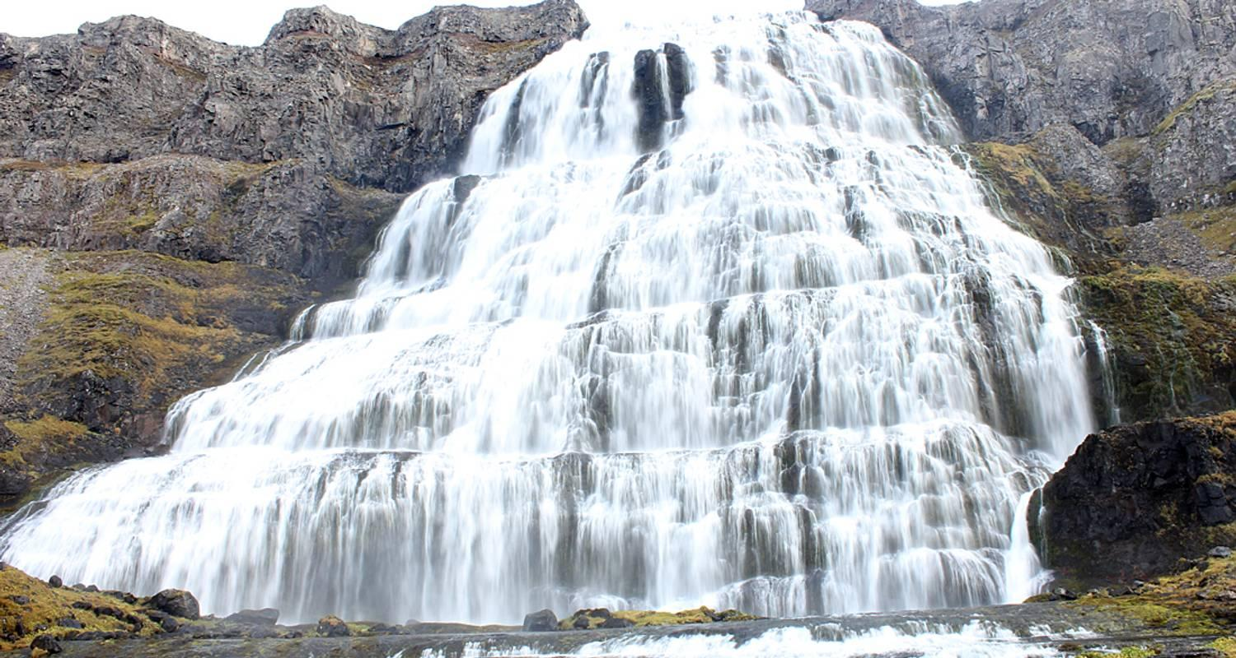

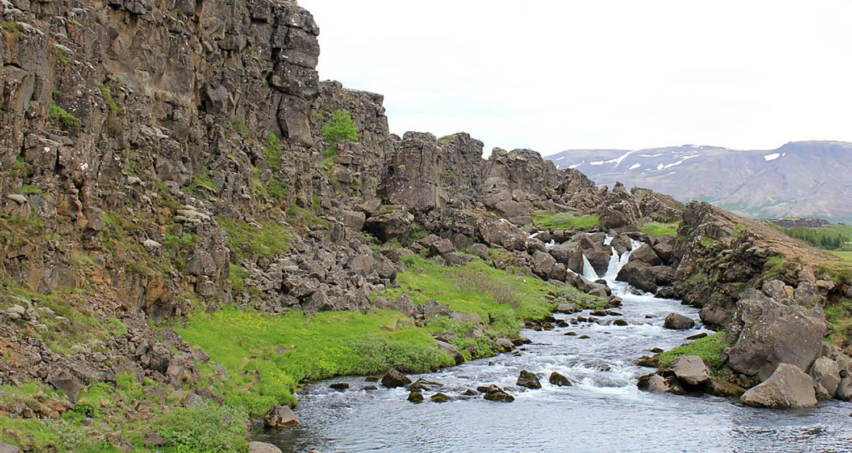

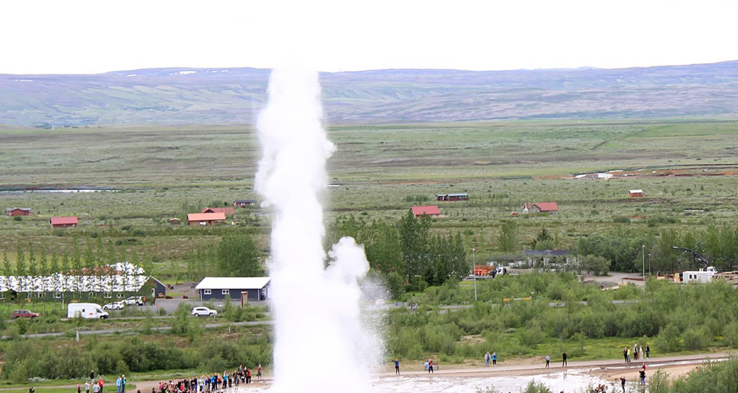

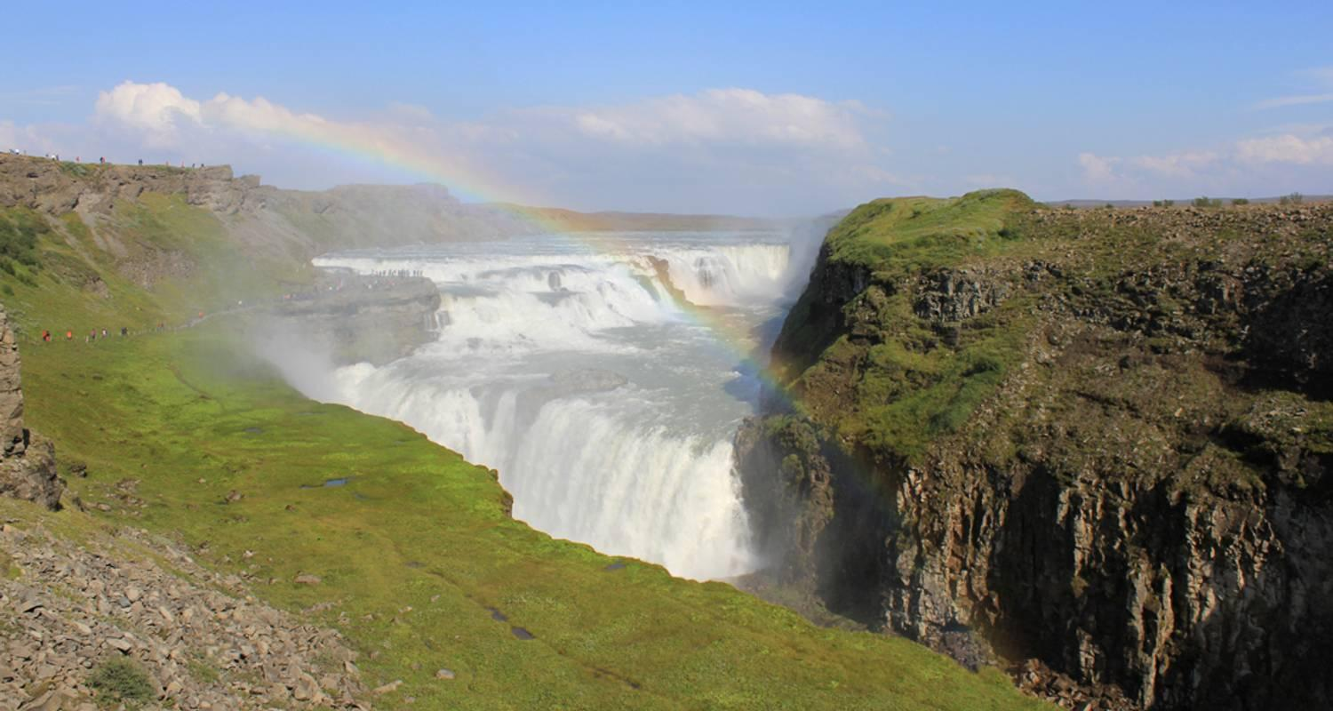

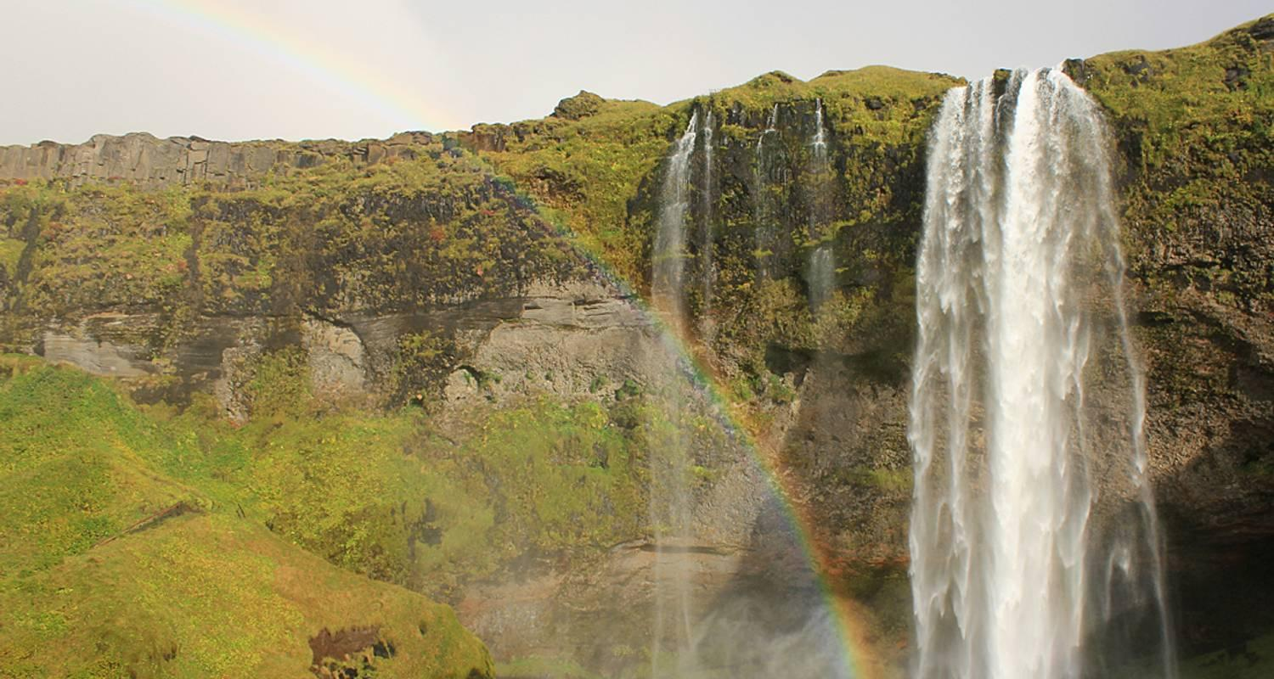

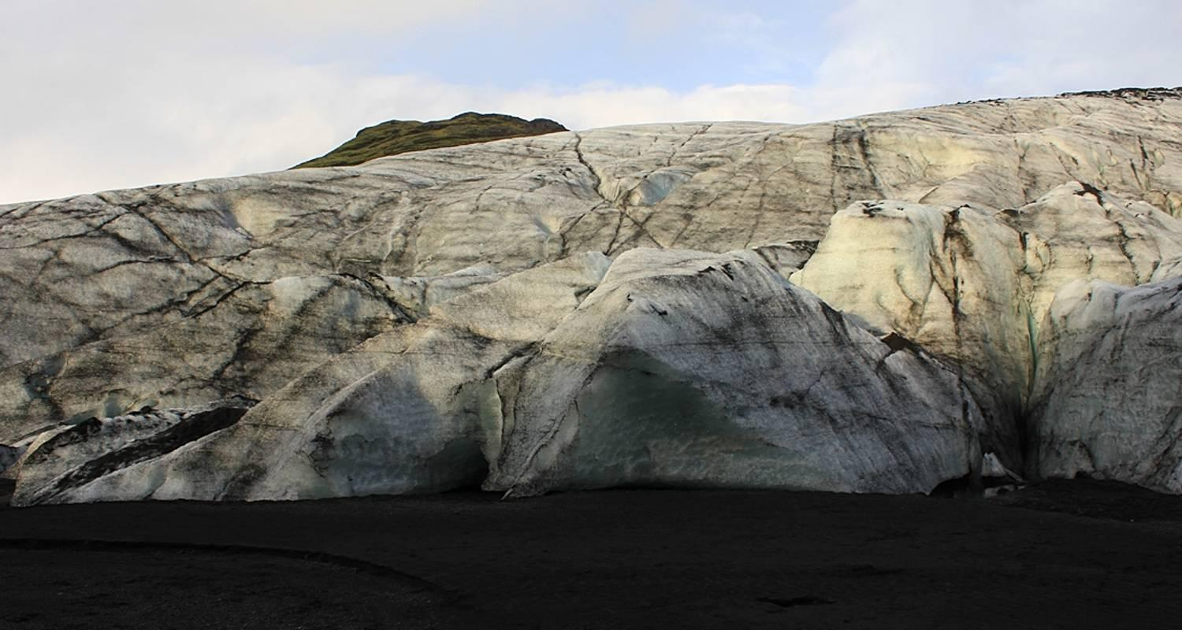

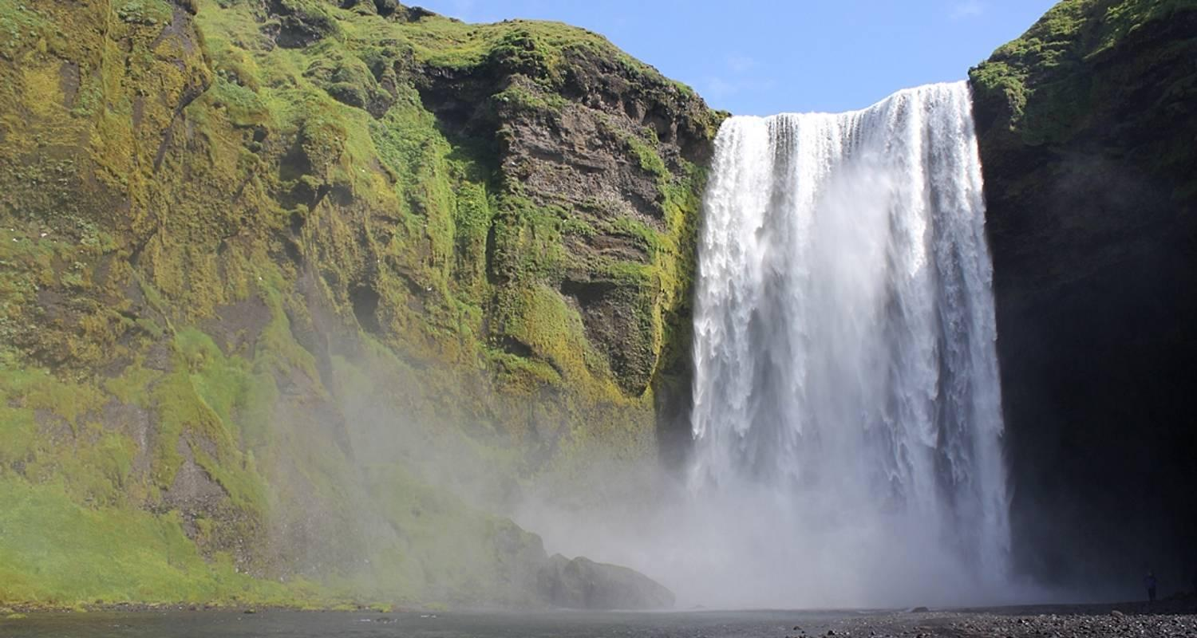

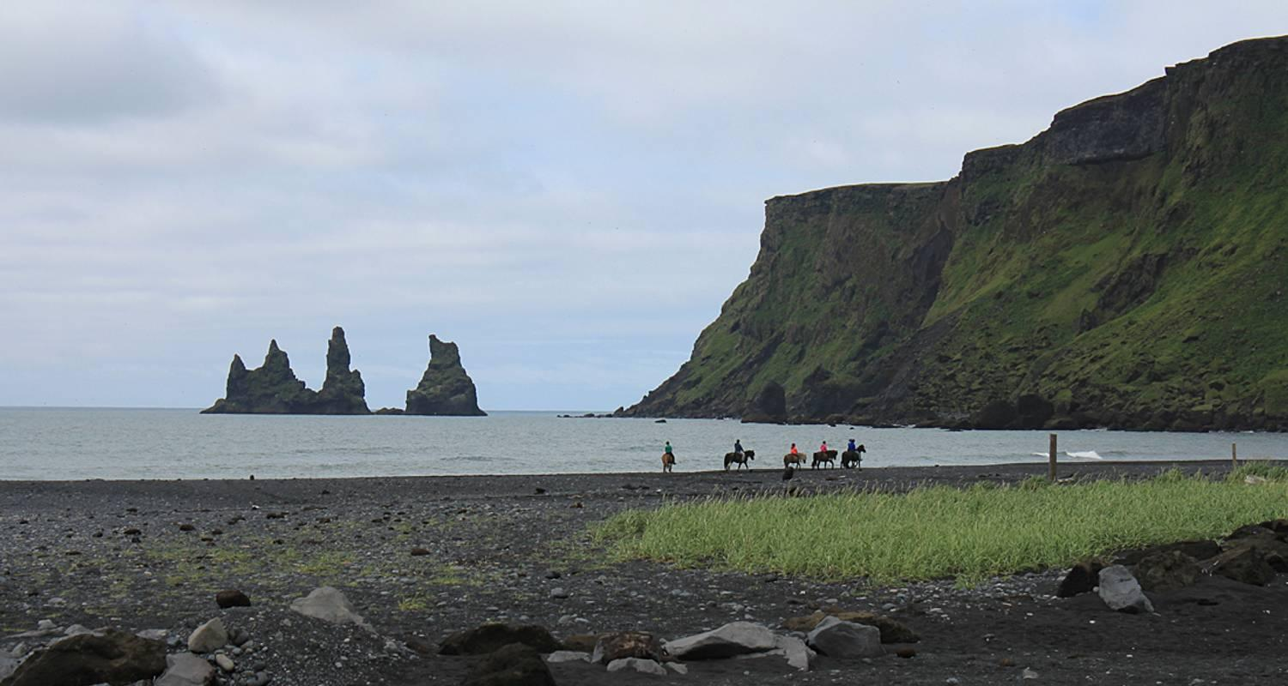

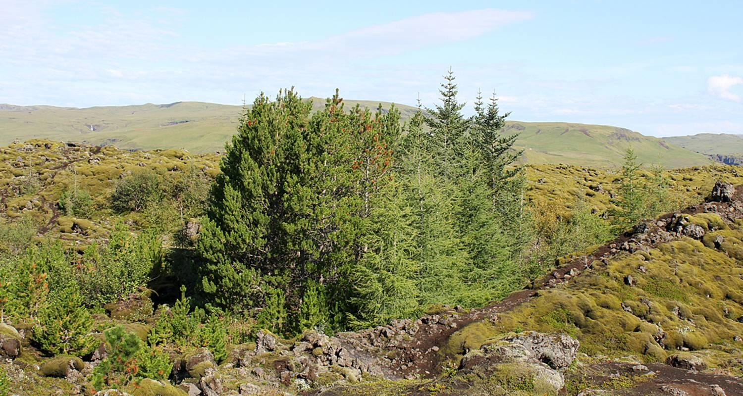

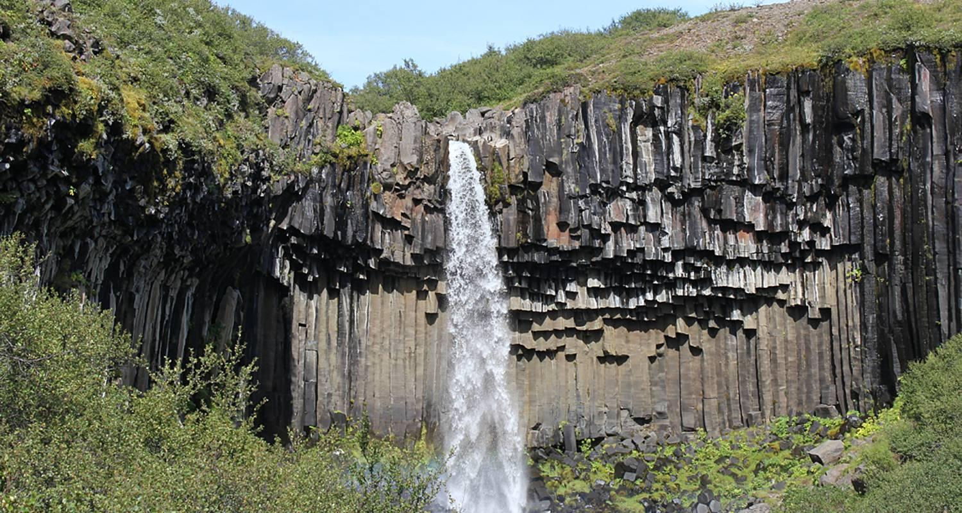

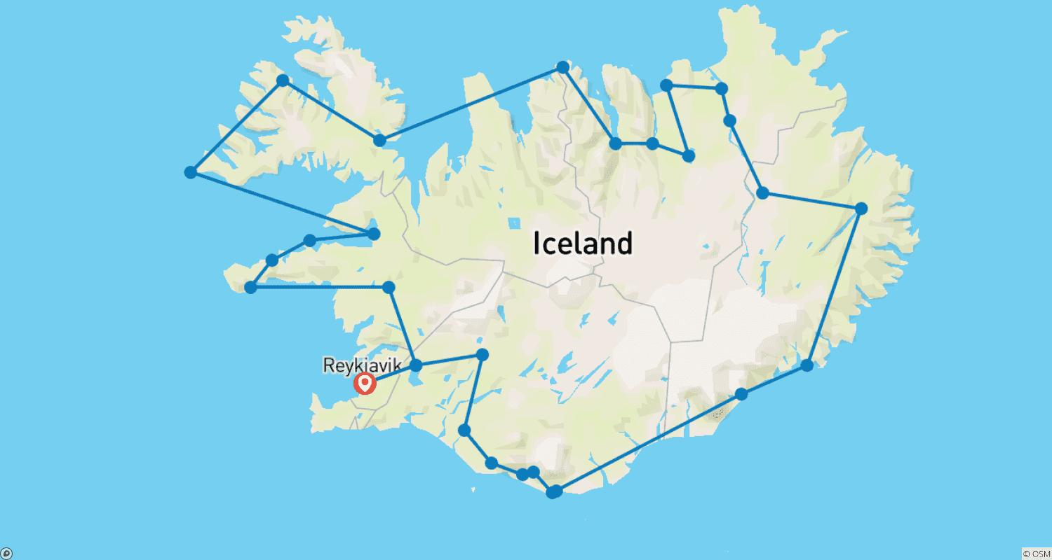

Tour ID: 105086  
Tour Name: Glaciers and Aurora Tour: Around Iceland in Winter

Tour destinations: ['Reykjavik', 'Thingvellir National Park', 'Gullfoss', 'Hella', 'Seljaland', 'Skogafoss', 'Reynisfjara', 'Vik', 'Jokulsarlon', 'Hofn', 'Djupivogur', 'Egilsstadir', 'Modrudalur', 'Dettifoss', 'Myvatn', 'Godafoss', 'Akureyri', 'Siglufjordur', 'Saudarkrokur', 'Hvammstangi', 'Stykkisholmur', 'Djupalonssandur', 'Arnarstapi', 'Grábrók Volcano']

Tour destinations images:

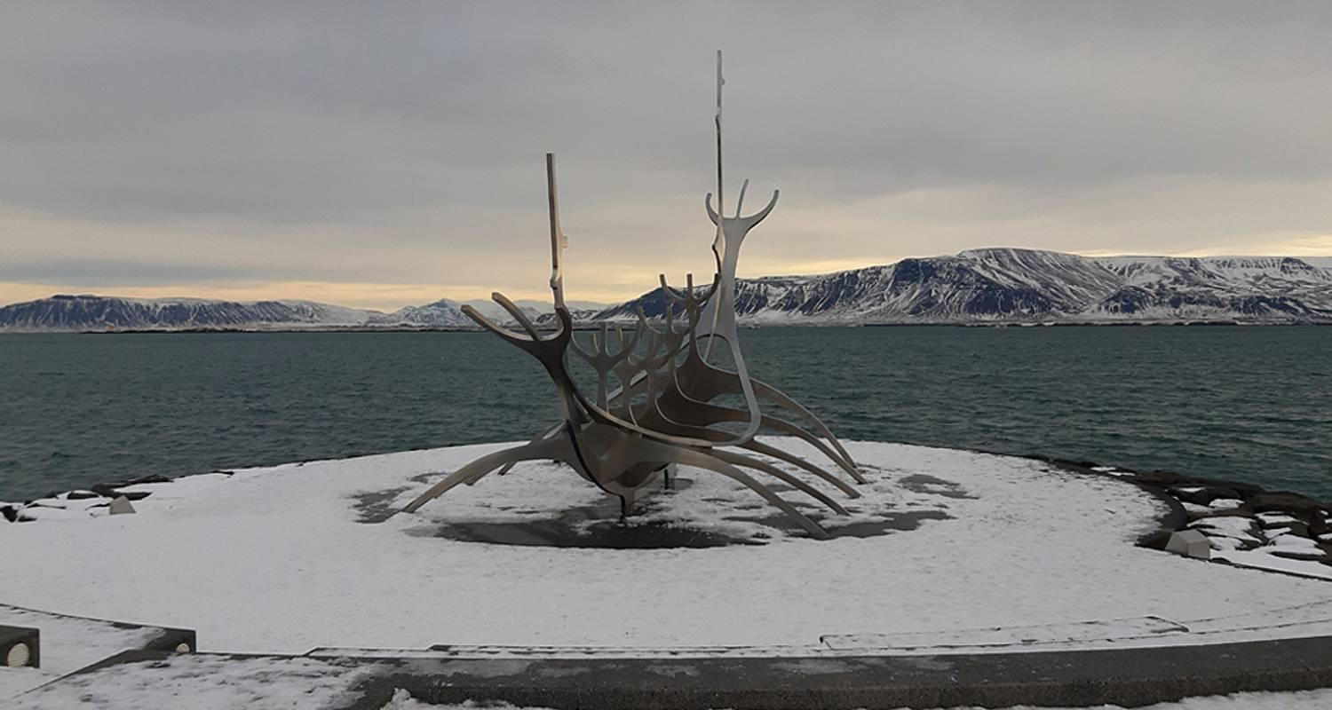

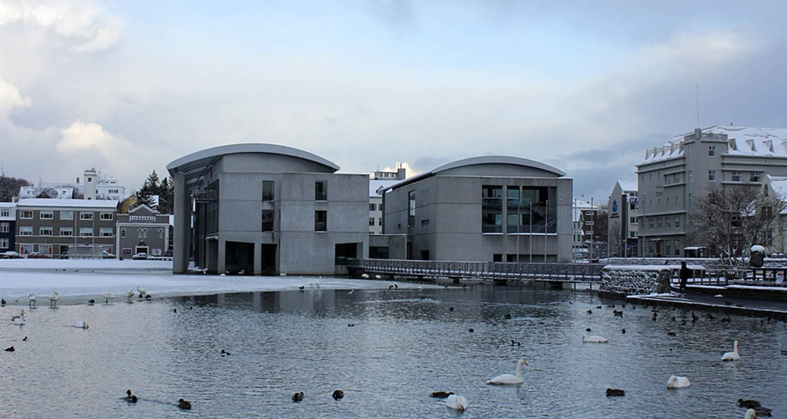

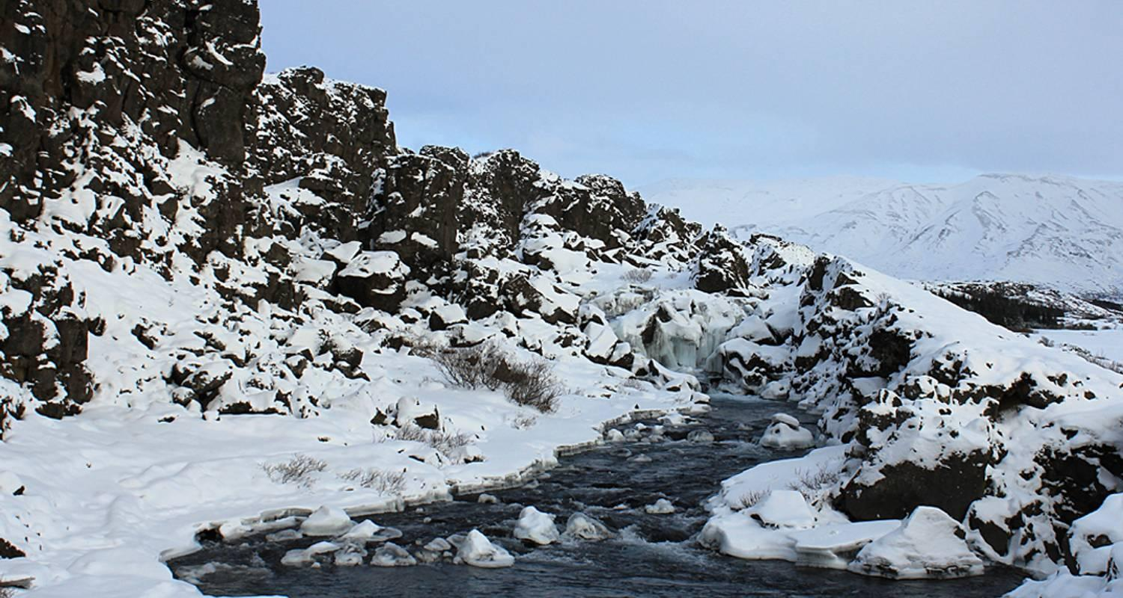

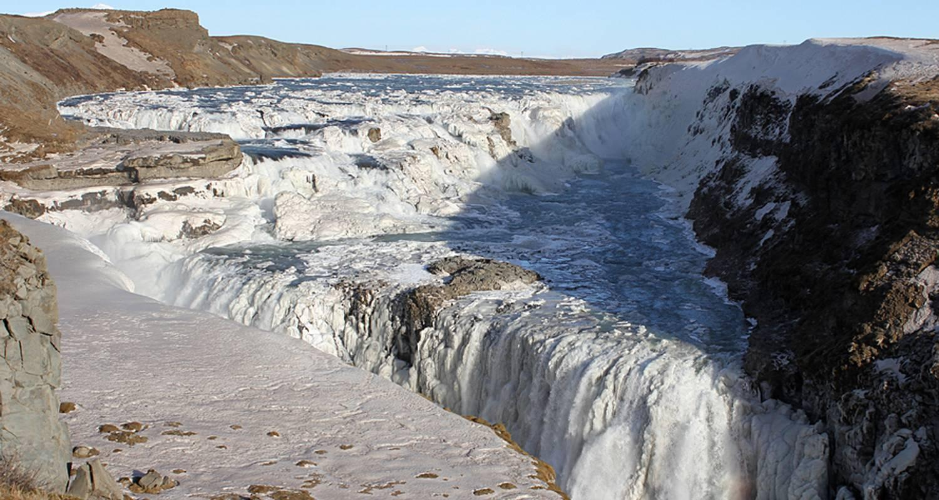

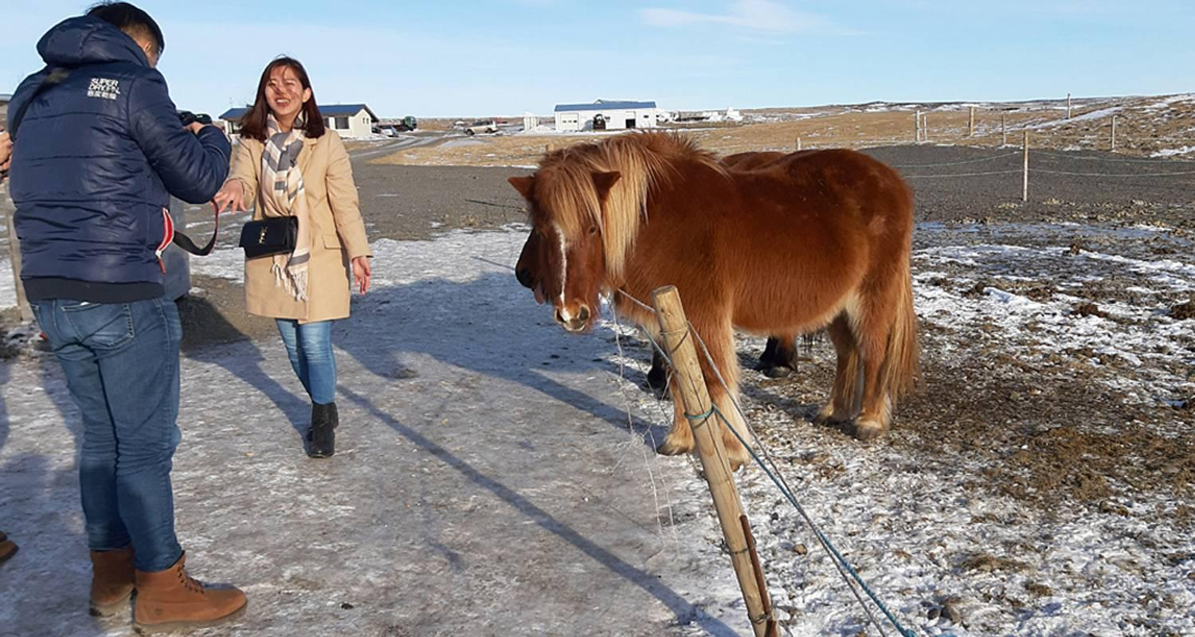

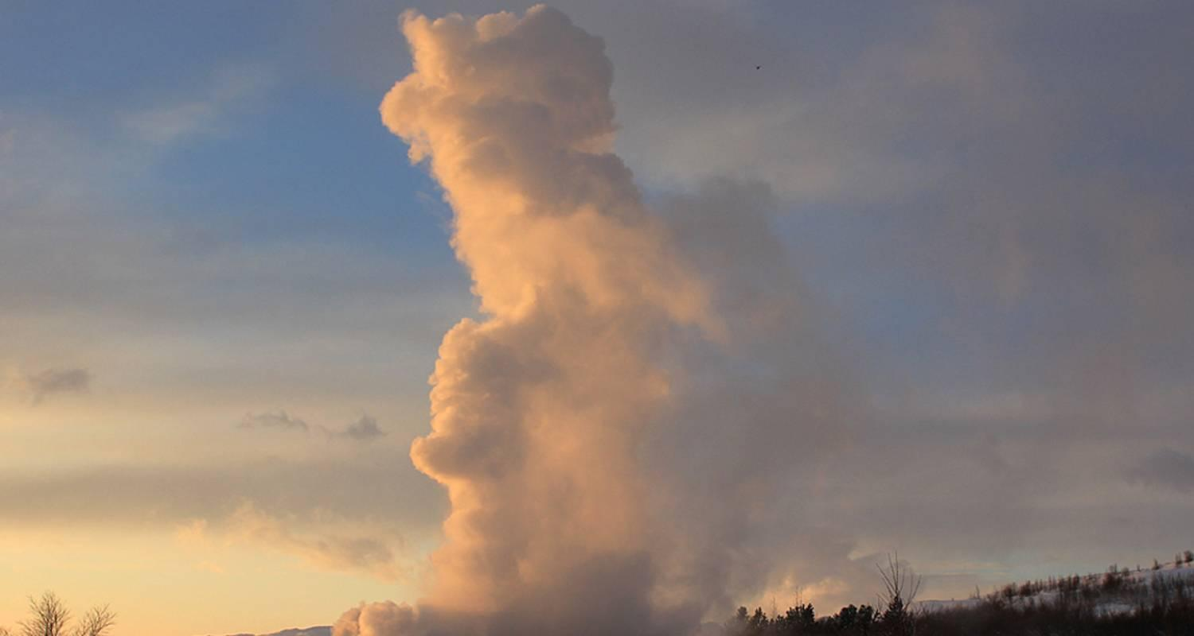

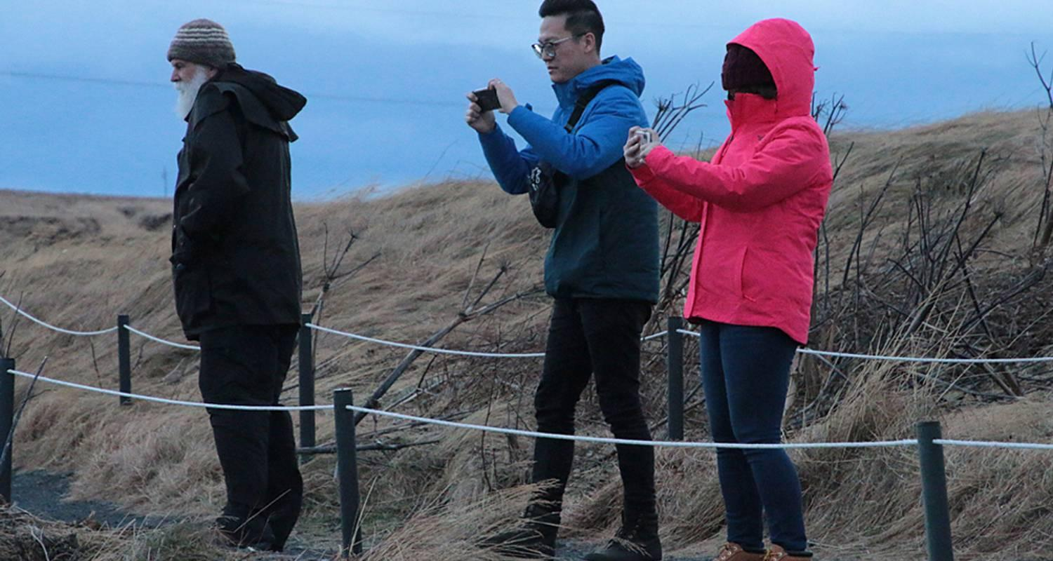

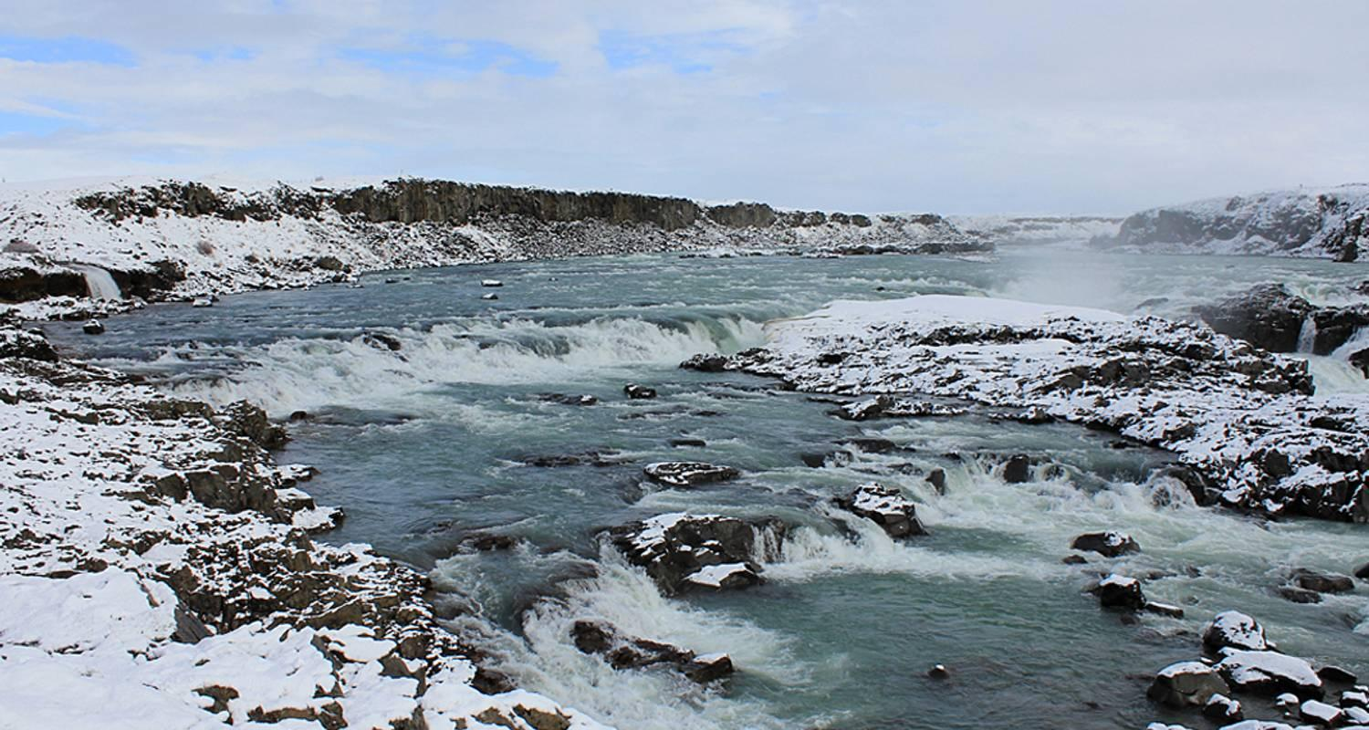

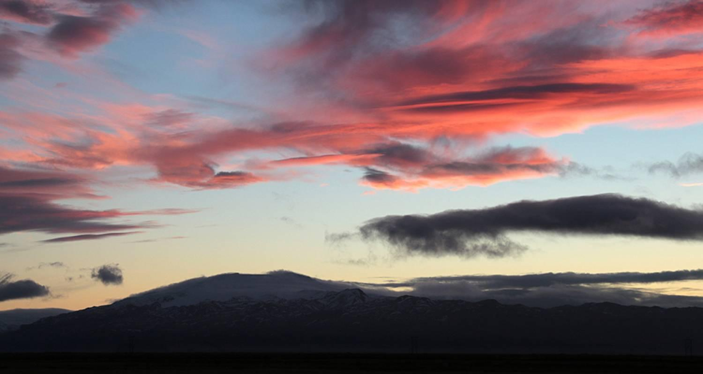

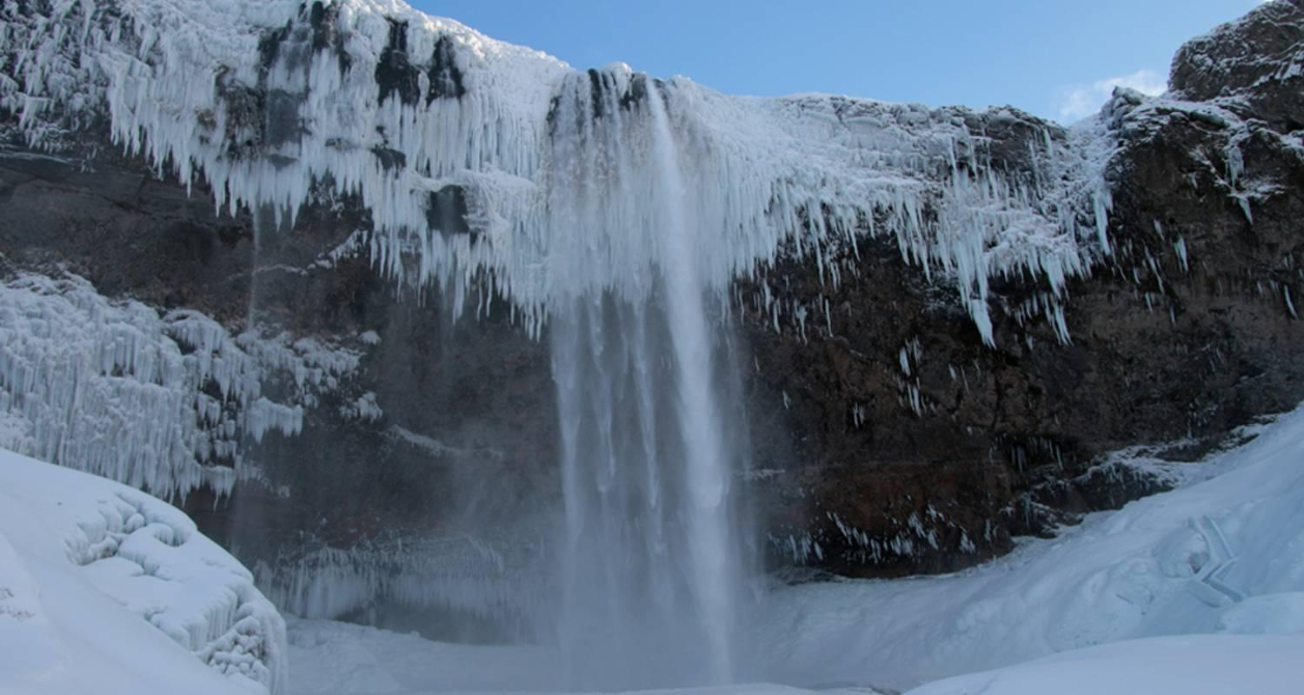

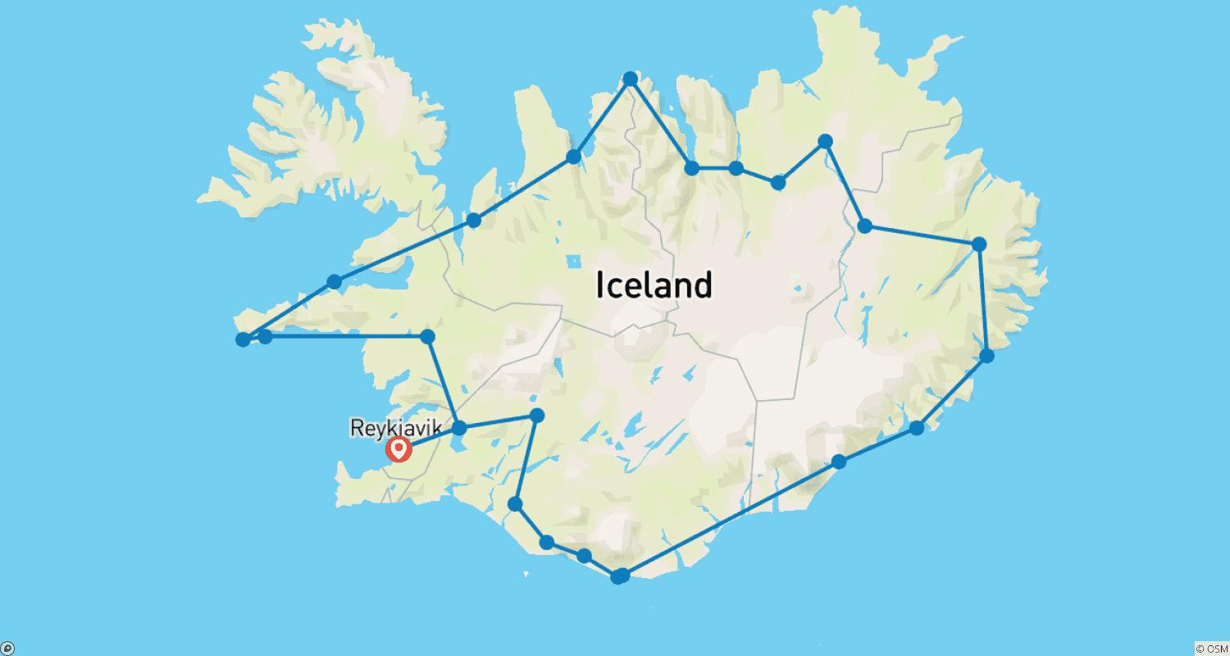

Tour ID: 106767  
Tour Name: Iceland 11-Day Trip: A slow-paced, small group tour

Tour destinations: ['Reykjavik', 'Thingvellir National Park', 'Gullfoss', 'Hvolsvollur', 'Skogafoss', 'Reynisfjara', 'Kirkjubaejarklaustur', 'Vatnajokull National Park', 'Skaftafell', 'Jokulsarlon', 'Modrudalur', 'Egilsstadir', 'Dettifoss', 'Krafla Volcano', 'Myvatn', 'Godafoss', 'Akureyri', 'Borgarnes', 'Hraunfossar', 'Blue Lagoon']

Tour destinations images:

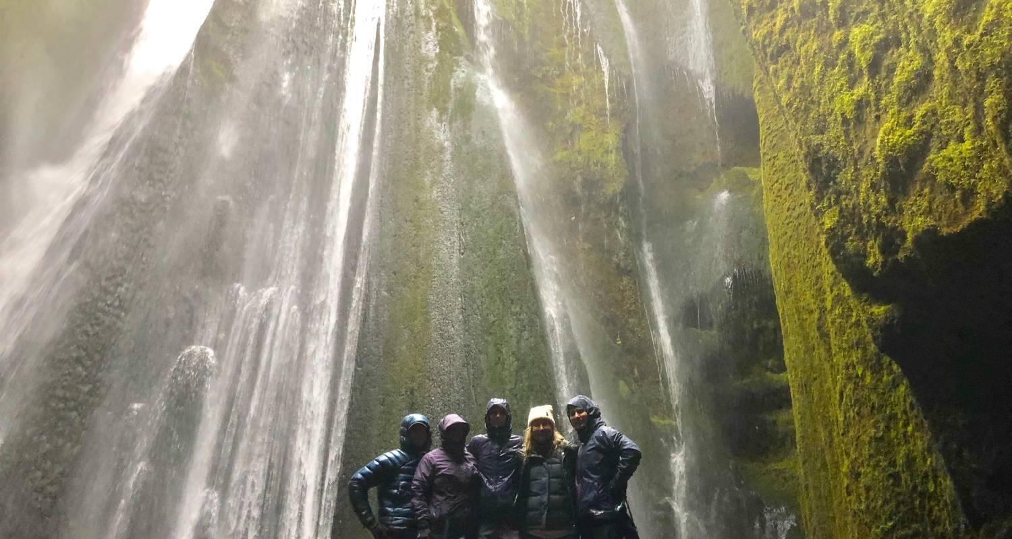

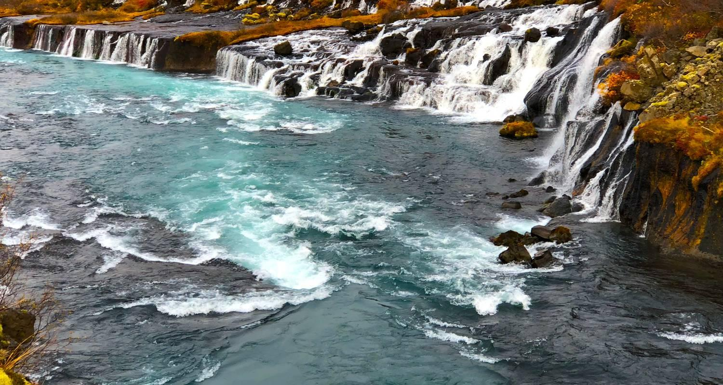

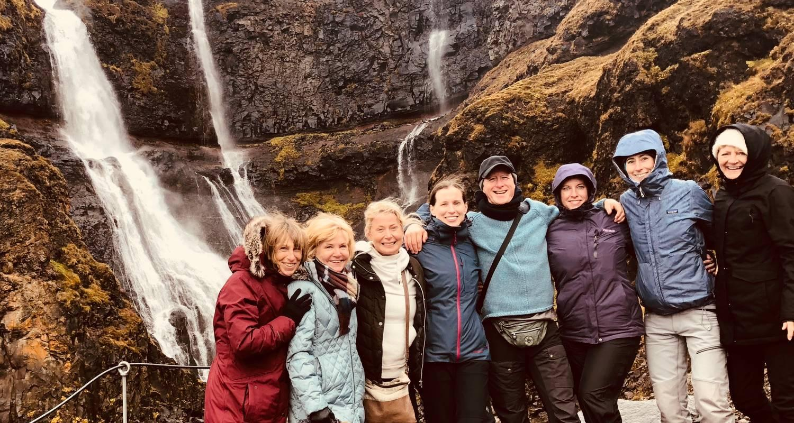

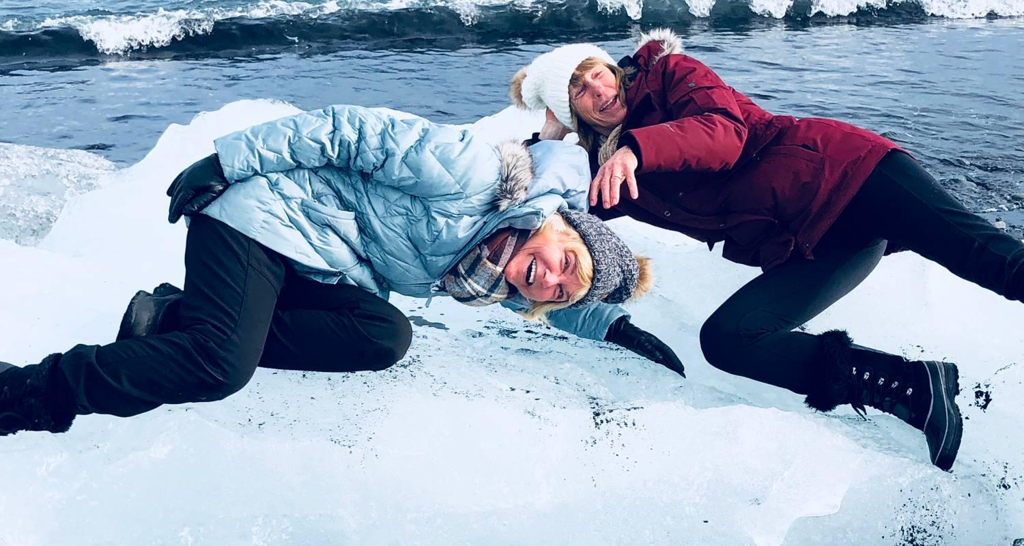

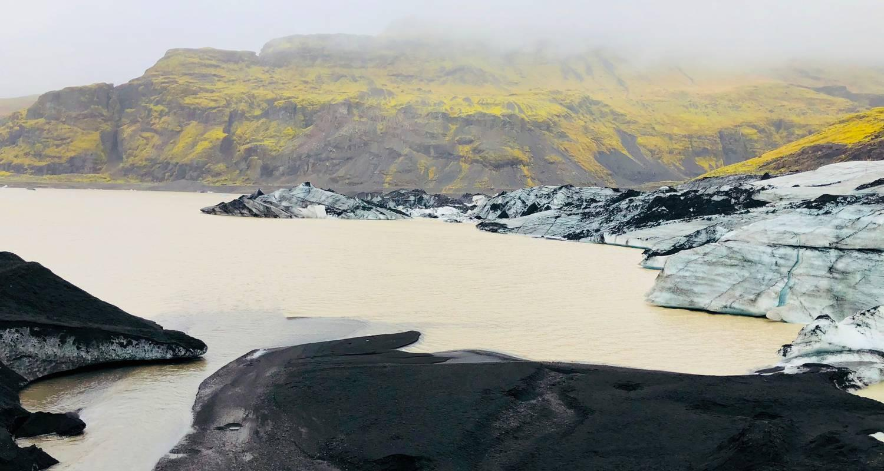

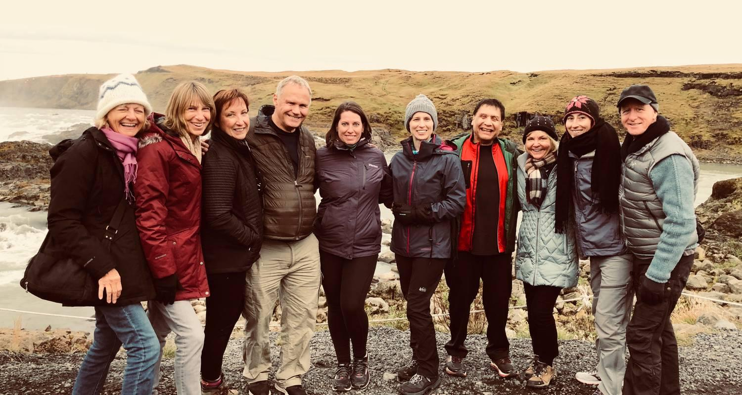

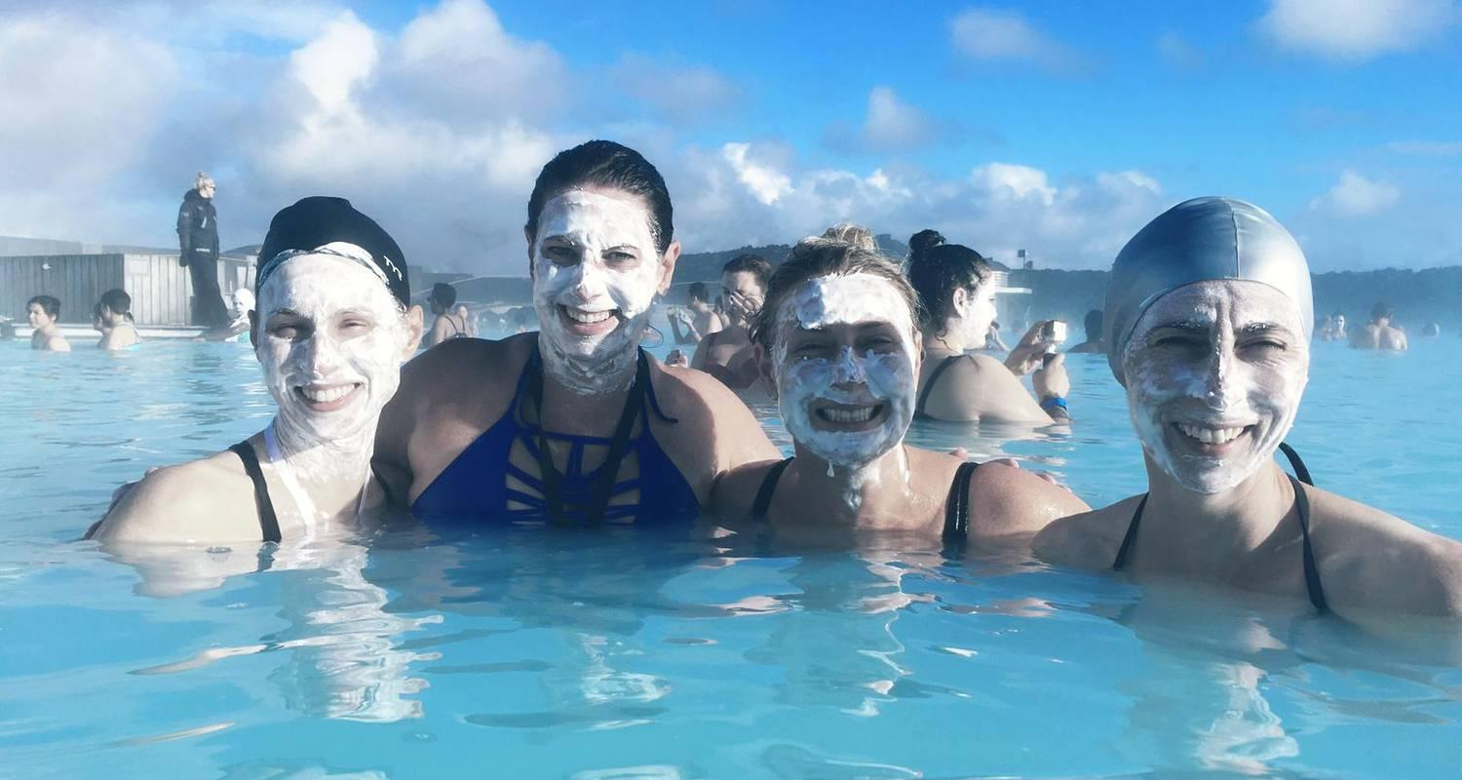

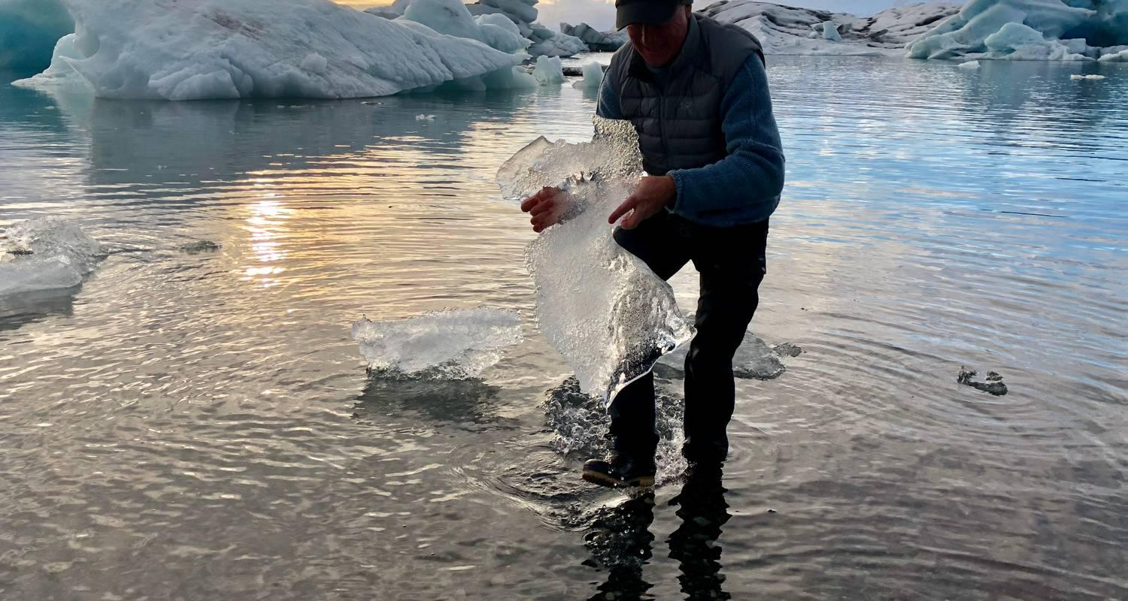

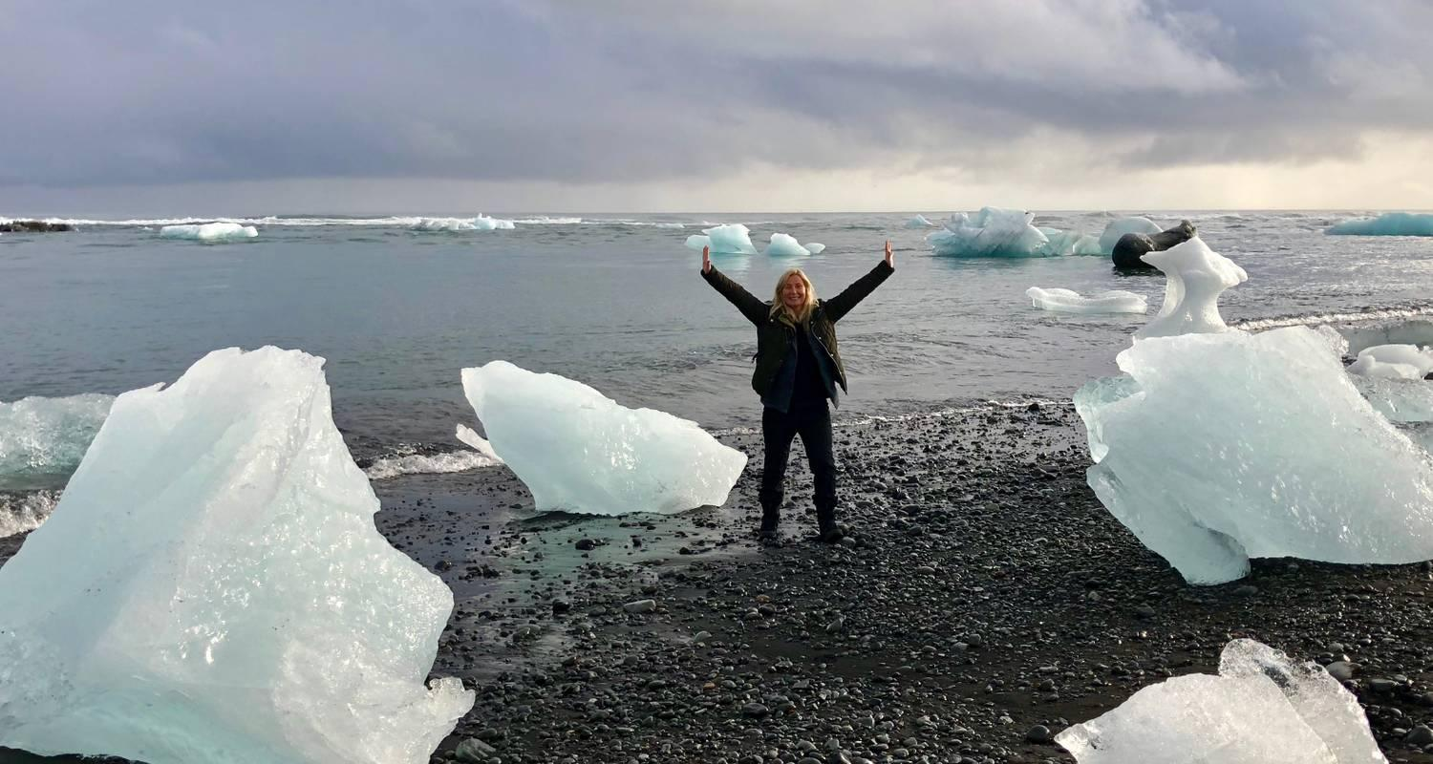

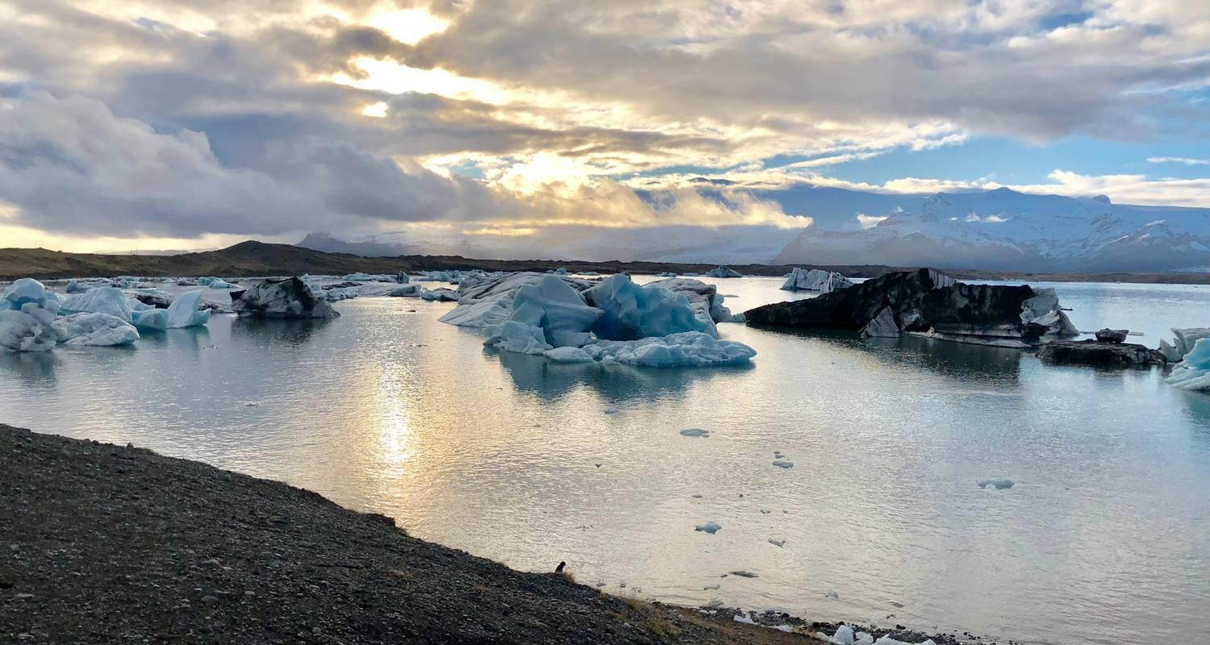

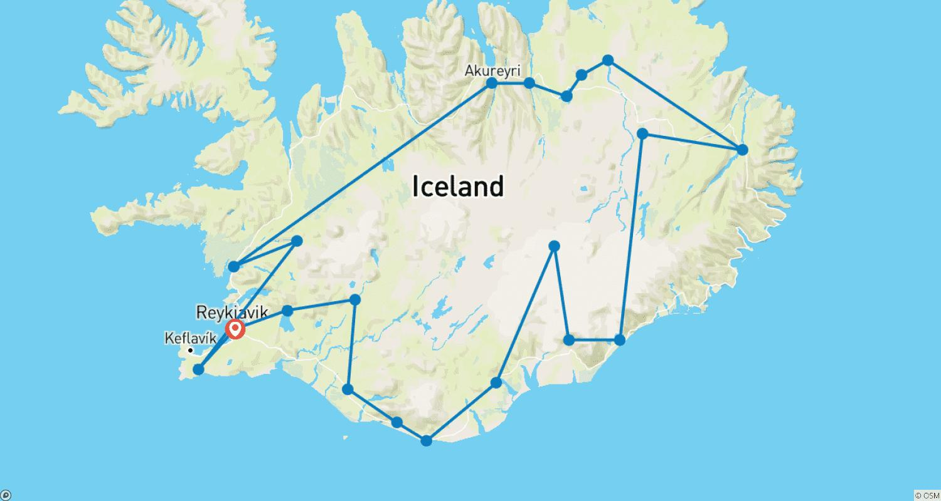

Tour ID: 108469  
Tour Name: Wild Camp Discovery

Tour destinations: ['Isafjordur', 'Vigur']

Tour destinations images:

